Covered Clips
A Weekly Summary of News and Activities for the Cover Arizona Coalition
Weeks of November 2nd and 9th

Arizona Health Insurance Co-op Off the Marketplace
Arizona Republic
A low-cost health insurance co-op that covers about one in three Arizonans that have an Affordable Care Act marketplace plan won't be allowed to sell health plans Sunday — the opening day consumers can purchase insurance — after the state of Arizona and the federal government took action against the entity.
The Arizona Department of Insurance said Friday afternoon that Meritus Health Partners/Meritus Mutual Health Partners has been placed into "supervision" and only can continue to serve existing clients until the end of the year. The federal government also suspended Meritus from the Affordable Care Act's federal marketplace, which means the company won't be able to sell health plans via healthcare.gov when the health-care law's three-month enrollment period begins Sunday.
The government decisions will require about 59,000 Arizona residents who are covered by Meritus to switch health-insurance providers to maintain coverage in 2016, state officials said.
The Arizona Department of Insurance, which regulates the non-profit, said the co-op has declined to accept the state's order for supervision. Under the order of supervision, it cannot sign new or renew existing policies.
Meritus CEO Tom Zumtobel said the co-op took steps to strengthen its finances and thought it met the state law's requirements for insurers to remain viable, but it was unable to convince Arizona Department of Insurance's director that the co-op was on solid financial footing.
"This really caught us by surprise," Zumtobel said. "We couldn't get feedback from DOI (Department of Insurance) on what specifically we needed to do."
Meritus becomes the 11th non-profit co-op plan to face regulatory action or close operations. It follows Utah's Arches Health Plan, which disclosed Tuesday that it also would close. Co-ops in Colorado, Kentucky, Louisiana, Nevada, New York, Oregon, South Carolina and Tennessee also have announced plans to close. A co-op that served Iowa and Nebraska closed in February, the first casualty of the health-care law's experimental program.
A total of 23 consumer-run, non-profit health plans were established under the federal health-care law with more than $2 billion in federal loans. The idea was to promote competition in markets where a single or couple of private health insurers held sway, theoretically lowering rates or slowing rate increases for consumers and businesses.
Nearly half of the co-ops have folded, creating a headache for proponents of President Barack Obama's signature health-care law and forcing more than a half-million consumers to pick a new health plan for 2016.
The co-ops that are closing often rank among the least-expensive or second-least-expensive plans in the market they serve, said Cynthia Cox, Kaiser Family Foundation's associate director of health reform and private insurance.
Cox said that the co-op closings will disproportionately affect rural communities, where there are fewer insurance options.
Officials with the Centers for Medicare and Medicaid Services said they are closely monitoring the financial performance of the remaining health co-ops, with calls as often as every week. In some cases, as with Arizona, CMS regulators pressed state health insurance regulators to determine whether Meritus had the financial strength to last through 2016. The Arizona Department of Insurance and Meritus agreed it would be prudent for the insurer to close.
A CMS spokesman said the agency's top priority is to make sure coverage is not disrupted through the end of the year. Those currently enrolled in the plan will be able to switch plans during the open-enrollment period, which runs through the end of January.
Meritus was awarded startup loans of $20.9 million and solvency loans of $72.4 million, according to a General Accountability Office report issue in April. It's unclear how much of those authorized loans that Meritus spent or how much money was paid back.
The Arizona non-profit's first year was a slow one, with fewer than 1,000 customers enrolled in 2014, the first year of the health-care law's enrollment, according to the GAO report.
In late 2014 and 2015, Meritus took aggressive steps to boost enrollment. The co-op agreed to sign up all customers outside of the normal enrollment period. Outside the open enrollment period, health insurers are required to take new customers only if a consumer has a life change, such as a job loss, divorce or newborn.
The co-op also slashed plan prices in 2015 to become the lowest-cost provider in Arizona's largest counties. Enrollment soared to 59,000 for both its health-maintenance organization and preferred-provider plans, according to Arizona Department of Insurance figures.
"It's disappointing that the Meritus CEO and board of directors declined to consent to this order," said Andy Tobin, who was appointed Arizona Department of Insurance director three weeks ago. "However, with open enrollment beginning this weekend and many Meritus policyholders subject to automatic re-enrollment, it was vital that the department step in and protect Arizona citizens."
The rash of recent co-op failures comes after the Centers for Medicare and Medicaid Services announced a health-care law program created to stabilize the individual market. Called a risk corridor, it would be funded at lower levels than many insurers anticipated.
Zumtobel told The Arizona Republic that the state health insurance department this summer had warned Meritus about the possibility of lower risk-corridor payments even before CMS' announcement. That prompted Meritus to seek larger rate increases for 2016 to stabilize the insurer's finances.
Zumtobel said he first learned that the company's standing with state regulators may be in jeopardy after he met with Tobin last week.
Still, the insurer had prices for 2016 that were among the least expensive plans. Of the 10 lowest-priced plans in the marketplace for 2016, Meritus had three of those plans, Arizona Department of Insurance records show.
Consumer advocates said Meritus' customers will need to closely examine their options for health coverage.
"Meritus leaving the marketplace means a significant number of Arizonans will need to find a new plan that offers comparable costs and coverage," said Diane Brown, executive director of Arizona Public Interest Research Group Education Fund, a consumer watchdog organization.
http://www.azcentral.com/story/news/arizona/investigations/2015/10/31/arizona-health-insurance-co-op-off-marketplace/74766508/#

More on Meritus

The Yellow Sheet

Insurance Co-op Races to Stay Alive

Officers from the insurance co-op Meritus, which was taken off the Arizona health care exchange just days before the opening of the enrollment period, met with Ducey staffers on Wednesday and laid out an option to keep the company open through 2016. That option, however, would likely change Meritus from a non-profit cooperative into a for-profit insurance company. Jim Walsh, the company’s COO, told our reporter that Meritus is in talks with a potential investor, and the hope is that an infusion of cash would convince the Dept of Insurance that the company is financially healthy to last through 2016. As noted earlier, DOI placed Meritus under supervision, which means it may not renew existing policies or write new ones. DOI said the company was operating at a loss and reaching solvency levels that, under state law, warranted intervention. “We’re talking to one [investor] in particular that has been looking at co-ops and what they had been looking at is a co-op that kind of meets their criteria, and at that point, they’d be willing to invest,” said Meritus COO Jim Walsh. Lobbyist Stuart Goodman, who is working with Meritus, said he and others from the company met with Mike Liburdi and Christina Corieri on Wednesday. He said the governor’s office’s overarching goals are clear: balancing the needs of customers and consumer protection with the interests of Meritus staying in business, while ensuring the autonomy of DOI as a regulator. Walsh said the governor’s office essentially wants to see Meritus strengthen its financial status, which would allay fears and hopefully persuade the feds to allow the company back on the exchange. Walsh also said he understands where DOI is coming from. “We want to work with the department and find out what amount of capital infusion they would feel comfortable with, so that they have that certainty that they needed that we would be solvent throughout 2016, and frankly, be able to flourish,” he said.

A Promise Made, a Promise Undelivered

As outlined earlier, Meritus was hard hit when money from a federal program, which was meant to help companies offset losses in case they ended up with a sicker or more costly patient pool, failed to materialize. As it turned out, insurance firms were only getting a fraction of the amount they were promised. In the case of Meritus, the co-op was going to get only 12.6 percent from the “risk corridor” funds (YS, 11/2). Walsh said co-ops from other states are facing a similar struggle: They anticipated operating at a loss for the first two years but hope to turn things around in the third year. The “risk corridor” funds were crucial to helping them get over the hump, he said. “We were promised all along that we would receive something to the tune of $14 million, and we ended up getting about 12 percent of that $14 million,” Walsh said. Back in July, DOI had notified Meritus that it was only going to get roughly 10 percent of risk corridor funds, so the company had hunkered down to streamline its operations. Since then, the company has laid off roughly 20 percent of its staff and taken steps to make it more efficient. Walsh suggested that it would be wrong to conclude Meritus had made major mistakes. “The big difference is that millions of dollars that were promised to us were not delivered. We were executing our plan appropriately, and then had a big hole blown in our budget,” he said. Things turned for the worse two weeks ago, when DOI got a call from US CMS asking the state agency to declare whether Meritus would make it through 2016. “They had to kind of guarantee that we would be fine, and that put them in a pretty terrible position, and we understand that,” Walsh said, adding that the company’s estimation is that it would be operating at a profit finally in 2016.

We’ll Know By December 1st

Walsh said the time for action is very short. At the very least, the company doesn’t want to disrupt the insurance plans of 59,000 Arizonans, who could simply renew them if Meritus were allowed back on the marketplace. The company has a self-imposed deadline of Dec. 1 to get the situation resolved. “I think that’s realistic,” Walsh said, adding that any later than that would quickly shorten the window for its clients to find other plans. “We know that we’ve brought competition to the marketplace. We’ve helped saved Arizonans money and offered innovative plans,” he said. Before it was put under supervision and off the market place, Meritus was offering some of the cheapest plans on the insurance exchange.

White House Announces “Healthy Communities Challenge”

HHS

As the Affordable Care Act’s coverage provisions have taken effect, 17.6 million Americans have gained coverage, and, since 2010, we’ve reduced the uninsured rate in this country by 45 percent. The nation’s uninsured rate now stands at its lowest level ever. But still, in communities across the country, 10.5 million people eligible for Marketplace coverage remain uninsured.

Today, we are launching the White House “Healthy Communities Challenge” to engage key communities with large numbers or high percentages of uninsured in states across the country where strong federal, state and community collaboration can have a meaningful impact on reaching the uninsured. Through this challenge, we are calling on community leadership to build outreach efforts to reach these remaining uninsured and help them gain coverage.

At the end of this third open enrollment period, the Department of Health and Human Services (HHS), along with State-based Marketplaces, will publish tallies of new Marketplace signups in participating communities. These tallies will be compared to HHS estimates of the number of eligible uninsured people at the start of open enrollment to see which communities made the most progress during the challenge.

The victorious community gets bragging rights, a healthier community, and a visit from President Obama to celebrate their success in helping ensure every American has health coverage.

Communities Participating in the “Healthy Communities Challenge”

Based on particularly high opportunity for impact, the White House reached out to local officials in each of these 20 communities, who embraced the “Healthy Communities Challenge” to get their uninsured constituents covered:

• Atlanta, GA | • Milwaukee, WI
• Charlotte, NC | • Nashville, TN
• Chicago, IL | • New Orleans, LA
• Dallas, TX | • Oakland, CA
• Denver, CO | • Philadelphia, PA
• Detroit, MI | • Phoenix, AZ
• Great Falls, MT | • Richmond, VA
• Kansas City, MO | • Salt Lake City, UT
• Las Vegas, NV | • Seattle, WA
• Long Beach, CA | • Tampa, FL

Get Covered Plan Explorer Launched for Open Enrollment
For the start of the third open enrollment period, we've launched a new tool: the Get Covered Plan Explorer. Here's how the tool makes it easier for users to pick the health plan that best fits their needs and budget:
- It gives people free, personalized estimates of how much they would spend -- not just on premiums, but also out-of-pocket costs -- under each marketplace plan available in their area.
- Users can also get information about which plans cover their favorite doctors.
- If you're an enrollment assister, you can use the tool in your appointments with consumers.
To make sure as many consumers as possible know about this free resource, you can embed the tool on your website at no cost. Click here to see the Plan Explorer in action and learn more about how it works.

HealthCare.gov Pilots New Doctor Lookup Feature

Beginning today, HealthCare.gov is piloting a new beta feature that allows consumers to search plans by their preferred provider or health facility. Some consumers will be part of a pilot that allows them to use the beta Doctor Lookup feature as they compare their coverage options in window shopping or when selecting a plan.
This phased-in approach will reach about one in four visitors to HealthCare.gov – selected at random – allowing us to examine the consumer experience with the feature and to analyze the quality of the data based on consumer feedback as we finalize the feature and determine how best to meet consumer needs. In this early stage, some data will be missing or may be inaccurate. As of today, HealthCare.gov has access to data from over 90 percent of insurance companies on the Marketplace. If an insurance company has not provided validated data, consumers will be alerted when they search for a provider that there is “no data from insurance company.” CMS will continue to provide technical assistance to insurance companies that have not yet provided access to their data and will update HealthCare.gov on a daily basis.

Consumers are reminded that health plans can change which doctors and facilities are in their network on a continual basis and providers can change locations and affiliations frequently. That is why we’re encouraging consumers to check with their doctor or plan to confirm that the doctor accepts that plan. Consumers will be asked to opt-in to use the tool to be sure they understand limitations with the data and will be able to leave comments directly through the site.

Read the full press release here.

Great News! We’re Not Doomed to Soaring Health Care Costs

David Brooks, New York Times

It really matters who the next president is. But there are other things that matter just as much to the nation’s future prosperity. One of them is: What is happening to health care costs?
If health care costs start to rise again the way they did before, then health care spending will swallow the economy and bankrupt the federal government. If they are contained, then suddenly there’s a lot more money for everything else, like schools, antipoverty efforts and wages.
The good news is that recently health care inflation has been at historic lows. As Jason Furman, the chairman of President Obama’s Council of Economic Advisers, put it in a speech to the Hamilton Project last month, “Health care prices have grown at an annual rate of 1.6 percent since the Affordable Care Act was enacted in March 2010, the slowest rate for such a period in five decades, and those prices have grown at an even slower 1.1 percent rate over the 12 months ending in August 2015.”
As a result of the slowdown in health care inflation, the Congressional Budget Office keeps reducing its projections of the future cost of federal health programs like Medicare. As of October, projections for federal health care spending in the year 2020 were $175 billion lower than the projections made in August 2010. That would be a huge budget improvement.
The big question is whether these trends will continue. Many people believe that health care inflation came down for entirely temporary reasons and that over the long run we’re still doomed.
One group in this camp emphasizes that the economy went into the tank, so of course people went to the doctor less often. As history demonstrates, it can take up to six years for a recession’s impact to work its way through the system; then health care costs shoot up just as before.
Another group emphasizes that health care inflation is down because general inflation is down, and once general inflation is back to normal, health care costs will shoot upward.
A third group argues that we’ve recently had a decline in technological innovation. Not many useful but costly new drugs or machines have come on the market over the past few years, but if innovation resumes then so will rising costs.
But other experts say the reduction in health care inflation is partly structural and therefore more longstanding. Some point out that health care inflation really began trending downward in 2003 or 2004, during George W. Bush’s first term and long before the recession hit. Second, the reduction in health care cost growth seems to be global. Health cost growth has slowed in just about every high-income country since 2000, possibly as efficiencies are passed from place to place.
Members of the Obama administration like to argue that Obamacare has pushed things along. For example, the Affordable Care Act pushed providers into Accountable Care Organizations. Instead of getting paid for doing more tests and procedures, providers have a greater incentive to just keep people healthy.
The law also encouraged bundling. If you go in to get a hip replacement, the government makes a single payment for all services associated with that episode of care. The law also penalizes hospitals when patients have to be readmitted. There’s been a significant drop in readmissions.
There’s still a lot of uncertainty about which side of the debate is right. The most recent numbers have indicated a scary surge in health care prices, and some firms are projecting 6.5 percent inflation for 2016. While parts of the law reduce spending, other parts may lead to more spending, especially as the industry gets more concentrated.
And yet the weight of the evidence suggests that part of the change is permanent. Moving away from the bad old fee-for-service system has got to be a good thing. The greater pressures providers feel to reduce costs have got to be a good thing, at least fiscally.
Last March, Jonathan Rauch wrote a report for the Brookings Institution, arguing that the health care market is more open to normal business model innovation than ever before. The quality of health care data and analytics is improving exponentially. Pressures to reduce costs are ratcheting up. Profitable niches are growing for efficiency improving products.
In the past, most innovation involved improving quality of care at high cost. Rauch described many entrepreneurs who are providing innovations that maintain current quality of care but at lower cost.
We seem to be making at least some incremental progress toward a structural reduction in health care inflation. Many Americans are feeling gloomy about accomplishing anything these days, but progress is possible. We haven’t whipped health care inflation, or defeated our intractable budget issues. But the evidence suggests we’re landing a few serious blows.
http://www.nytimes.com/2015/11/06/opinion/great-news-were-not-doomed-to-soaring-health-care-costs.html?_r=0

Health Insurers Struggle to Profit from ACA Plans

Wall Street Journal
The Affordable Care Act’s third open enrollment season got under way, with a new array of health plans that show how the law’s influence is starting to transform the insurance industry.
Sunday’s kickoff appeared to go relatively smoothly, with little evidence of technical glitches at HealthCare.gov as consumers started to shop for coverage that will take effect in 2016. But this enrollment season will be a challenge as the Obama administration and insurers try to lure holdouts who haven’t previously signed up for ACA coverage, even as premiums for many products appear set to rise sharply. Premiums for a type of plan that is closely watched as a signal of consumer costs—the second-lowest-priced insurance product in the law’s “silver” metal tier—will increase 7.5% on average across the roughly three dozen states that rely on the HealthCare.gov marketplace, according to the administration.
Behind those shifts is a tough business reality: Under the ACA, insurers have seen an influx of new membership in individual plans and in Medicaid plans they administer for the government, expanding the industry’s total U.S. revenue to $743 billion in 2014, the year the law’s biggest changes took effect, from $641 billion the year before, according to a new analysis by consulting firm McKinsey & Co.
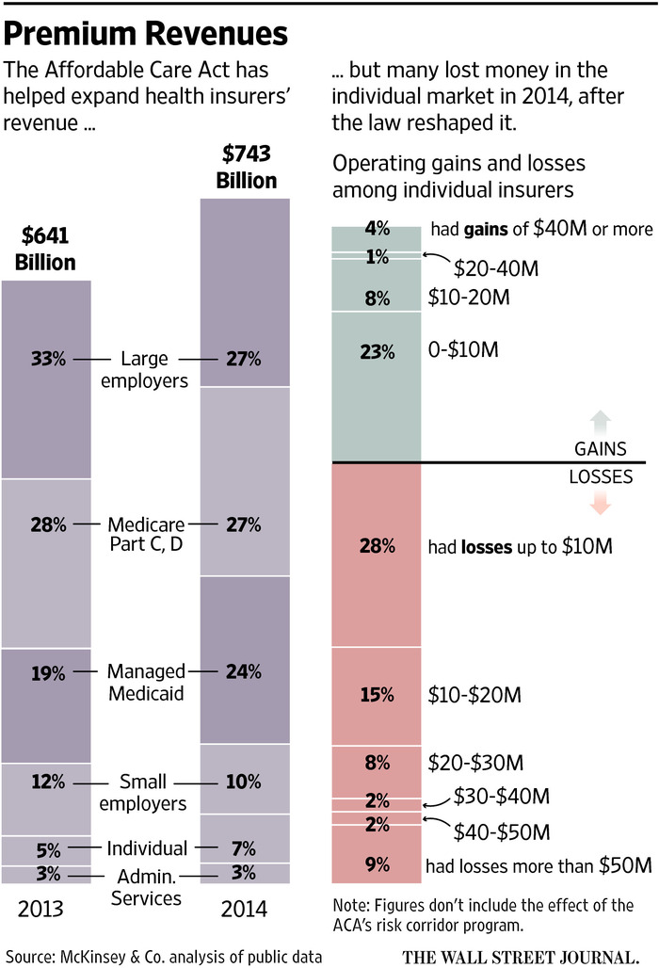
But much of that growth has been unprofitable. Health insurers lost a total of $2.5 billion, or on average $163 per consumer enrolled, in the individual market in 2014, McKinsey found. A number are also expecting to lose money on their marketplace business for 2015.
Now, a lot of insurers are recalibrating their approach for 2016, with changes visible at all levels of the industry—from pricing to product design.
At big insurer Aetna the evidence of the law’s impact could be spotted last month in a Phoenix classroom, where Aetna was training a class of customer-service hires who will support a suite of re-engineered ACA marketplace plans dubbed “Leap.” Those products will have a different service approach, with fewer automated phone prompts and a completely new staff that is supposed to spend more time solving customers’ problems.
A trainee stood at a whiteboard, drawing stick figures with speech bubbles in a Pictionary-style game. “Conversation?” asked a class member. “Transition of care?” ventured another. The teacher gave the answer: The new reps had to keep commitments to consumers. That meant calling them back if needed.
The health law remade the individual market, forcing insurers to sell plans to all consumers and banning them from charging rates based on health conditions. Insurers struggled to predict their costs, and many didn’t set rates high enough to cover the care of those they enrolled.
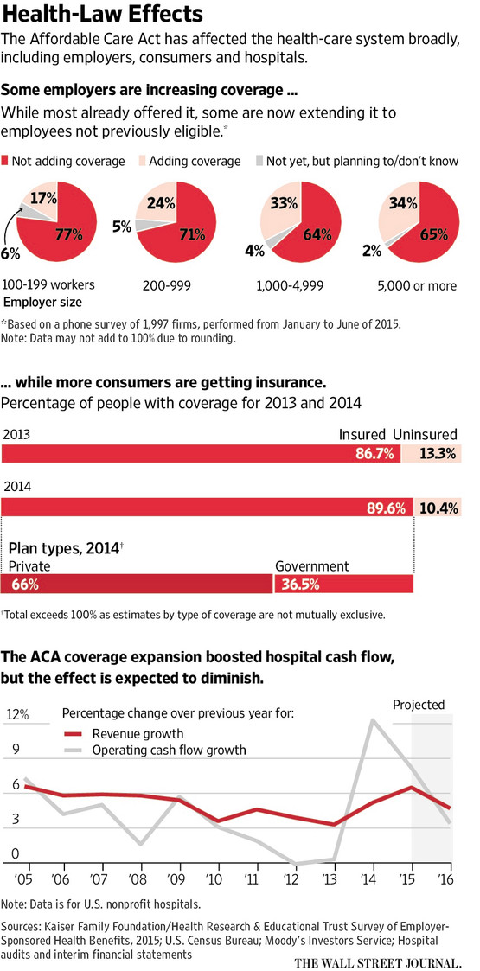
Now, a number of insurance startups are shutting down, including many of the law’s 23 cooperative insurers, which won’t have products for this fall’s open enrollment shoppers.
For larger companies, the losses were survivable. But rate increases create a risk that consumers may get sticker shock despite the availability of federal subsidies that reduce the cost sharply for many.
Peter Wainwright, 63 years old, who retired from a telecommunications job, currently has a plan bought on California’s ACA marketplace. He and his wife don’t get a subsidy and pay about $2,230 a month, and the rate is increasing for 2016. “Everything has gone up,” said Mr. Wainwright, of Half Moon Bay, Calif.
The administration’s goal is to have about 10 million people with paid-up coverage on the state and federal ACA exchanges by the end of 2016. The nonpartisan Congressional Budget Office earlier this year estimated that at least 20 million people would buy policies under the law for 2016 coverage.
Still, insurers believe over time that the overall consumer-oriented market is likely to grow, including burgeoning private Medicare plans, and approaches pioneered there are expected to spread into the larger employer-based business.
“The ACA is an accelerant, or a catalyst” for changes, said Brad Wilson, chief executive of Blue Cross and Blue Shield of North Carolina. “The market is, and will continue to evolve to, a consumer-centric, retail type.”
The nonprofit, which lost money on its exchange business in 2014 and expects to do so again in 2015, sought a roughly 35% rate increase for next year and is making other moves to rein in costs, including calling enrollees who have frequent emergency-room visits to encourage other options such as primary-care doctors.
Many insurers are tweaking their health-care-provider networks. Health Care Service Corp., which owns Blue Cross and Blue Shield plans in five states, lost money on its 2014 exchange business. For next year, it will stop offering preferred-provider-organization plans on the exchange in Texas, while in the Illinois marketplace it will no longer sell the PPO that featured the biggest selection of hospitals and doctors.
The insurer is developing plans like one it will sell in the Chicago area next year, with a network that, for most care, includes just one large health system. Individual consumers often don’t need a huge variety of providers, and care most about low premiums, said Steve Hamman, a senior vice president at Health Care Service.
With its Leap plans, Aetna is using many of the approaches that are gaining momentum in the industry. The Leap plans, which will roll out in four states this fall but are expected to be more widely available next year, rest on different technology than other Aetna products, including a new claims-processing platform, the company says.
“It’s a mammoth change in the offering, with everything being brand-new,” said Dijuana Lewis, an Aetna executive vice president. Aetna said this week it would likely lose money in 2015 on its exchange business.
The Leap insurance will include limited networks: In Arizona, it will be built around just one provider, the large Banner Health system. The Leap plans also aim to be easy to understand. For instance, they generally won’t include coinsurance, in which a consumer pays a percentage of the cost of a medical service, a concept many people find confusing.
But the Leap deductibles can be big, totaling $6,850 for some Leap plans at the “bronze” level, the lowest-cost metal tier created by the health law.
“The No. 1 thing is affordability” for consumers, said Ms. Lewis. Plans with higher deductibles typically have lower monthly premiums.
Aetna says it is also improving customer service. Among other changes, it says it has cut by 90% the number of automatic prompts in its call-in number, sending callers faster to live help.
It calls its newly hired customer-service staffers “service advocates.” The new reps won’t be rated on their number of calls per hour. Instead, consumer feedback will be a key determinant.
The customer-service trainees, whose classroom was lined with posters bearing mottos such as “Empathize,” are encouraged to phone health-care providers to resolve billing questions. “It is very different,” said Barbara Gagnon, a new hire who has worked previously in health-insurance call centers. “We will actually be listening to the person…you’re stepping out a little bit more.”
http://www.wsj.com/articles/health-laws-strains-show-1446423498?alg=y

Insurance Commissioners Aim to Address ACA Health Plan Networks

California Healthline
The National Association of Insurance Commissioners has issued recommendations that would require health insurance companies to have provider networks broad enough to ensure their enrollees can receive all covered services "without unreasonable travel or delay," the New York Times reports.
According to the Times, NAIC drafted the recommendations in response to consumers' complaints about limited networks offered in health plans sold through the Affordable Care Act's exchanges. The Obama administration earlier this year said it was waiting to see the NAIC's proposal before deciding whether to adopt federal standards for provider networks.

Proposal Details
The proposal was developed over an 18-month drafting process, which was open to consumers, insurers, providers and experts.
The recommendations -- proposed in the form of a model state law -- aim to:
- Help consumers receive in-network care; and
- Protect consumers from high costs if they receive out-of-network care.
The proposal recommends that when determining whether health plans have adequate provider networks, insurance commissioners should consider factors such as:
- Appointment wait times;
- The ability of insurers to meet the health care needs of low-income enrollees and "children and adults with serious, chronic or complex health conditions or physical or mental disabilities";
- The ratio of plan enrollees to the number of physicians in each specialty who are included in the network; and
- The "geographic accessibility of providers."
The proposal also would require insurers to update their provider directories at least once monthly.
The proposal calls for hospitals and insurers to notify patients of any possible extra charges they could incur from health care providers who are not included in their insurers' networks.
Further, the proposal recommends that when individuals receive out-of-network care, they should not be required to pay more than the typical share of costs they would be required to pay for in-network services. Providers who disagree with such payments could use a mediation process to negotiate with insurers, but patients would be "held harmless" for the costs (Pear, New York Times, 11/8).
http://www.californiahealthline.org/articles/2015/11/9/insurance-commissioners-aim-to-address-aca-health-plans-networks

Universal Health Care to Appear on Colorado Ballot in 2016

New York Times
Supporters of universal health care have gathered enough signatures to put on next year's ballot a plan to make Colorado the first state to opt out of the federal health law and replace it with taxpayer-funded coverage for all.
Proponents submitted 158,831 qualified signatures, about 60,000 more than required to put the measure on the ballot, Secretary of State Wayne Williams said Monday. The question would make Colorado the first state to opt out of the federal Affordable Care Act and replace it with universal health care.
Vermont lawmakers passed universal health care in 2011. But three years later, the state abandoned the plan as too expensive.
The ColoradoCareYES campaign says employers would have to pay a new tax — about 7 percent of a worker's wages — into the health co-op, on top of deductions for Social Security and Medicare. Employees would have a payroll tax of about 3 percent. Both employers and workers then would not have to pay premiums to a private health insurer.
The campaign says those taxes would raise enough money to cover children and adults who do not work. They say the plan will cost $3 billion a year but will save $9 billion in health care administration costs compared with the current system.
Skeptics say costs would run out of control.
The campaign is expected to face intense opposition and could make for a heavily funded, highly visible debate over the viability of single-payer health care in a key swing state in the 2016 presidential election.

http://www.nytimes.com/aponline/2015/11/09/us/ap-us-universal-health-care.html?_r=1&utm_campaign=KHN:+First+Edition&utm_source=hs_email&utm_medium=email&utm_content=23592736&_hsenc=p2ANqtz-_G9RjgAYYkcsYbtMVqVu1GUKUKqHWCi2axOWbMkRYgwfWJfibHiss6Qr5Kz&tr=y&auid=16194107

Rural v. Urban Marketplace Enrollment by State
 | All Persons |  | Metropolitan |  | Non-Metropolitan
 | Enrolled | Enrolled at Percent of the Potential Marketplace | Enrolled | Enrolled at Percent of the Potential Marketplace | Enrollled | Enrolled at Percent of the Potential Marketplace
Arizona | 205,666 | 32.7% | 198,323 | 33.3% | 7,340 | 22.3%
All Medicaid Expansion States | 2,609.598 | 38% | 2,202,155 | 38.9% | 407,461 | 33.9%

http://cph.uiowa.edu/rupri/publications/policybriefs/2015/Rural%20Enrollment%20in%20HIM.pdf

_____________________________

Have something you want us to possibly add to next week’s newsletter? Email Kim VanPelt at kim.vanpelt@slhi.org.

