Covered Clips
A Weekly Summary of News and Activities for the Cover Arizona Coalition
Weeks of September 21st and 28th

2015 Arizona Enrollment Trainings

The Cover Arizona Coalition, in partnership with the Centers for Medicare & Medicaid Services (CMS) San Francisco Regional Office and the Department of Health and Human Services, invite you to attend the 2015 Arizona Health Insurance Marketplace Training and Workshop. Workshops will be taking place in Yuma, Flagstaff, Tucson, and Phoenix. City-specific dates are below.
Workshops will be two full days and feature Health Insurance Marketplace training and updates by CMS, plus local experts sharing tactics and lessons learned from the last enrollment period, best practices for enrollment, and more. Day one will focus on providing new assister and refresher information. Day two will focus on information new to this open enrollment period, as well as information on best practices. Experienced assisters have an option of signing up for both days of training, or only Day Two of training.
There is no registration fee associated with this training and it is open to the public. Lunch will be provided as part of each day’s training (donated by Cover Arizona Coalition partners). These trainings are not required by CMS.
Advance registration is required. Click here to register.
Please note: Space is limited. Limits may be placed on the number of attendees per organization, depending on response and room capacity. Priority will be given to Navigator organizations and Certified Applications Counselor organizations.
Dates/Locations
Tucson, AZ
October 13th and 14th
9am – 5pm
Inn Suites – Tucson City Center
475 N Granada Ave, Tucson, AZ 85701
Yuma, AZ
October 15th – 16th
9am – 5pm
Regional Center for Border Health, Inc.
Main Conference Room – 2nd Floor
214 W. Main Street
Somerton, AZ 85350
Flagstaff, AZ
October 20th and 21st
9am – 5pm
1702 N. 4th Street
Flagstaff, AZ 86004
Phoenix, AZ
October 22nd and 23rd
The Sheraton Crescent Hotel
2620 W. Dunlap Ave
Phoenix, AZ 85021
Crescent A and B
If you have any questions regarding these trainings, please feel to contact Kim VanPelt at St. Luke’s Health Initiatives at kim.vanpelt@slhi.org

Percent of Uninsured Kids Drop, Still Many without Coverage

Children’s Action Alliance
New data from the U.S. Census Bureau found some encouraging news about Arizona children: the percentage of those without health insurance is dropping; even if slowly, the number is going in the right direction. The survey results from 2014 found 10% of Arizona kids lack coverage, down from 12% in 2013.
While it is no surprise the Affordable Care Act is having a positive impact on uninsured families, there are still too many children in our state without coverage. Arizona has the third highest rate of kids without health insurance, behind only Alaska and Texas. Additionally, Arizona ranks highest in the percentage of UNINSURED children who could qualify for low-cost coverage through KidsCare – coverage for children in working families available in every state EXCEPT Arizona.
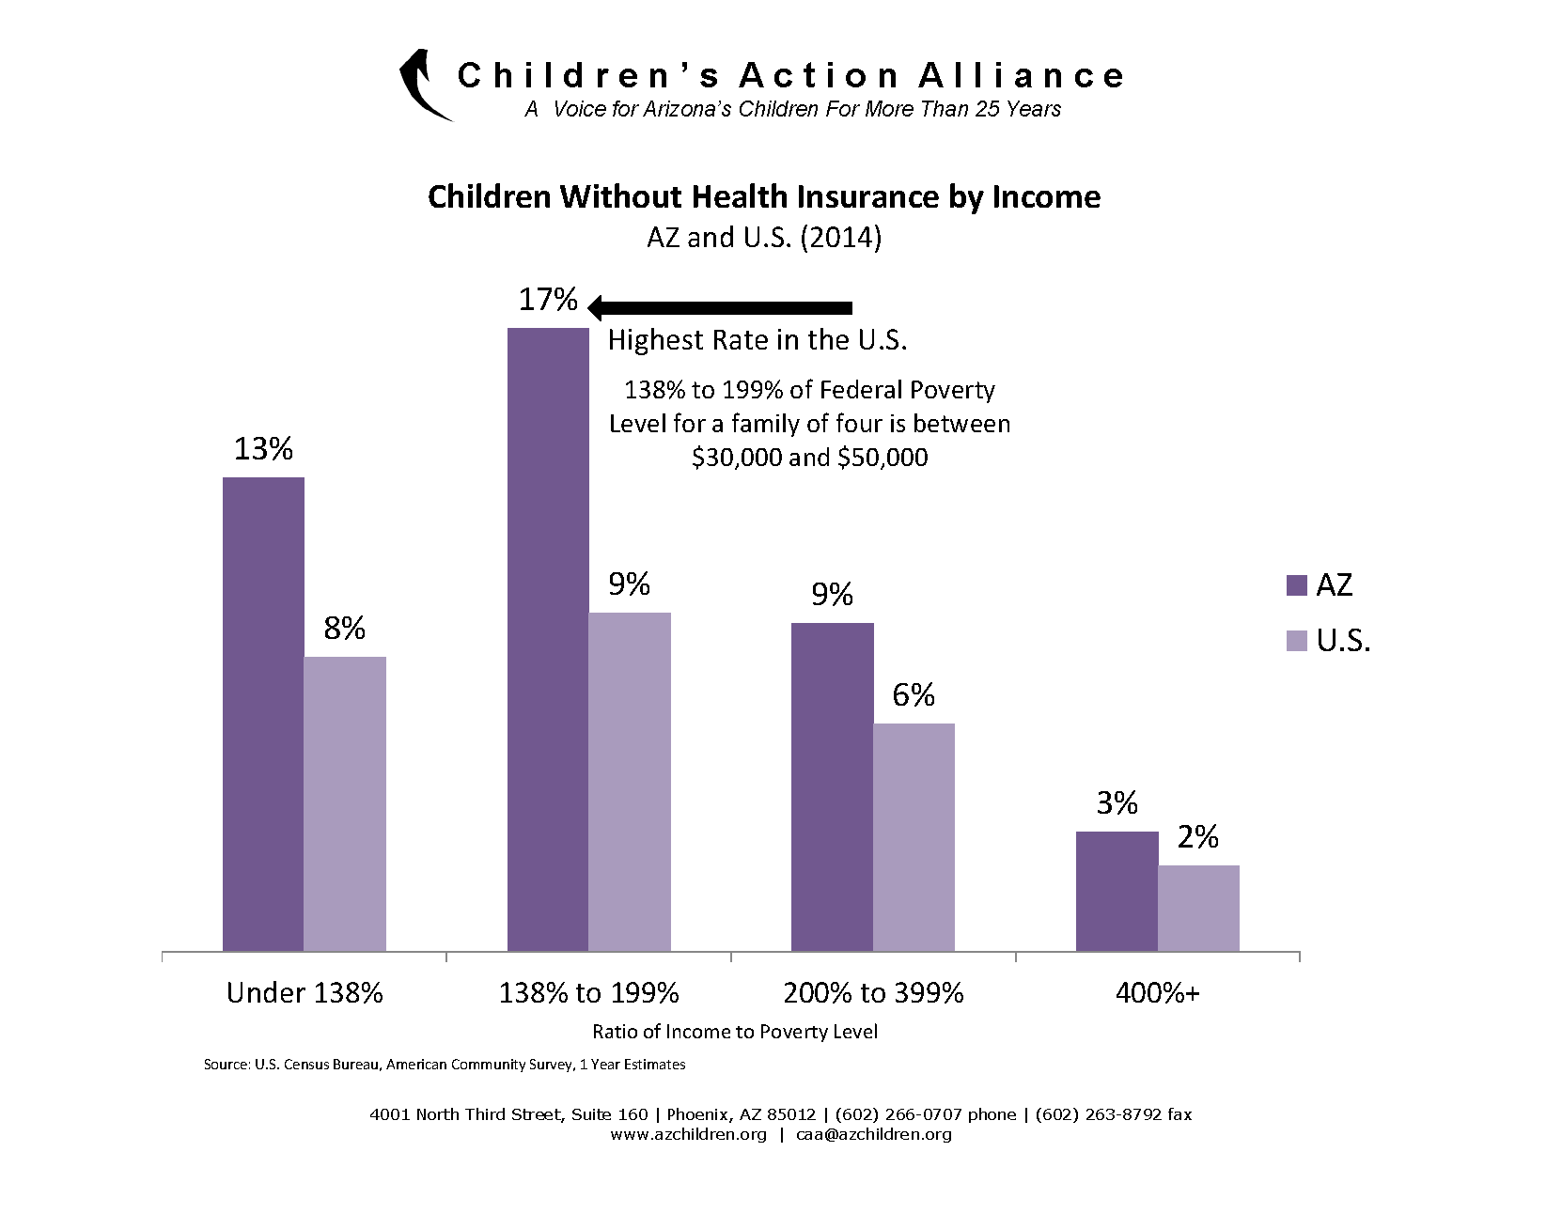
Many working families face high costs in Obamacare Marketplace health plans – even if they qualify for federal subsidies. As a result, too many children in families with incomes of $30,000 to $50,000 remain left out of health care. Enrollment in KidsCare has been frozen since 2010. But now Arizona has the opportunity to lift the freeze. As Arizona explores health care reform strategies, covering more kids should be a top priority.

Arizona Metro Areas with the Largest Percent Uninsured

Lake Havasu City- Kingman 17.3 percent
Flagstaff, Arizona 16.6 percent
Yuma, Arizona 15.1 percent
Prescott, Arizona 13.6 percent
Phoenix-Mesa-Scottsdale 13.3 percent
Tucson 13.2 percent

http://blogs.wsj.com/economics/2015/09/17/more-americans-have-health-insurance-heres-who-still-doesnt/?tr=y&auid=16006990

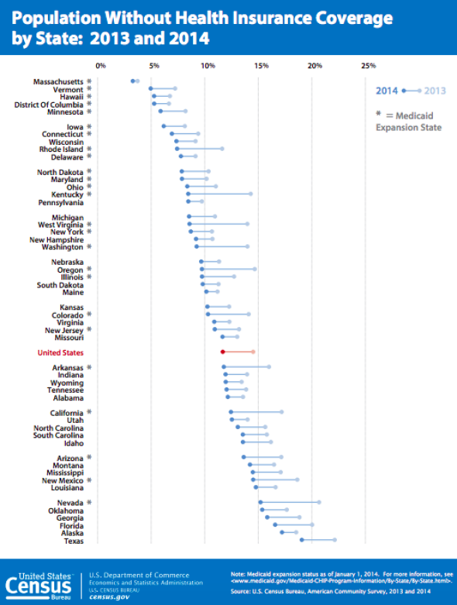

US Targets Four States in Effort to Enroll the Uninsured

New York Times
With the third open enrollment season under the Affordable Care Act beginning in about six weeks, Obama administration officials said Tuesday that they would focus efforts to expand health coverage to the uninsured in Dallas, Houston, northern New Jersey, Chicago and Miami. ‘Over all, this open enrollment period is going to be tougher than last year,’ Sylvia Mathews Burwell, the secretary of health and human services, said in a speech here at Howard University Hospital. Many of the uninsured have already signed up, she noted, shrinking the pool of eligible people who do not have coverage. And ‘with our economy improving,’ she said, ‘more people can get coverage under employer plans.’ Ms. Burwell said the administration would focus on 10.5 million uninsured Americans who were eligible for coverage through the public insurance exchanges, also known as marketplaces. The enrollment period runs from Nov. 1 through Jan. 31, 2016, and she encouraged Americans to prepare. At the end of the year, Ms. Burwell said, ‘we expect that 9.1 million individuals will have active coverage through the marketplace’ — the federal and state exchanges where consumers can shop for insurance. That number is down from 10.2 million at the end of March and 9.9 million at end of June. Some people failed to pay their premiums, and others could not adequately answer federal questions about their citizenship or immigration status. Ms. Burwell did not state a numerical goal for enrollment in the coming year. The Congressional Budget Office predicted in March that enrollment through the exchanges would reach 11 million this year and 21 million in 2016. But administration officials said those forecasts were based on two assumptions that inflated the numbers but have proved invalid. One assumption was that significant numbers of employers would drop insurance coverage and send their workers into the new insurance exchanges, but that has not happened, the officials said. The Congressional Budget Office also assumed that few consumers would buy insurance on their own outside of the new exchanges, but some have done so, officials said. Under the 2010 health care law, consumers who buy private insurance on their own, outside of the exchanges, cannot obtain federal subsidies for such policies. The subsidies are available only for insurance purchased through the public exchanges.

http://www.nytimes.com/2015/09/23/us/politics/us-targets-four-states-in-effort-to-enroll-the-uninsured.html?emc=edit_tnt_20150922&nlid=58462464&tntemail0=y&utm_campaign=KHN:+First+Edition&utm_source=hs_email&utm_medium=email&utm_content=22258664&_h&tr=y&auid=16028788

To Enroll or Not To Enroll? Why Many Americans Have Gained Insurance under the Affordable Care Act While Others Have Not

The Commonwealth Fund

According to the most recent Commonwealth Fund Affordable Care Act Tracking Survey, March–May 2015, an estimated 25 million adults remain uninsured. To achieve the Affordable Care Act’s goal of near-universal coverage, policymakers must understand why some people are enrolling in the law’s marketplace plans or in Medicaid coverage and why others are not. This analysis of the survey finds that affordability—whether real or perceived—is playing a significant role in adults’ choice of marketplace plans and the decision whether to enroll at all. People who have gained coverage report significantly more positive experiences shopping for health plans than do those who did not enroll. Getting personal assistance—from telephone hotlines, navigators, and insurance brokers, among other sources—appears to make a critical difference in whether people gain health insurance.

See full report at http://www.commonwealthfund.org/publications/issue-briefs/2015/sep/to-enroll-or-not-to-enroll?omnicid=EALERT885300&mid=kim.vanpelt@slhi.org

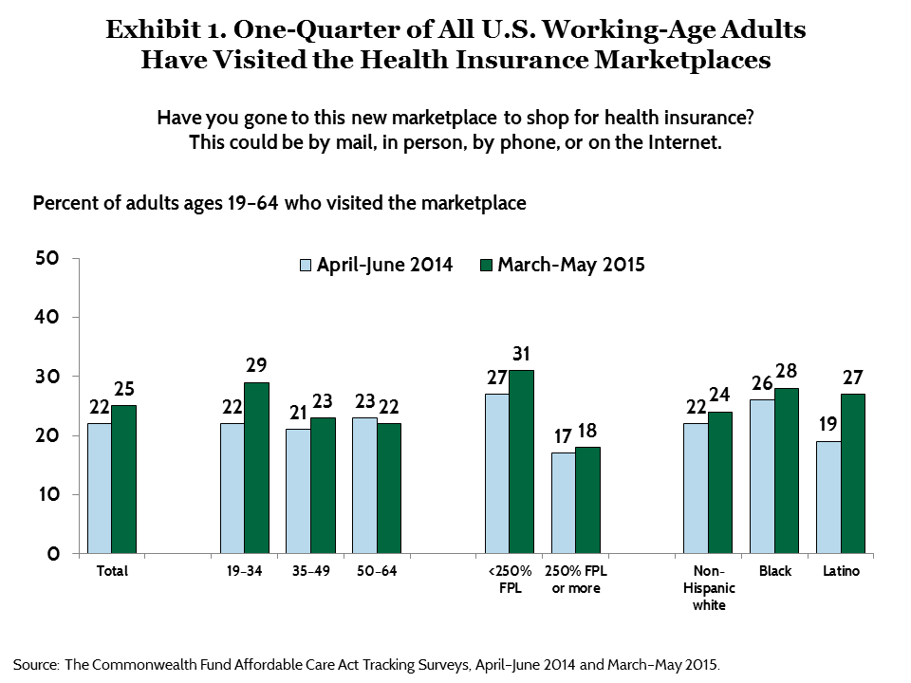

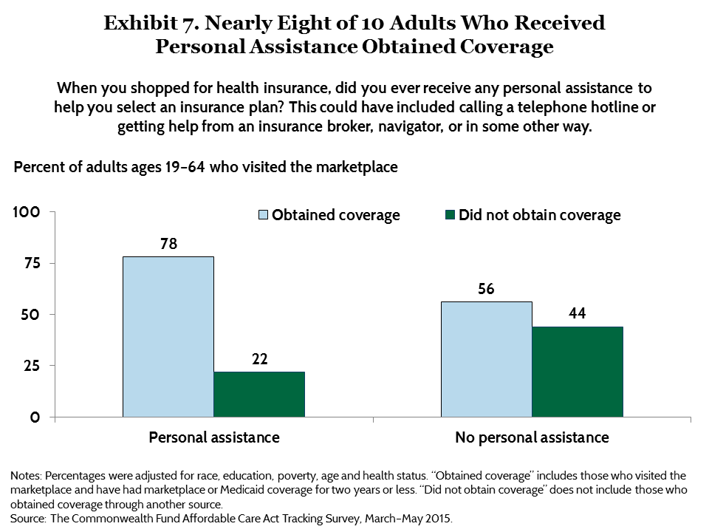

Employer Family Health Premiums Rise 4 Percent to $17,545 in 2015, Extending a Decade-Long Trend of Relatively Moderate Increases

Kaiser Health News
Single and family premiums for employer-sponsored health insurance rose an average of 4 percent this year, continuing a decade-long period of moderate growth, according to the Kaiser Family Foundation/Health Research & Educational Trust (HRET) 2015 Employer Health Benefits Survey released today. Since 2005, premiums have grown an average of 5 percent each year, compared to 11 percent annually between 1999 and 2005.
The average annual premium for single coverage is $6,251, of which workers on average pay $1,071. The average family premium is $17,545, with workers on average contributing $4,955.
The survey also finds that 81 percent of covered workers are in plans with a general annual deductible, which average $1,318 for single coverage this year. Covered workers in smaller firms (three to 199 workers) face an average deductible of $1,836 this year. That’s 66 percent more than the $1,105 average deductible facing covered workers at large firms (at least 200 workers).
Since 2010, both the share of workers with deductibles and the size of those deductibles have increased sharply. These two trends together result in a 67 percent increase in deductibles since 2010, much faster than the rise in single premiums (24%) and about seven times the rise in workers’ wages (10%) and general inflation (9%).
“With deductibles rising so much faster than premiums and wages, it’s no surprise that consumers have not felt the slowdown in health spending,” Foundation President and CEO Drew Altman said.
“Employees are benefiting from stable employer health benefits coverage and modest premium growth,” said Maulik Joshi, president of HRET, an affiliate of the American Hospital Association. “Also noteworthy is that many employers are tying financial incentives to employee participation in health and wellness programs.”
The 17th annual Kaiser/HRET survey of nearly 2,000 small and large employers provides a detailed picture of the status and trends in employer-sponsored health insurance, costs and coverage, including employers’ responses to provisions of the Affordable Care Act. In addition to the full report and summary of findings released today, the journal Health Affairs is publishing a Web First article with select findings, and the Foundation is releasing an updated interactive graphic that allows users to chart the survey’s premium trends for different groups, including by firm size, region and industry.
http://kff.org/health-costs/press-release/employer-family-health-premiums-rise-4-percent-to-17545-in-2015-extending-a-decade-long-trend-of-relatively-moderate-increases/

Health Insurance Deductibles Outpacing Wage Increases, Study Finds
New York Times
It may not seem like much — just an extra hundred dollars or so a year. But the steady upward creep in health insurance deductibles has easily outpaced the average increase in a worker’s wages over the last five years, according to a new analysis released on Tuesday by the Kaiser Family Foundation. Kaiser, a health policy research group that conducts a yearly survey of employer health benefits, calculates that deductibles have risen more than six times faster than workers’ earnings since 2010. ‘It’s a very powerful trend,’ said Drew Altman, Kaiser’s chief executive. Four of five workers who receive their insurance through an employer now pay a deductible, in which they must pay some of their medical bills before their coverage starts, according to Kaiser. Those workers’ deductibles have climbed from a yearly average of $900 in 2010 for an individual plan to above $1,300 this year, while employees working for small businesses have an even higher average of $1,800 a year. One in five workers has a deductible of $2,000 or more. The nation’s largest health insurers are engaged in a round of consolidation, and consumer advocates worry that the mergers will result in even higher costs for coverage. A Senate hearing on Tuesday scrutinized the merger plans. While the Kaiser survey examines plans provided by employers, Mr. Altman said many of the insurance policies being sold under the federal health care law through the state exchanges also rely on high deductibles to keep premiums low. Some employers also increased their deductibles to reduce the higher costs associated with the law. The law may be prompting even more changes by companies, in order to have workers shoulder more of their medical costs. The prospect of the so-called Cadillac tax, a new tax created under the law on high-price health plans, is causing more companies to consider changes like increasing the size of their employees’ deductibles. The tax, which is expected to go into effect in 2018 but faces widespread opposition, could change the steady increase in deductibles into a ‘spurt,’ Mr. Altman said. But asking employees to cover more of their medical bills through high deductibles raises questions about whether some workers, especially those with expensive, chronic conditions, are being discouraged from seeking the care they need. Companies have traditionally relied on higher deductibles to reduce premiums, both to lower their own costs and to reduce what they take out of the employees’ pay for coverage, said Laurel Pickering, the chief executive of the Northeast Business Group on Health, an employer group. ‘Clearly, it’s the go-to solution,’ she said.”
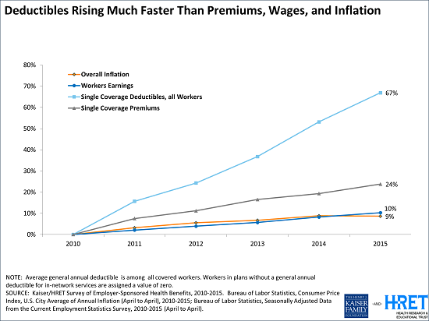

Employer Requirements Lead to Modest Changes in Worker Hours
This year, 57 percent of employers offer health benefits to at least some of their workers, statistically unchanged from 55 percent last year. Offer rates vary by firm size, with 98 percent of large firms (200 or more workers) offering coverage, compared to less than half (47%) of the smallest firms (three to nine workers).
Beginning in 2015, employers with at least 100 full-time equivalent employees (FTEs) must offer to their full-time workers health benefits that meet minimum standards for value and affordability or pay a penalty. The requirement applies to employers with 50 or more FTEs beginning in 2016.
Of firms reporting at least 100 FTEs (or, if they did not know FTEs, of firms with at least 100 employees), 5 percent say that they offered more comprehensive benefits this year to some workers who previously were only offered a limited benefit plan, and 21 percent say that they extended eligibility to groups of workers not previously eligible.
Among employers with 50 or more FTEs (or, if they did not know how many FTEs, firms with at least 50 employees), 4 percent report that they changed some job classifications from full-time to part-time (less than 30 hours per week) so employees would not be eligible for health benefits, while 10 percent report changing some job classifications from part-time to full-time to enable workers to obtain coverage. Four percent also report reducing the number of full-time employees they planned to hire because of the cost of health benefits.

Large Employers Take Early Steps to Prepare for ‘Cadillac tax’ in 2018
The survey provides an early look at employers’ response to the Affordable Care Act’s excise tax on high-cost health plans, sometimes called the “Cadillac tax,” which begins in 2018.
A majority (53%) of large employers (200 or more workers) offering health benefits say that they conducted an analysis to determine if any of their plans would exceed the Cadillac tax thresholds, and about one in five (19%) of this group say their plan with the largest enrollment will exceed the threshold amount. In addition, 13 percent of large firms offering health benefits say they have made changes to their plans to avoid reaching the excise tax thresholds, and 8 percent say they switched to a lower-cost health plan.
“Our survey finds most large employers are already planning for the Cadillac tax, with some already taking steps to minimize its impact in 2018,” said study lead author Gary Claxton, a Foundation vice president and director of the Health Care Marketplace Project. “Those changes likely will shift costs to workers, but exactly how and how much will vary for individual workers.”
The survey also captures some steps employers have taken to limit their provider networks as a way to reduce costs: 9 percent of firms offering health benefits say that one of their plans eliminated a hospital or a health system from their network, and 7 percent offer a “narrow network” plan, generally considered more limited than the standard HMO network.

One Third of Large Firms Offer Financial Incentives for Participating in Wellness Programs
Many large employers offering health benefits offer health screening programs including health risk assessments (50%), which are questionnaires asking employees about lifestyle, stress or physical health; and biometric screenings (50%), which are in-person health examinations conducted by a medical professional.
The survey finds that 31 percent of large employers offering health benefits have a financial incentive for employees to complete health-risk assessments, and 28 percent have an incentive for employees to complete biometric screening.
The majority of large employers continue to offer wellness programs, such as smoking cessation, weight loss or other lifestyle coaching. Thirty-eight percent of those offering one of these wellness programs provide a financial incentive for employees to participate or complete the program. Among these firms, 15 percent offer a maximum incentive greater than $1,000 for all of a firm’s health and wellness programs, including any incentives for health screening.
http://www.nytimes.com/2015/09/23/business/health-insurance-deductibles-outpacing-wage-increases-study-finds.html?utm_campaign=KHN:+First+Edition&utm_source=hs_email&utm_medium=email&utm_content=22258664&_hsenc=p2ANqtz--1QBi2Hd1jbS1BmeBGG1v-c9oDrid&tr=y&auid=16028789&_r=0

_____________________________

Have something you want us to possibly add to next week’s newsletter? Email Kim VanPelt at kim.vanpelt@slhi.org.

