Covered Clips
A Weekly Summary of News and Activities for the Cover Arizona Coalition
Weeks of August 24th and 31st

AHCCCS WINS ROUND 1 IN EXPANSION FIGHT

The Yellow Sheet

In his ruling this morning upholding the Medicaid expansion, Maricopa County Superior Court Judge Douglas Gerlach wrote that the 36 GOP legislators challenging the measure failed both to prove that the hospital assessment was a tax instead of a fee and that it didn’t meet the exemptions laid out in Prop 108. He wrote in his 20-page opinion that, in both cases, the legislators and Goldwater Institute attorney Christine Sandefeur failed to provide evidence supporting its claims, and in one of its briefs actually critically undercut their own case. The crux of the argument that the assessment is actually a tax is that the beneficiaries of the money are “the general public,” and any benefit to the hospitals is merely “incidental.” However, Gerlach wrote that the plaintiffs never gave any evidence that the public benefits more than the hospitals, who saw their uncompensated care costs significantly reduced because of the AHCCCS expansion: “That contention… confuses the concepts of means and ends. Assisting with AHCCCS funding is a means to an end, but not the end itself… [I]t is undisputed that the assessment produces a reduction in uncompensated health care provided by the hospitals that transcends any other benefit, and that is sufficient to survive plaintiffs’ challenge, even though others may benefit, or other benefits may result, because of the assessment.” And Sandefeur torpedoed her own argument in a later filing when she insisted that “the true beneficiaries of Arizona’s Medicaid expansion are not the people, but the politically connected hospitals who lobby for tax exemptions and stand to line their pockets with reimbursements.” After ruling that the assessment is not a tax, Gerlach turned his attention to whether it qualifies under the exceptions outlined in Prop 108, which require any assessment be authorized by statute, have no set amount and be set by an agency or state officer. The judge rejected Sandefeur’s contention that “authorized by statute” means the assessment must be authorized by a separate statute. He also ruled that her argument that the fee is actually set by federal requirements is “no more than a theoretical possibility.” The ruling is likely only temporary, as there is little doubt that the legislators will appeal.

More like conveniently conservative, amirite?

Gerlach peppered his ruling with subtle digs at how the arguments made by the legislators and the Goldwater Institute run counter to the “constitutional conservative” philosophy they frequently espouse. In explaining the need for courts to presume a statute is constitutional, he noted that the plaintiffs’ argument boils down to a request that the court disregard that presumption, “notwithstanding its recognition since the country’s early years.” He continued: “Leaving aside that the approach plaintiffs urge effectively increases opportunities for judges to overturn legislation based merely on their own substantive policy preferences, the presumption that courts apply when passing on the constitutionality of a legislative act is not, as plaintiffs’ argument would have it, mere deference to the legislature. Instead, it is respect for the separation of powers.” Later, while dissecting the plaintiffs’ argument that the assessment is actually a tax because it is viewed as a tax by the US Dept of Health and Human Services and its director, Gerlach wrote that “it should go without saying that, in matters that pertain to the interpretation of this state’s statutes, Arizona courts are not required to defer to what an out-of-state bureaucrat thinks, says, or does.” Gerlach especially trained his sights on how the plaintiffs’ arguments deviated from their usual rhetoric in the section on whether the assessment was “authorized by statute.” Their argument basically was that the language should be read as “authorized by some other statute,” effectively reading into the law words that aren’t there. “Typically, that invites outcries about the judicial usurpation of legislative authority,” he wrote. He also took them to task for arguing that it is “absurd” and “illogical” to read the provision as not requiring a separate statute to implement the assessment, noting that the “plain and unambiguous text” refers “merely to a statute, period.” History is full of times when laws allowed consequences that weren’t anticipated, but Gerlach wrote that it’s not his job to correct that: “[I]t is not the court’s duty to recraft that section under the pretense of interpretation in a way that comports with their view of what is appropriate. Indeed, it is the court’s duty not to do so.” Two paragraphs later, he concedes that the Goldwater Institute’s use of “the absurd result principle” is a potentially valid reason to ignore the plain meaning of the text, but said the “extraordinary power” granted to the court to do so should be rarely exercised. He cited the words of Chief Justice John Marshall (who served on the US Supreme Court from 1801-35), who wrote in an 1819 opinion that a court should only disregard the plain reading of a text if “the absurdity and injustice of applying the provision to the case, would be so monstrous, that all mankind would, without hesitation, unite in rejecting the application.” Gerlach added that the plaintiffs’ argument “falls well short” of that mark. For extra emphasis, a footnote also refers to “Reading Law: The Interpretation of Legal Texts,” a 2012 book co-authored by Justice Scalia in which the conservative jurist writes that application of the absurdity principle is not an appropriate means to overcome “a drafter’s failure to appreciate the effect of certain provisions.”

Navigator Grantees Announced
CMS recently announced navigator grantees for Arizona for the next open enrollment period. They include:
Arizona Association of Community Health Centers
Anticipated grant amount: $1,188,316
Counties Served: Statewide
Target Population: All consumers, with a focus on children, rural, African America, Latino, and Asian American/Pacific Islanders populations

The Arizona Association of Community Health Centers has served as Arizona's Primary Care Association since 1985 and continuously strives to fulfill its mission of promoting the development and delivery of affordable and accessible healthcare. The Arizona Association of Community Health Centers was a 2013 and 2014 Navigator grantee and will continue to coordinate outreach opportunities throughout Arizona by leveraging their alliance of more than 850 community partners, 288 enrollment sites, 100 experienced Navigators, CACs, and Community Health Workers. Through the alliance, they will continue to build a group of culturally-sensitive Navigators who are effective in reaching and assisting Arizona’s underserved populations.
Arizona Board of Regents, University of Arizona
Anticipated grant amount: $680,951
Counties Served: Statewide
Target Population: Rural populations, Latino, American Indian, Asian American/ Pacific Islander, and disabled adults

The Arizona Center for Rural Health (AzCRH) is based out of the University of Arizona and was a 2013 Navigator Grantee. AzCRH plans to create a consortium with existing contractual relationships with AZ's 15 Critical Access Hospitals (CAHs), their 17 affiliated Rural Health Clinics (RHCs), and 5 Regional Area Health Education Centers (AHECs). They will continue to build on their experience and work to help uninsured and underinsured enroll in AZ FFM QHPs, answer questions, and hear and process grievances and complaints about existing coverage.
https://www.cms.gov/CCIIO/Programs-and-Initiatives/Health-Insurance-Marketplaces/Downloads/2015_Navigator_Grantee_Summaries_FINAL_09-01-2015.pdf
CMS Assister Training Launched
CMS
The 2016 training for FFM State Assisters (CACs) has been launched. You can find the training here: https://marketplace.cms.gov/technical-assistance-resources/training-materials/launch-ffm-assister-training.pdf
It’s Been 33 Years since America’s Uninsured Problem Was This Small
Vox Health Care
Earlier this month, the government reported something incredible: Just 9.2 percent of Americans lack health insurance.
Why such big news? As I flagged at Forbes, it was the first time ever that a major survey found more than 90 percent of Americans had health coverage.
Percentages don't always convey the real-world impact of massive policy changes, though. So I graphed out the past 25 years of insurance coverage trends, which show America's steadily mounting uninsured problem — and Obamacare's amazing effect on reducing it.
Nearly 50 million Americans were uninsured in 2010, as the effects of the nation's economic crisis hit their peak. Even in 2013, almost 45 million Americans didn't have coverage.
But just 29 million Americans were uninsured as of March 2015, according to the Centers for Disease Control and Prevention's National Health Interview Survey.

The biggest drop in the uninsured rate in 50 years
There's never been a decline in the uninsured like this, save the introduction of Medicare and Medicaid 50 years ago. And the last time there were only 29 million uninsured Americans was back in 1982 — when the nation's population was about 30 percent smaller.
At this point, it's clear that the Affordable Care Act's strategy to expand coverage, mostly through the Medicaid expansion and the launch of new insurance exchanges, has been a major success.
There are some important caveats, however. Getting "coverage" doesn't always translate to "access." Millions of newly Americans are still dealing with major out-of-pocket spending on health care.
And as the CDC acknowledges, the survey's methodology has repeatedly changed since it was introduced in 1957, partly because our health insurance system has evolved.
But the National Health Interview Survey has been continually conducted for more than 50 years, and it's arguably the most consistent (and reliable) metric to gauge insurance levels over that time. And surveyors have never found that this few Americans, as a portion of the population, have been uninsured.

http://www.vox.com/2015/8/25/9206209/obamacare-insurance-gif

Business Leaders, GOP Question HHS’ Change on Families’ Out-of-Pocket Limits
Kaiser Health News
One of the health law’s key protections was to cap how much consumers can be required to pay out of pocket for medical care each year. Now some employers say the administration is unfairly changing the rules that determine how those limits are applied, and they’re worried it will cost them more. In addition, they, along with some Republicans on Capitol Hill, are questioning whether federal officials have the authority to make those changes. Under the health law, the maximum that a consumer with individual coverage can be required to pay in deductibles, copayments and coinsurance for in-network care is $6,600. People with family plans max out at $13,200. These limits apply to all plans except those that have grandfathered status under the law, Once someone hits the spending limit, the health plan pays 100 percent of the cost of medical care for the law’s 10 essential health benefits, which cover most services. Next year, the spending limits increase to $6,850 and $13,700, respectively. In a rule published in February, the administration said that starting next year individuals must not be held financially responsible for more than the individual annual maximum spending limit, regardless of the type of plan they’re in. So under the provision for next year, even if a family plan has a $13,700 maximum out-of-pocket limit, no one in the family can be on the hook for more than $6,850 before the employer or insurer starts covering that person’s medical bills at 100 percent. As an example, consider the situation where a mother, father and child will be covered by a family plan with a $13,700 out-of-pocket spending limit. If the mother gets sick and has $10,000 in out-of-pocket spending, the health plan would have to start covering her care after she spent $6,850, even if the total family medical spending hadn’t yet hit the plan’s $13,700 out-of-pocket maximum.

http://khn.org/news/business-leaders-gop-question-hhs-change-on-families-out-of-pocket-limits/

Fewer Americans Go Without Medical Care Due to Cost, Survey Says

The Huffington Post
More than 15 years have passed since this small a share of Americans didn't get medical care they needed because of the cost, a new federal government report reveals.
During the first three months of 2015, 4.4 percent of Americans surveyed said they went without health care at some point in the past 12 months because they couldn't afford it, according to Centers for Disease Control and Prevention research released on Tuesday.
That's the lowest percentage of Americans forgoing health care since 1999, when 4.3 percent of respondents said they abstained from medical care because they couldn't afford it. It's also the first time since 2002 that the number dropped below 5 percent.
Since the late 1990s, more and more Americans didn't get medical care they should have because they couldn't afford it. The problem was at its worst when the share of Americans forgoing health care approached 7 percent in 2009 and 2010, during the immediate aftermath of the Great Recession.
Paychecks and health benefits have returned to workers amid the economic recovery and the shrinking unemployed rate since then. Meanwhile, the Affordable Care Act has brought the share of U.S. residents without health insurance to historic lows.
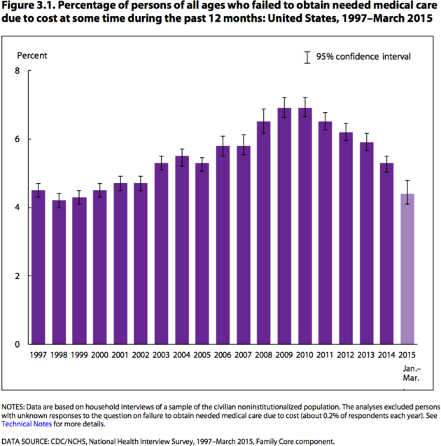
Centers for Disease Control and Prevention

Tuesday's CDC survey also found the uninsured rate during the first three months of 2015 has fallen to 9.2 percent -- after hovering around 15 percent for years and reaching a high of 16 percent in 2010.
The uninsured rate in the first quarter of this year is down from more than 14 percent in 2013, the year before the Affordable Care Act benefits became available for the uninsured.
According to the CDC findings, 15.8 million fewer people were uninsured during the first three months of this year than in 2013. The agency released these new data on the uninsured earlier this month. The numbers are consistent with other surveys, including those from Gallup and other organizations.
The CDC report published Tuesday includes data collected for the National Health Interview Survey, which the agency has conducted since 1957. The full findings are due later this year. The agency only included data going back to 1997, because the survey underwent methodological changes that year, which made comparisons to older findings inaccurate.
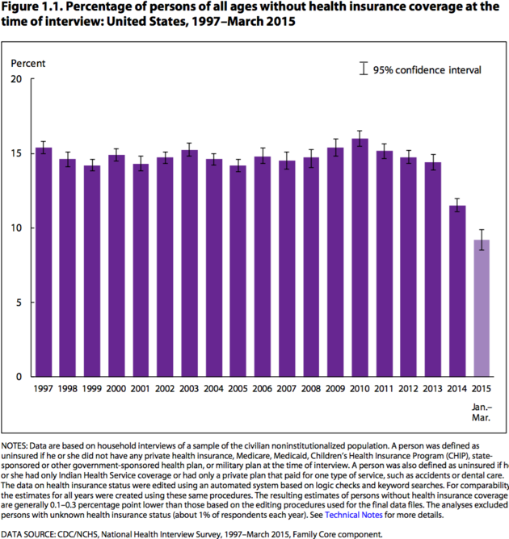Centers for Disease Control and Prevention

According to previous reports by the Department of Health and Human Services, 10 million people have purchased health coverage via the health insurance exchanges created by the Affordable Care Act, and more than 11 million additional people are enrolled in Medicaid since the law's coverage expansion took effect in 2014.
http://www.huffingtonpost.com/entry/obamacare-health-care-survey_55e4d402e4b0b7a9633a07e2?tr=y&auid=15946888

_____________________________

Have something you want us to possibly add to next week’s newsletter? Email Kim VanPelt at kim.vanpelt@slhi.org.

