Covered Clips
A Weekly Summary of News and Activities for the Cover Arizona Coalition
Weeks of June 29th and July 6th

Poll: 62 Percent of Public Supports Supreme Court Ruling on Obamacare

The Washington Post

Twice as many Americans support the Supreme Court’s decision last week to uphold a key provision of the health-care law as are opposed, according to a poll released Wednesday.
When told that the court ruled to allow Americans to continue receiving subsidies to afford health insurance in all states, about 6 in 10 surveyed said they approve of the decision while about one-third disapprove, according to the latest tracking poll by the Kaiser Family Foundation.
Although Democrats were more likely to approve of the decision, even among Republicans and those who view the Affordable Care Act unfavorably, about 3 in 10 say they approve of the court’s decision.
The ruling in the court case, King v. Burwell, doesn’t appear to have changed the public’s overall views of the law, at least not yet. Opinion remains pretty evenly divided (43 percent favorable, 40 percent unfavorable), as it has been for the past several months, the poll found.
The poll showed that the public’s understanding of the ruling was “at a gut level” about fairness, Drew Altman, Kaiser Family Foundation’s president and chief executive, said at a panel discussion Wednesday about what comes next after the decision.
Referring to the public’s reaction, he said people didn’t understand why residents could get subsidies in some states and not in other states. The justices said in a 6-3 ruling that the subsidies that 6.4 million people currently receive do not depend on where they live, as challengers to the law contended.
Still, most Americans don’t think President Obama’s signature domestic achievement has cleared its last big hurdle; just 18 percent think the recent debate over who can receive financial help under the law was the last major battle over the ACA, while nearly 8 in 10 think there will be more major battles about the law in the future.
Half (51 percent) think it’s important to continue the debate, while 44 percent say they are tired of hearing about the law and think the country should focus more on other issues.
Public approval of the decision is higher than it was after the 2012 Supreme Court ruling that upheld most major provisions of the Affordable Care Act. About half (47 percent) approved and 43 percent disapproved according to Kaiser’s June 2012 tracking poll.
When it comes to the next steps Americans would like to see Congress take on the ACA, the public is as divided as ever, with a quarter (25 percent) saying they want lawmakers to expand what the law does, a similar share (27 percent) saying they want a full repeal, and the rest falling in the middle of these two extremes.
The poll was conducted from June 25-29 among a nationally representative random telephone sample of 1,202 adults. Interviews were conducted in English and Spanish by landline and cellphone. The margin of sampling error is plus or minus three percentage points for the full sample.
http://www.washingtonpost.com/national/health-science/poll-62-percent-of-public-support-supreme-court-ruling-on-obamacare/2015/07/01/62dea65a-201b-11e5-aeb9-a411a84c9d55_story.html?utm_campaign=KHN:+First+Edition&utm_source=hs_email&utm_medium=emai&tr=y&auid=15769802

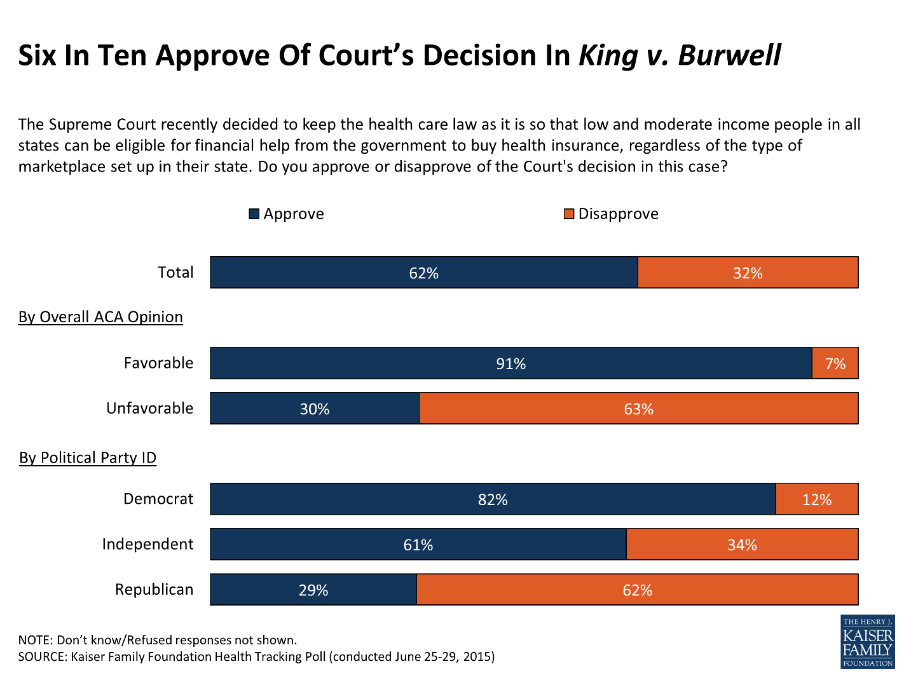

2015 Qualified Health Plan Selections in the Health Insurance Marketplace by Tax Credit (APTC) and County, as of February 22, 2015

HHS

(All figures are based on plan selections with coverage periods that include March 1, 2015 in the 37 states using the HealthCare.gov platform)

County Name | No APTC | Yes APTC | Total Plan Selections
Apache County | 33 | 420 | 453
Cochise County | 497 | 2,742 | 3,239
Coconino County | 547 | 3,102 | 3,649
Gila County | 184 | 1,154 | 1,338
Graham County | 138 | 684 | 822
Greenlee County | 15 | 98 | 113
La Paz County | 37 | 284 | 321
Maricopa County | 37,310 | 92,229 | 129,539
Mohave County | 557 | 5,638 | 6,195
Navajo County | 165 | 1,798 | 1,963
Pima County | 9,052 | 22,708 | 31,760
Pinal County | 1,978 | 8,505 | 10,483
Santa Cruz County | 311 | 2,018 | 2,329
Yavapai County | 1,077 | 7,969 | 9,046
Yuma County | 428 | 3,975 | 4,403
 | 52,329 | 153,324 | 205,653
 | 25% | 75% | 100%

http://aspe.hhs.gov/health/reports/2015/MarketPlaceEnrollment/EnrollmentByCounty/rpt_EnrollmentByCounty_July2015.cfm

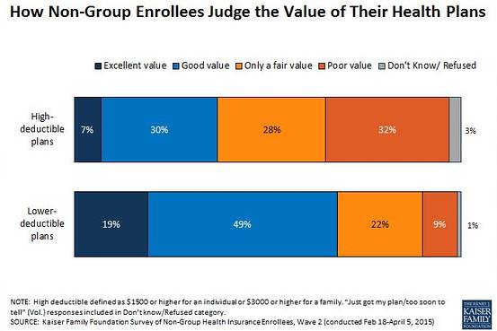

The Wall Street Journal
A Kaiser Family Foundation survey of people who buy insurance in the non-group market found that while many people may choose higher-deductible plans so they can pay a lower premium, they aren’t all that happy about it. It may just be the only way they can get a premium they feel they can afford.
As the chart above shows, 37% of people with high-deductible plans described their plan as an “excellent” or “good” value for what they pay, compared with 68% of people with lower-deductible plans saying the same. A high deductible was defined as $1,500 or more for an individual and $3,000 or more for a family. Sixty percent of those with higher-deductible plans rated the value of their plan as “fair” or “poor.”
People with higher deductibles are significantly more likely than those with lower deductibles to say they feel vulnerable to high medical bills (55% vs. 22%). Whether a deductible is a barrier to seeking needed care or a blow to a family budget depends on income. People with higher incomes are more likely to have larger deductibles and to be able to afford them. People with lower incomes are more likely to be getting premium and cost-sharing subsidies under the Affordable Care Act, but in the new Kaiser survey, people with both lower and higher incomes gave high-deductible plans lower marks.
When asked what they would do if they had a $1,500 medical bill, 43% of those with high-deductible plans said they would have to borrow money or go into credit-card debt to cover a $1,500 medical bill. Fifteen percent said they would not be able to pay such a bill.
Insurers and employers may feel that they have no recourse but to keep raising deductibles to constrain premium increases. Many people will feel a high-deductible plan is their best option, either because they presume they won’t need care or because they can’t afford a plan with a higher premium. But the survey found that choosing a plan with a very high deductible can feel like a Faustian bargain if deductibles bite when people do need care. Deductibles, like all forms of cost-sharing, help keep health-care use and costs down, but finding the right balance between appropriate and excessive cost-sharing has become a major challenge for employers, insurers, the government, and consumers.
http://blogs.wsj.com/washwire/2015/05/21/the-value-trade-off-in-high-deductible-health-plans/

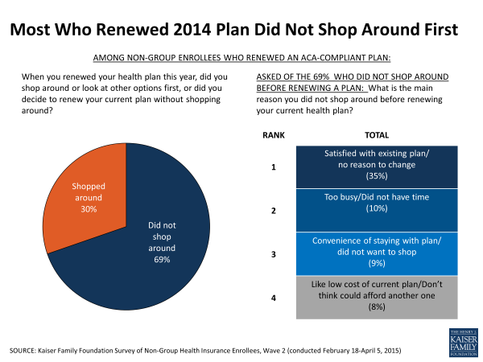

Proposed Rate Increases Vary Tremendously, Even within States

The public can now see insurers’ rate proposals for plans sold to individuals and small employers (plans sold in the individual and small group markets) in 49 states by visiting ratereview.healthcare.gov. (California insurers’ rate proposals will be posted later in July. Individual market insurers in Maine were not required to publicly post premium rates because they proposed increases lower than 10 percent.) In addition, some states make information about lower proposed increases and about insurers’ justifications for those increases available on their insurance department websites.
We looked at proposed rates for plans sold to individuals that are “ACA-compliant,” meaning they cover the 10 essential benefits required by the Affordable Care Act (and they cover care for pre-existing conditions). These proposed increases range from less than 10 percent to a staggering 40 percent or more.
It is important to note that in many of the states where insurers have proposed high premium increases, there are other insurers that have proposed much lower increases. Here’s the breakdown of rate increases that were posted on Healthcare.gov:
- No increases of 10 percent or more: In 1 state, Maine, no insurer in the individual market has proposed an increase of 10 percent or more. So, no rates are posted for individual market ACA-compliant products in Maine.
- Increases of 10-19 percent: 43 states have an insurer that has proposed an increase in the 10-19 percent range.
- Increases of 20-40 percent: In 26 states, the highest proposed increase is in the 20-40 percent range. However, 21 of those states also have an insurer that has proposed an increase in the 10-15 percent range.
- Increases of more than 40 percent: 14 states have an insurer that has proposed an increase of more than 40 percent. But 9 of those states also have an insurer that has proposed an increase in the 10-15 percent range.

Context is Important When Reviewing Rate Increases

Families USA

Now that insurers’ proposed health insurance premium rates for 2016 have been made public by federal and state regulators, the rate review process—where the public and consumer groups can comment—is in full swing. Not surprisingly, the highest proposed rates are garnering the most attention from the media and others. This blog describes trends in these rate increases and explains why it’s important to look at proposed rates in context.
Although some of the proposed rates are high, many consumers will have much lower increases—or they won’t have any rate increases at all.
Advocates and consumers should keep these factors in mind when looking at proposed rates:
- The posted rates don’t paint a complete picture, because only rate increases of 10 percent or more are made public in most states (a few states require all rate increases to be made public).
- A recent Kaiser Family Foundation study showed that, despite some high proposed rates, enrollees in silver plans (which is the most popular type of plan sold in the marketplace) will face only modest increases in 2016 in many communities. But enrollees may need to shop around during open enrollment to maintain these low prices.
The study looked at the price of the two lowest-cost silver plans in 11 major cities. The average increase in price for the lowest-cost silver plan was 4.5 percent, and the increase in price for the second lowest-cost silver plan was 4.4 percent. However, which plans in a city were priced low changed in about half the cities, so enrollees may need to shop around to keep their premiums low.
- These proposed rates could change significantly. Some proposed rate increases will be lowered or rejected entirely. When consumer groups comment on these proposed rates, they can urge regulators and insurers to lower them.
- The percentage increases posted on healthcare.gov are average increases for a health care “product.” A “product” is a package of benefits that an insurer offers in a state with a set of rating and pricing methodologies. So, the posted increase is an average price increase across a number of different plans, areas, and age groups. The exact increases consumers will face depend on their age, their geographical location, the plans they choose, whether they use tobacco, and whether they receive financial assistance with paying premiums (premium tax credits).
- When open enrollment begins again in November and plans post their final premiums, people should shop for the plan that best meets their needs and budget. If consumers find that their plan has raised its premiums, they may be able to get a better deal from a different insurer for 2016.
- Many people receive financial help with paying their premiums (premium tax credits), and for them, the cost of coverage will still be based on their incomes and the plan they choose.
Consumers who could be affected by high premium increases should weigh in to try to reduce premiums that are unaffordable or unjustified.
http://familiesusa.org/blog/2015/07/observations-proposed-health-insurance-premium-rates-2016

After Health Care Act, Sharp Drop in Spending on Birth Control

The New York Times
Out-of-pocket spending on most major birth control methods fell sharply in the months after the Affordable Care Act began requiring insurance plans to cover contraception at no cost to women, a new study has found. Spending on the pill, the most popular form of prescription birth control, dropped by about half in the first six months of 2013, compared with the same period in 2012, before the mandate took effect.
The study, by health economists from the University of Pennsylvania, analyzed health insurance claims from a large private insurer with business in all 50 states and the District of Columbia. It evaluated the effect of the Affordable Care Act, the biggest piece of social legislation in decades, on women’s pocketbooks. It estimated that savings from the pill alone were about $1.4 billion in 2013.
Cost has long been a major obstacle to women getting birth control, and declines in what they pay for contraceptives have the potential to increase access and reduce unplanned pregnancies. About half of the 6.6 million pregnancies a year in the United States are unintended, far higher than in most developed countries.
The study, published online in Health Affairs on Tuesday, was not able to definitively establish whether the law drove women’s falling expenditures on birth control, but experts said the magnitude and timing of the decline suggested that it was.
Researchers who led the study took a random sample from a private database of millions of patients — about 790,000 women from 13 to 45 — and analyzed their contraceptive use from 2008 to 2013. The data was leased by the University of Pennsylvania on the condition that the insurer not be identified.
Experts cautioned that the sample, while large, represented claims from just one insurer and was not designed to be nationally representative. However, they said the trends it showed were convincing. Smaller studies also have found sharp declines in out-of-pocket spending, though experts said Tuesday’s study was the largest to date.
“I find this study persuasive and consistent with what other studies are finding,” said Alina Salganicoff, the director of women’s health policy at the Kaiser Family Foundation, a health policy research group, who did not take part in the study. “I think we’re seeing a clear pattern in the research.”
The study did not address whether free or cheaper birth control led to fewer unintended pregnancies. Findings from pilot studies in St. Louis and Colorado suggested that when cost was not an issue, birth control use increased and women tended to choose the most effective methods, such as long-acting intrauterine devices and implants. That helped drive down rates of abortion and unintended pregnancy in both states.
“We have no doubt that the cost makes a difference,” said Diana Zuckerman, the president of the National Center for Health Research in Washington. “When you have free contraception, it’s going to affect pregnancy and abortion as well because money matters.”
Contraception coverage has improved drastically since the early 1990s, with most insurance companies now covering the full range of birth control methods. But women still had to bear some cost, a requirement that experts say discouraged some lower-income women from getting it and that the Affordable Care Act largely eliminated.
“Co-payments were part of the movement to dissuade people from getting unnecessary care, but they ended up dissuading people from getting necessary care too,” said Adam Sonfield, a senior policy analyst at the Guttmacher Institute, which tracks reproductive health measures and policies.
The study comes amid growing calls for birth control to be available to women over the counter, a change that some women’s groups and professional medical societies support. Such a step would require approval from the Food and Drug Administration, and a Republican bill in the Senate would encourage companies to apply for over-the-counter status for their products.
Opponents have criticized the Republican legislation, saying it could reduce access for women if it meant that birth control was no longer covered in full. (Plans are required to cover most prescription medication, but not over-the-counter medication.) Senator Patty Murray, a Democrat from Washington who helped write the Affordable Care Act, called birth control “an extremely important part of women’s health care and their costs.”
Some Democrats in Congress note that many of the Republican sponsors of the bill on over-the-counter sales have voted to repeal the Affordable Care Act, which mandated the provision of free prescription contraceptives. Republicans say their bill does not take away women’s right to get birth control with a prescription, it simply increases women’s options.
The Affordable Care Act requires insurance plans to cover the full cost of preventive services, including prescription contraception. The mandate for contraception began in August 2012, and insurers were supposed to comply by the beginning of new plan periods, which for many women was Jan. 1, 2013.
Researchers used data from 2008 as a baseline for spending on prescription contraception, but their analysis compared spending in the first six months of 2012 with that in the first six months of 2013, when the mandate was in effect.
Average spending on the pill dropped by about half to $117 for the first six months of 2013, compared with $244 in the first six months of 2012. Spending per prescription — which can be up to three months of the pill — fell to $20.37 from $32.74. Spending on intrauterine devices declined by about 70 percent to about $110. (That includes the cost of insertion but not of removal.)
Average spending on implants, small devices inserted under the skin that prevent pregnancy for several years, declined by about 72 percent to about $91 per device. The steepest decline was for emergency contraception, which fell by more than 90 percent to an average of $1.75 per prescription.
Birth control represented about 44 percent of out-of-pocket spending on medical care in the first six months of 2012 among women in the study. That share had declined to about 22 percent in the first half of 2013. The age groups represented in the study tend to have relatively few health problems.
There were many reasons spending did not fall to zero, said Nora Becker, one of the study’s authors. Health plans phased in the requirement, so the change did not happen immediately for everyone, and not all brands were required to be covered. Some older plans were grandfathered — about a third of all plans in 2013, according to the study — and others received an exemption for religious reasons. Some plans continued to leave some costs uncovered, a pattern that the Obama administration has warned against.
Spending on two methods in the data remained largely unchanged — the ring and the patch — a pattern some experts attributed to that sporadic coverage.
http://www.nytimes.com/2015/07/08/health/after-health-care-act-sharp-drop-in-spending-on-birth-control.html

New Benefits and Coverage Regulation Issued

HHS

On Friday, June 12, 2015, the Departments of Health and Human Services (HHS), Labor, and the Treasury issued final regulations on the Summary of Benefits and Coverage (SBC). These final rules revise the current SBC regulations to make it easier for people and employers to compare their options when shopping for and renewing health insurance coverage, and they enhance the consumer shopping experience in a number of ways. For example, health insurance issuers must now provide online access to a copy of the individual coverage policy for each plan or group certificate of coverage. And these documents must be made publicly available to all potential consumers prior to when a consumer applies for coverage, so they are clearly informed about what a plan will and will not offer.

Resources:
- Click here for a Fact Sheet detailing consumer protections provided in these rules, and click here to view a press release with additional information on this announcement.
- Click here for consumer-friendly information about SBC’s on HealthCare.gov

Study Finds Doctors Order Fewer Preventive Services for Medicaid Patients

Kaiser Health News
Gynecologists ordered fewer preventive services for women who were insured by Medicaid than for those with private coverage, a recent study found.
The study by researchers at the Urban Institute examined how office-based primary care practices provided five recommended preventive services over a five-year period. The services were clinical breast exams, pelvic exams, mammograms, Pap tests and depression screening.
The study used data from the National Ambulatory Medical Care Survey, a federal health database of services provided by physicians in office-based settings. It looked at 12,444 visits to primary care practitioners by privately insured women and 1,519 visits by women who were covered by Medicaid between 2006 and 2010. That difference reflects the fact that the share of women who are privately insured is seven times larger than those on Medicaid, the researchers said. Pregnancy-related visits and visits to clinics were excluded from the analysis.
Overall, 26 percent of the visits by women with Medicaid included at least one of the five services, compared with 31 percent of the visits by privately insured women.
As for specific preventive services, the study found “strong evidence” that visits by Medicaid patients were less likely include a clinical breast exam or a Pap test, says Stacey McMorrow, a senior research associate at the Urban Institute’s Health Policy Center and the study’s lead author. The differences for depression screening weren’t statistically significant, and once patient characteristics such as age, race and home address were taken into account weren’t significant for mammograms or pelvic exams either.
For example, 20.5 percent of visits by privately insured women included a clinical breast exam, and 16.5 percent of visits included a Pap test. But the percentage of Medicaid-insured visits that included those services was only 12 percent and 9.5 percent, respectively. (The differences narrowed but remained statistically significant when adjusted for patient characteristics.)
The Medicaid-insured women were not necessarily receiving lower quality care, according to the study. They may have been receiving additional care at a community health clinic or from a nurse practitioner, for example, but the study only examined physician services provided in office-based practices.
In addition, privately insured women may have been receiving services more frequently than recommended. For example, current guidelines generally recommend a Pap test to screen for cervical cancer every three years. But if a patient asks for a Pap test every year the doctor may provide it, McMorrow says.
In addition, private insurers generally pay providers better than does Medicaid, sometimes significantly better, she says: “Where providers are getting reimbursed better, they’re going to provide services more frequently.”
http://khn.org/news/study-finds-doctors-order-fewer-preventive-services-for-medicaid-patients/

Adult Medicaid Dental Benefits by State

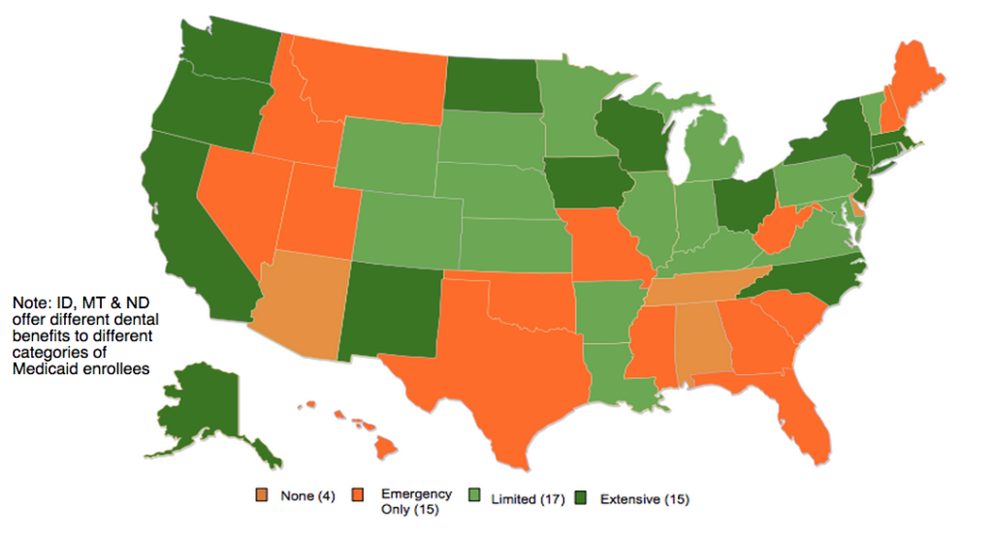
http://www.nashp.org/map-of-current-adult-dental-coverage/

________________

Have something you want us to possibly add to next week’s newsletter? Email Kim VanPelt at kim.vanpelt@slhi.org.

