Covered Clips
A Weekly Summary of News and Activities for the Cover Arizona Coalition
Weeks of July 13th and July 20th

Arizona Marketplace Enrollment by Age (OE 2)

County | 0-17 | 18-25 | 26-34 | 35-44 | 45-54 | 55-64 | 65+
Apache County | 113 | . | 49 | 48 | 68 | 147 | .
Cochise County | 641 | 217 | 336 | 417 | 602 | 1,009 | 17
Coconino County | 734 | 330 | 621 | 527 | 538 | 884 | 15
Gila County | 230 | 90 | . | 134 | 254 | 534 | .
Graham County | 275 | . | 120 | 107 | 86 | 171 | .
Greenlee County | 28 | 13 | . | . | 20 | 30 | 0
La Paz County | 59 | . | 22 | . | 50 | 141 | .
Maricopa County | 30,434 | 12,244 | 19,053 | 18,656 | 22,822 | 25,602 | .
Mohave County | 1,100 | 367 | 479 | 639 | 1,224 | 2,346 | 40
Navajo County | 504 | . | 149 | 237 | 315 | 641 | .
Pima County | 6,356 | 2,739 | 4,517 | 4,251 | 5,462 | 8,184 | .
Pinal County | 2,719 | 774 | 1,176 | 1,375 | 1,553 | 2,816 | .
Santa Cruz County | 530 | 216 | 186 | 297 | 488 | 584 | 28
Yavapai County | 1,668 | 567 | 889 | 1,077 | 1,621 | 3,176 | 48
Yuma County | 1,148 | 377 | 454 | 611 | 861 | 930 | 22

Source: http://aspe.hhs.gov/health/reports/2015/MarketPlaceEnrollment/EnrollmentByCounty/rpt_EnrollmentByCounty_July2015.cfm

Arizona Marketplace Enrollment by Race (OE2)

County | American Indian  /Alaska Native | Asian | Black | Latino | Multiracial | White | Unknown
Apache County | 42 | . | . | 32 | . | 221 | 139
Cochise County | . | 116 | 51 | 761 | 58 | 1,391 | 837
Coconino County | 91 | 76 | . | 263 | 57 | 2,047 | 1,090
Gila County | . | 44 | . | 115 | 20 | 838 | 301
Graham County | 16 | . | . | 169 | . | 462 | 161
Greenlee County | . | 0 | . | 26 | 0 | 40 | 44
La Paz County | 0 | . | . | 71 | . | 134 | 99
Maricopa County | 447 | 7,346 | 4,147 | 20,658 | 2,049 | 56,322 | 38,390
Mohave County | . | 107 | 27 | 564 | 59 | 3,615 | 1,797
Navajo County | 48 | 45 | . | 120 | 25 | 1,155 | 562
Pima County | 115 | 1,199 | 611 | 7,244 | 546 | 13,353 | 8,657
Pinal County | 156 | 242 | 313 | 1,727 | 168 | 4,892 | 2,973
Santa Cruz County | . | 33 | . | 1,596 | . | 229 | 466
Yavapai County | 34 | 120 | 36 | 572 | 111 | 5,637 | 2,525
Yuma County | . | 109 | 27 | 2,162 | 37 | 738 | 1,318

Source: http://aspe.hhs.gov/health/reports/2015/MarketPlaceEnrollment/EnrollmentByCounty/rpt_EnrollmentByCounty_July2015.cfm

Arizona Selects Essential Benefit Package

Arizona Department of Insurance

Arizona selected the 2014 State Employee EPO Health Plan as its Essential Health Benefits Benchmark Plan for 2017. This choice was communicated to CMS on June 26, 2015. CMS will publish the proposed list of states’ benchmark plans this summer, and will publish the final benchmark plans later in the year. ADOI will post the benchmark plan and formulary documents to its website next week.

Hearing on Challenge to Arizona Medicaid Plan Rescheduled
Arizona Capitol Times
A hearing for arguments on the constitutionality of a fee collected from hospitals to pay for an expansion of Arizona’s Medicaid program has been postponed.
The hearing had been scheduled for Friday in Maricopa County Superior Court but Judge Douglas Gerlach has reset it for July 30.
The hearing is for arguments on motions for a pretrial judgment in a lawsuit filed by Republican legislators. They lost a 2013 legislative battle over expansion of coverage provided by the Arizona Health Care Cost Containment System.
The case could decide whether nearly 350,000 Arizonans retain coverage they’ve received under the expansion.
The case was reassigned to Gerlach this week after another judge disqualified herself. That judge got the case in May after the original judge was rotated to a different assignment.
Read more: http://azcapitoltimes.com/news/2015/07/23/hearing-on-challenge-to-arizona-medicaid-plan-rescheduled/#ixzz3gjhZPS92

ACA Marketplace Insurers Garner $7.9 Billion from Reinsurance Program

Healthcare Financial Management Association
Those payments to insurers with higher shares of sick enrollees are less than the $8.7 billion collected so far from insurers with less costly claims, according to a report from the Centers for Medicare & Medicaid Services (CMS). The agency had expected to collect $10 billion, but also had anticipated higher shares of costly claims. The agency expects to collect and pay out another $1 billion by Nov. 15 from the insurers, which covered a total of 6.3 million enrollees in 2014.
Because the number of qualifying insurer claims was lower than CMS anticipated, the agency increased from 80 percent to 100 percent the share of enrollees’ claims between $45,000 and $250,000 that it will reimburse.
“We are pretty happy with the way the results have turned out,” Jeff Grant, a deputy director in the Center for Consumer Information and Insurance Oversight at CMS, said during a conference call about the results. “The results look pretty reasonable, and it does look like the right issuers are receiving the right levels of compensation for the risk that they’ve taken on.”
That view was echoed by insurance industry watchers.
The report “indicates the permanent risk-adjustment and the temporary reinsurance programs are working as intended,” said Susan Horras, director, healthcare finance policy, health plan and population health initiatives at HFMA.
"These programs are critical to help consumers transition to the ACA market and to provide important stability in the early years of implementation," said Clare Krusing, a spokeswoman for America’s Health Insurance Programs.
The risk-adjustment and reinsurance programs are two of three programs created by the Affordable Care Act (ACA) to serve as a financial backstop for insurance plans offered in the new marketplaces. Information on the third program—the risk corridors program, which protects issuers against excessive losses—will be released later this year.
Grant said CMS expects the three-year reinsurance program to collect more funds than needed this year, and the agency will apply the surplus to the next two years.
Results from the Risk-Adjustment Program
Meanwhile, the permanent risk-adjustment program transferred about 10 percent of premiums among 468 individual marketplace insurers and about 21 percent of premiums among 291 catastrophic plan issuers, according to the report. The risk-adjustment data excluded Massachusetts because the state ran its own program.
The CMS report listed both the risk-adjustment transfers and the reinsurance amounts paid or received by each insurer in each state. Ten insurers failed to create an “EDGE server” or transfer the necessary data, which led to a default risk-adjustment charge.
The report noted that the risk-adjustment transfer amounts and reinsurance payment amounts listed did not reflect any payment or charge adjustments due to discrepancies, appeals, or the effects of sequestration.
“I would expect some issuers to exercise their appeal rights, so I wouldn’t view this report as the final amounts,” Horras said.
Self-Sustaining Programs?
The data indicated that the risk corridor program will not be affected by cost overruns. The program was originally expected to be budget-neutral, but some observers had raised concerns that insurers could incur greater 2014 losses than projected because higher-than-expected shares of sick people enrolled in the plans.
“We anticipate that over the life of the three-year program that risk corridors is going to be budget-neutral,” Grant said. “In any event, the administration is committed to seeking funding to the extent available through appropriations to pay for this.”
A federal funding package enacted in December for FY15 limited the use of new funding for the risk corridor program if it is not budget-neutral. At least one marketplace insurer cited that limitation as impacting its solvency. CoOpportunity Health, one of the co-op plans provided seed money under the ACA, was liquidated in February after its officials said it was at risk for losing $60 million under changes to the risk corridor program.
Key results described in the CMS report included the provision of risk-adjustment payments to many other co-op plans, while some co-ops paid into the risk-adjustment program, Tim Jost, a an expert on the ACA and supporter of the law, noted in a Health Affairsblog post. Additionally, Blue Cross and Blue Shield plans, the largest insurers in many state marketplaces, generally received support under the reinsurance programs but had “mixed results” in the risk-adjustment program.
“But the big news is that two incredibly complex programs that play a key role in encouraging insurers to accept high-cost patients and to discourage insurers from risk selection seem to have come off without serious technical problems,” Jost wrote.
http://www.hfma.org/Content.aspx?id=32076&utm_source=Real%20Magnet&utm_medium=Email&utm_campaign=77645943

New Medicaid Beneficiaries are Costing More than Expected
Modern Healthcare
Federal and state costs associated with the Affordable Care Act's Medicaid expansion are proving higher than previously estimated, which could rekindle the political debate over the law in the 2016 presidential race.
Newly eligible adults are estimated to have had average benefit costs of $5,517 in 2014, 19% greater than non-newly eligible adults' average benefit costs of $4,650, according to a new report from the CMS' Office of the Actuary. These estimates are significantly different from previous ones, according to the report, in which average benefit costs for newly eligible adults in 2014 were estimated to be 1% lower than those of non-newly eligible adults.
Opponents of the ACA argue the new figures may discourage additional states from expanding Medicaid eligibility under the law. Several policy experts, though, said the numbers simply show that the law is successfully extending care to people who previously couldn't get it.
Medicaid enrollment is estimated to have increased 9.6% to 64.6 million people in 2014 and will hit 78.8 million by 2023, .
Total Medicaid spending grew 9.4% between 2013 and 2014 to $498.9 billion. The CMS actuaries project it will reach $835 billion by 2023, increasing at an average rate of 6.2% per year over the next 10 years.
That's less than the $918.8 billion the CMS actuaries projected last fall. But they say in the report they were caught off guard by the financial impact of Medicaid expansion. “The average benefit costs of newly eligible adult enrollees are expected to have been substantially greater than those for non-newly eligible adult enrollees in the program,” they write.
The CMS theorizes that costs for new beneficiaries were higher because they were uninsured before gaining coverage under the ACA and are now getting care for unmet needs. Also, the actuaries note, most of the states that expanded Medicaid put newly eligible residents into managed care programs. On average, the capitation rates for the newly eligible adult enrollees were significantly greater than the projected average costs.
That may be because the rates in some states also included adjustments for adverse selection with the expectation that the people who were most likely to enroll in the first year would be those with the greatest health care needs, the agency says. The agency was also surprised by the magnitude of the new enrollment. It estimates 5.7 million adults joined the program in 2014. In a previous estimate, the agency anticipated 4.9 million enrollees for the year.
The report is likely to provide political ammunition in the debate over the healthcare reform law as the 2016 presidential election heats up.
“The Obama administration had projected (new beneficiaries) would cost about $50 less than other Medicaid-eligible adults, but they actually cost about $1,000 more,” said Michael Cannon, a critic of the Affordable Care Act and director of health policy studies for the Cato Institute, a libertarian think tank. Cannon said the numbers "could give states that expanded Medicaid buyer's remorse and strengthen opposition to expanding Medicaid in states that haven't.”
Others, however, saw the numbers in a more positive light. “I am sure that Republicans will have a field day with this, but the fact of the matter is that it shows the programs is working as it is supposed to,” said Jim Manley, director of the communications practice at the consulting firm QGA and former spokesman for Sen. Harry Reid (D-Nev). “Naturally the more people covered means that costs will go up. Leaving people uncovered is not an option that we as a country can afford in the long run.”
Others agreed. “The excess costs for newly enrolled Medicaid recipients is typical. This typically reflects deferred utilization—people who can't afford healthcare can now access care and use it,” said Dan Mendelson, CEO of Washington-based consulting firm Avalere Health. “This is very often due to increased use of primary care, preventive care, and dental care, all of which are commonly deferred.”
Sara Rosenbaum, a healthcare policy expert at George Washington University, said the numbers suggest that the newly covered people are getting access to healthcare in spite of reports to the contrary.
And the per-beneficiary costs could come down in subsequent years, said Judy Solomon, vice president for health policy at the left-leaning Center on Budget and Policy Priorities. “The pent up demand and initial enrollment effects will diminish,” she said.
http://www.modernhealthcare.com/article/20150710/NEWS/150719984

The Real Story behind Obamacare’s Double-Digit Rate Hikes
Vox
The headlines about Obamacare's ‘skyrocketing’ premiums are pretty much everywhere right now. The Wall Street Journal ran a recent op-ed titled ‘The Unaffordable Care Act.’ Slate asserted ‘Obamacare's Bill is Due.’ And, in its typically sober headline format, the New York Times noted ‘Health Insurance Companies Seek Big Rate Increases for 2016.’ All of these articles make a similar argument: This is the year that Obamacare premiums go up. Way up. Most of them cite a recently approved 25 percent rate hike for the largest Obamacare plan in Oregon, Moda Health. And they look at similarly big increases that insurers in North Carolina and Tennessee have proposed. Are these double-digit rate increases the new normal? Not exactly. I've spent the past few days talking to experts about what to expect from Obamacare rates in 2016. And they do expect premiums to rise faster this year, largely because health-care costs are going up faster, too. But they caution against reading too much into the little information currently available — and they don't expect the huge rate increases making headlines now to be the norm. ‘This is going to vary dramatically across the country,’ says Elizabeth Carpenter, a director at health research firm Avalere Health. ‘Each state has a different process for releasing rates, and the bottom line is it will probably be very close to enrollment when we actually have a complete picture.’
http://www.vox.com/2015/7/15/8972121/obamacare-rate-hikes-double-digit?tr=y&auid=15805853
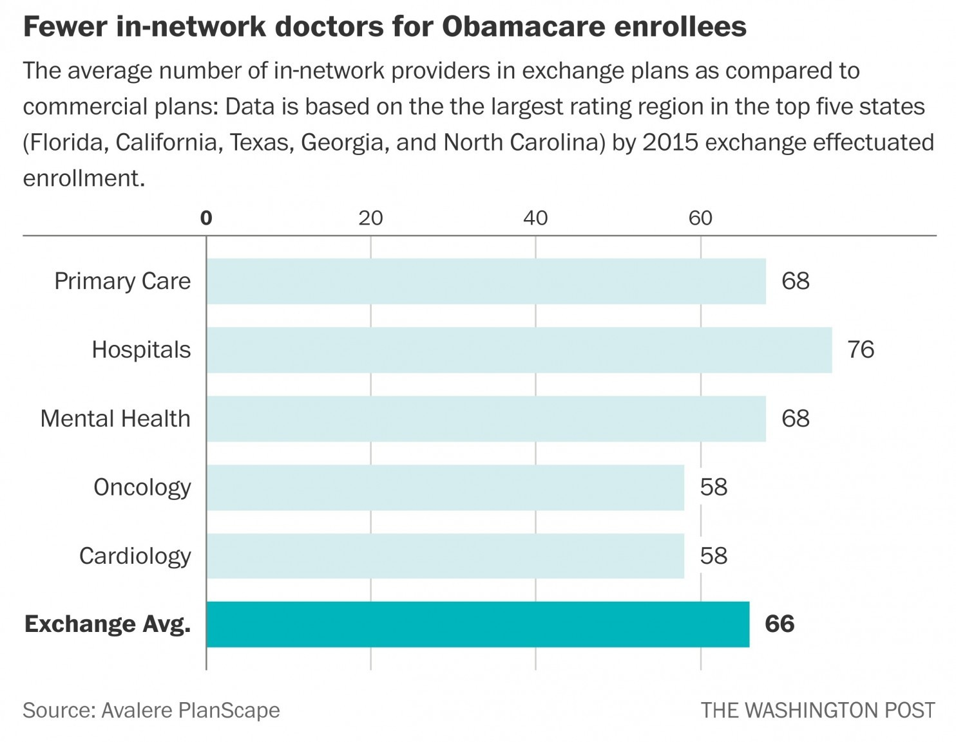

‘Balance Billing’ Still and Issue for Consumers under the ACA
California Healthline
Insured individuals can still receive unexpected bills for out-of-network medical services under the Affordable Care Act, despite protections in the law designed to protect consumers against medical bankruptcy, Kaiser Health News reports.
According to KHN, insured individuals under the ACA can still face high medical bills under a practice called "balance billing," in which out-of-network providers charge patients for the difference between what patients' insurers cover and what providers' charge for the service.
Insured patients can face this issue when:
- Insurers or providers give false or incomplete information about which providers are in-network;
- Physicians have multiple offices, some of which are not in-network;
- Hospitals use out-of-network physicians; or
- Patients enroll in health plans with narrow networks that do not include emergency department physicians or other specialists.

Insured Patients Susceptible to Balance Billing
Proponents of the ACA have said the law will help reduce the number of bankruptcies that occur for medical reasons. The law includes caps on consumers' out-of-pocket costs and requires insurers to provide coverage for emergency care. In addition, the ACA prohibits insurers from charging members higher copayments if they use ED services at out-of-network hospitals.
However, the ACA does not count consumers' charges at out-of-network providers toward the annual out-of-pocket cap. In addition, the law does not prohibit out-of-network emergency care providers from engaging in balance billing.
Meanwhile, few states have addressed the issue of balance billing. The states that have addressed the practice have done so in limited circumstances, such as for ED visits or for specific insurance plan types, such as health maintenance organizations.
Timothy Jost, a Washington and Lee University law professor, said, "It's not fair and probably not legal that consumers be left holding the bag when an out-of-network doctor treats them" when they are unaware that is the case.

Some Call for More Consumer Protections
Some consumer advocacy groups have called for regulators to place more limits on balance billing. For example, Consumers Union and the American Cancer Society Action Network have called on regulators to place strict limits on the practice when an insured individual receives care from an in-network medical facility.
Consumers Union in a recent letter to the National Association of Insurance Commissioners wrote, "Without protection from balance billing, the cost of out-of-network care can be overwhelming."
NAIC is in the process of updating a model network adequacy rule, which states could use and adapt to regulate their own insurance networks. However, its current draft does not directly address balance billing, according to KHN.
http://www.californiahealthline.org/articles/2015/2/18/balance-billing-still-an-issue-for-consumers-under-aca

Texas Bill Signed Protecting Consumers against Surprise Medical Bills
Chron

Gov. Greg Abbott has signed a scaled-back version of legislation to help Texans who receive surprise medical bills.

The legislation, Senate Bill 481, sponsored by North Richland Hills Republican Kelly Hancock, will open up a mediation process to patients who receive a bill of at least $500. Currently, it is only available to patients who receive a bill of at least $1,000.

The original version of the legislation would have allowed anybody to pursue mediation.
The reform is a response to "balance billing," an increasingly common phenomenon that occurs when a patient is treated at a facility in the network of his health insurance plan, but by at least one individual doctor who is not part of the network.

Because patients are responsible for paying for out-of-network costs, getting a balance bill can be very expensive -- especially for emergency room procedures.

"The Legislature listened to Texans who are fed up with surprise medical bills after emergency room visits or when they go to hospitals in their insurance network," said Bob Jackson, director of the Texas chapter of AARP, who said in a statement that mediation is "working well to the benefit of both patients and providers."

The legislation was passed overwhelmingly after the scaling-back won over the support of the Texas Medical Association. It takes effect Sept. 1.
http://www.chron.com/news/politics/texas/article/Abbott-signs-bill-expanding-protections-against-6333488.php

State of Arizona Agrees to Improve Immigrant Access to Federal Public Benefits Programs

HHS

The U.S. Department of Health and Human Services, Office for Civil Rights (OCR) has entered into a voluntary resolution agreement with the Arizona Health Care Cost Containment System (AHCCCS) and the Arizona Department of Economic Security (DES) to improve access to the Children’s Health Insurance Program (CHIP), Medicaid, Temporary Assistance for Needy Families (TANF), and other public benefit programs for eligible immigrants and children.

The Agreement resolves an OCR complaint investigation following Arizona’s implementation of HB 2008, which requires state employees, in the administration of public benefits programs, to report “discovered violations of federal immigration law” to Immigrations and Customs Enforcement (ICE). OCR’s investigation, involving issues of access to benefits only for those immigrants and children eligible to receive them, was conducted pursuant to Title VI of the Civil Rights Act, which prohibits discrimination on the basis of race, color, or national origin in programs that receive federal funding.

Eligible immigrants and U.S. citizens may encounter barriers that limit their ability to receive public benefits, chilling their willingness to apply for benefits for which they are eligible and resulting in individuals’ lack of access to crucial health care and cash assistance. Such barriers may stem from confusion about eligibility rules, assumptions regarding eligibility, and mistakes by eligibility workers. OCR is committed to removing these barriers and ensuring equal access for all eligible citizens and immigrants, including those that come from mixed immigrant-U.S. citizen families and households.
Under the Agreement, AHCCCS and DES will take steps to ensure that eligible citizens and immigrants are not improperly denied access to public benefits or improperly reported to ICE, and that they have access to vital healthcare programs, such as Medicaid and CHIP, and other federally funded benefits, including TANF. AHCCCS and DES have agreed to adopt and implement policies and procedures providing nondiscriminatory access to public benefits; utilize public benefits applications that reduce obstacles to those seeking and eligible for public benefits; provide outreach on available public benefits; and conduct staff training.

Significantly, the Agreement involves statewide health and human services programs that cover a wide variety of health and human services public benefits programs. The obligations under the Agreement will help provide other state health and human services agencies guidance on affirmative steps that can be taken to make sure that eligible citizens and immigrants have access to a variety of public benefits in compliance with Title VI.
AHCCCS is the single state agency in Arizona responsible for administration of Medicaid and CHIP, which is called the KidsCare Program. DES is the single state agency responsible for the administration of TANF. Through an intergovernmental agreement with AHCCCS, DES shares responsibility with AHCCCS for determining eligibility for the Medicaid program.
To read the Agreement, click here.

________________

Have something you want us to possibly add to next week’s newsletter? Email Kim VanPelt at kim.vanpelt@slhi.org.

