Covered Clips
A Weekly Summary of News and Activities for the Cover Arizona Coalition
Weeks of June 15th and June 22nd

Deficit Expected to Grow if Affordable Care Act is Repealed

Congressional Budget Office
Over the past several years, a number of proposals have been advanced for repealing the Affordable Care Act (ACA), which became law in March 2010. In this report, CBO and the staff of the Joint Committee on Taxation (JCT) analyze the main budgetary and economic consequences that would arise from repealing that law.
To conduct the analysis, CBO and JCT first considered the effects of the ACA’s repeal on health insurance coverage and on the federal budget over the next 10 years, holding gross domestic product (GDP) and other macroeconomic variables (such as interest rates) constant—assumptions that underlie most cost estimates used in the Congressional budget process. The agencies then examined the macroeconomic effects of repealing the ACA and estimated the consequences of the resulting feedback for the federal budget over the next decade (involving changes in tax revenue, for example, that stem from changes in GDP). Finally, CBO and JCT considered the budgetary and economic effects of repealing the ACA for the period beyond 2025.

http://www.cbo.gov/publication/50252?tr=y&auid=15727521

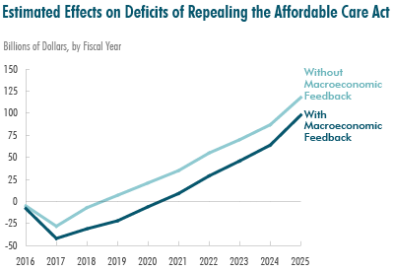

Economists Predict Shockwaves if Obamacare Subsidies are Nixed

New York Times
As the U.S. Supreme Court prepares to rule on whether people in 34 states can continue to receive Obamacare health insurance subsidies, economists are projecting billions of dollars in lost healthcare spending for hospitals, drugstores and drugmakers if the justices say the payments are illegal.
The immediate consequences of such a ruling would fall on the 6.4 million people who receive the subsidies and live in states that did not establish their own insurance exchanges under President Barack Obama’s healthcare law, instead relying on the federal HealthCare.gov website.
The case, known as King v Burwell, would not affect subsidies in the District of Columbia or in the 13 states that run their own exchanges. The decision is expected sometime this month.
Health economists calculate the economic impact of a ruling against the subsidies in different ways, but one thing many agree on is that about two-thirds of people who receive subsidies through HealthCare.gov would drop their insurance altogether rather than foot the entire bill.
Businesses that have benefited from spending by the newly insured would take a hit, though estimates of the lost revenues vary significantly based on which assumptions are built into the calculation.
For instance, a Kaiser Family Foundation economist put the 2015 figure at about $15 billion, based on the proportion of insurance premiums that are earmarked solely for medical costs under the healthcare law.
"There will absolutely be these second-order effects," said Larry Levitt, a senior vice-president and healthcare researcher at the Kaiser Family Foundation. "A reasonable assumption is that (spending on) healthcare by people who lose their existing subsidies will drop by at least half."
That would represent about $7.5 billion in spending on hospitalizations, doctor visits and prescriptions, depending on the baseline estimate.
Another rough estimate based on 2014 medical claims data and 2015 government enrollment data, suggests the federal marketplace states will see about $22 billion in healthcare spending this year among Obamacare plan holders assuming subsidies remain in place, according to Katherine Hempstead, a director at the Robert Wood Johnson Foundation. The majority of Obamacare members receive subsidies.
Health policy experts who are critical of the law have taken a different tack, focusing more on the potential financial returns to individual citizens if the Supreme Court ruling exempts them from penalties for not having insurance.
Conservative economist Douglas Holtz-Eakin and Brittany La Couture of the American Action Forum wrote recently that such a ruling could give a boost to small businesses by removing requirements on employers to provide health coverage.
Joseph Antos of the right-leaning think tank American Enterprise Institute says the estimates of healthcare spending effects are imprecise at best. He expects that a ruling invalidating the subsidies would be followed by a "fix" in which Congress or states somehow restore subsidies, at least temporarily.
In that case, he said, any drop in healthcare spending would be temporary and only "a very minor downward bump."
"They are going to extend the subsidies in some manner," Antos said. "I don't know how they are going to do it, but they are going to find some way."
The Affordable Care Act is one of the most politically divisive U.S. laws, opposed by many Republicans. Party lawmakers have fought in particular against its requirement that all Americans have health insurance or pay an annual penalty, and say they have plans to replace the law if the subsidies are ruled out.
Hospitals
Without a legislative fix, however, policy experts and Wall Street analysts expect hospitals will ke the biggest hit, as they bear the brunt of costs for patients who must be treated but can’t pay their own medical bills. Hospital associations said an increase in such costs could “devastate” some of their members, according to a brief filed with the Supreme Court.
When Obamacare was conceived, hospitals were so confident that newly insured patients would increase their revenues that they agreed to $269 billion in cuts to the government’s Medicaid and Medicare health plan reimbursement over 10 years.
"It was a quid pro quo, with hospitals agreeing to these reductions in return for coverage of more people," said Kevin Brennan, executive vice-president for finance at Geisinger Health System in Pennsylvania, which relies on HealthCare.gov.
Geisinger offers an insurance plan through the Obamacare exchange and estimates that 80 percent of the 22,000 people who hold those polices receive subsidies.
Pennsylvania is one of a handful of states that plans to set up its own exchange if the Supreme Court rules against the subsidies, and has said it could be ready for 2016.
Data from publicly-traded hospital operators show their costs for treating uninsured patients have dropped since Obamacare took full effect in 2014.
In the first half of that year, admissions of "self-pay" patients, who are almost always uninsured and unable to pay the full bill, fell 14.7 percent at Community Health Systems, 6.6 percent at HCA Holdings, 6.5 percent at Tenet Healthcare Inc, and 9.3 percent at Universal Health Services, according to an analysis by consultants at PwC.
Drug companies like Pfizer and Merck & Co and medical device makers such as Medtronic agreed to new taxes in exchange for the expected increase in paying Obamacare customers. The bet has paid off: Pharmacy benefits manager Express Scripts Holding Co estimates that each Obamacare patient now accounts for an average of $79 per month in prescription drug spending.
That works out to roughly $6.1 billion a year for the 6.4 million people whose subsidies would be eliminated.
Not all of the $6.1 billion would dry up, since drug spending by the uninsured is not zero, said Rand Corporation economist Christine Eibner, who has studied healthcare utilization by Obamacare patients. "On average, people will not fill as many prescriptions" if losing their subsidies causes them to drop their insurance, she said.
Insurers will see a more limited hit to revenue if the subsidies are thrown out, largely because Obamacare customers are only a small percentage of any single health insurer’s total business. At the nation's largest insurer, UnitedHealth Group, for instance, about 1 percent of its 46 million members are receiving subsidies that are at risk.
http://news.yahoo.com/economists-predict-shockwaves-obamacare-subsidies-nixed-142827841.html

New Digital Tool: How the Get Covered Plan Explorer Will Help Consumers Look beyond Premiums
Enroll America
Have you worked with consumers that have difficulty selecting a plan that meets their needs and budget? Are you an assister that consistently crunches numbers to help consumers understand how much they may pay over the course of a year on health care services? Do you struggle to help your clients identify what drugs or providers are covered for the plans available in their area?
Over the first two enrollment periods, we consistently heard from consumers and partners alike that the current plan comparison process can be cumbersome, and a survey we conducted after the second enrollment period found that almost half of the uninsured say they lack the confidence to pick a plan for themselves in the future. To address these challenges, we are partnering with Clear Health Analytics to develop a solution based on the very latest data and best practices for consumer-friendly digital tools.
We will be releasing the Get Covered Plan Explorer — a digital plan comparison tool that will help consumers look beyond the lowest premiums — just in time for the third open enrollment period! The Get Covered Plan Explorer (available for free to consumers and enrollment assisters living in states using the HealthCare.gov platform) will help potential enrollees understand how different plans might fit their medical needs and budget. This digital tool will allow consumers to quickly and easily estimate their likely out-of-pocket costs for each plan available in their area, as well as make sure their prescription drugs and preferred providers are covered. Along with the Get Covered Calculator and Connector, the Plan Explorer will join a suite of successful digital tools consumers can use to find out about financial help, in-person assistance, and choosing a plan.
Consumers who wish to compare plans using the Get Covered Plan Explorer will be asked to answer a few simple questions about their health status, prescription drugs, and preferred health care provider. Using this information, the Plan Explorer will offer visual, easy-to-read summaries of the most important information to consider for each plan. Consumers will be able to move quickly to the enrollment process when they are ready to begin, or have their results emailed to them to review or talk about with an assister. Assisters will also be able to use the tool to help consumers better understand their options before choosing a plan.
If you have more questions about the tool, or are interested in embedding it on your website for the third open enrollment period, we’d love to hear from you! You can contact us at planexplorer@enrollamerica.org.

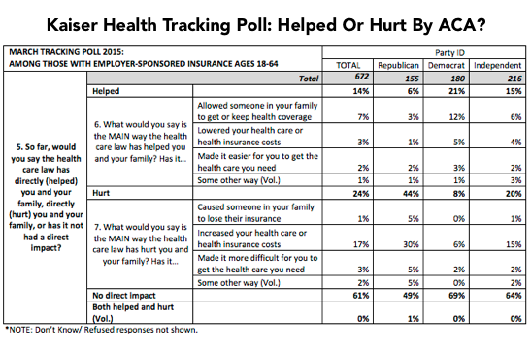

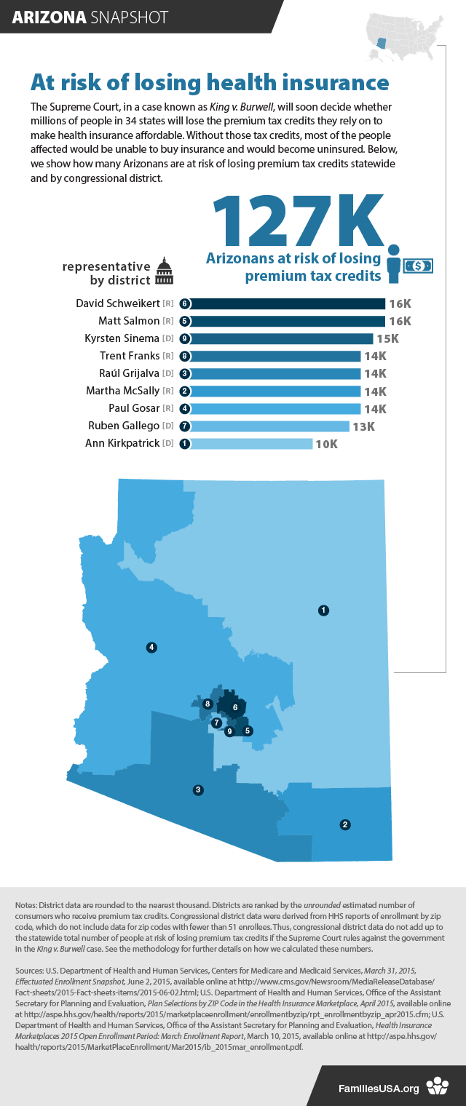
________________

Have something you want us to possibly add to next week’s newsletter? Email Kim VanPelt at kim.vanpelt@slhi.org.

