Covered Clips
A Weekly Summary of News and Activities for the Cover Arizona Coalition
Weeks of February 9th and 16th, 2015

Affordable Care Act Sign-Ups Jump 70% in Arizona

Arizona Republic
Arizona health insurance sign-ups surged by 70 percent during the Affordable Care Act's second annual enrollment period that ended Sunday, with more than 204,000 Arizona residents either renewing plans or signing up for new coverage, according to preliminary figures.
During the final nine days alone, more than 20,000 Arizonans signed up for health-insurance plans via the federal marketplace.
A total of 204,187 Arizona residents either re-enrolled or signed up for a new plan as of the deadline, the U.S. Department of Health and Human Services said Wednesday. A total of 120,071 Arizonans signed up during the first enrollment period that ended April 2014, but the federal government has not said how many kept their plans through 2014.
There is a constant churn in the health-insurance market as people drop individual plans when they get health coverage through an employer or a spouse's insurance plan. And not everyone who signs up for health coverage pays their monthly premium to activate coverage, so the federal figures released Wednesday will likely change.
The federal government also granted a one-week reprieve for those who encountered computer glitches or long waits through the marketplace call center during the final weekend. Individuals who "attest" to such delays can enroll through this Sunday. Prospective customers should visit www.healthcare.gov or call 800-318-2596 for more details.
After the end of enrollment, people can access the marketplace only if they experience a life change such as getting married, having a baby or losing employer-provided health insurance.
There is no enrollment period for Medicaid plans, the public health-insurance program for low-income adults and people with disabilities. Individuals who qualify for the Arizona Health Care Cost Containment System, also known as AHCCCS, can enroll year-round.
More than 313,000 Arizonans have secured health coverage through AHCCCS, the state's Medicaid program. Arizona restored and expanded its Medicaid program mostly using funding provided by the federal health-care law.
Health-care law observers suggested that, in addition to securing health coverage, consumers have been motivated to avoid tax penalties assessed to some who don't get coverage.
"One of the big drivers is individuals are starting to get their taxes done, and they are seeing the penalties they are incurring from last year," said Cheryl O'Donnell, Arizona state director for Get Covered America, a health-care-law outreach group.
The federal health-care law mandates most people secure health insurance or pay a penalty. The penalty was the greater of $95 per person or 1 percent of household income, in 2014. It will increase to the greater of $325 per person or 2 percent of household income, in 2015.
The tax penalty is calculated when individuals file federal income-tax returns the following year. So uninsured individuals who are filing their federal incomes taxes this spring may have learned about the penalty for not getting coverage in 2014.
When people learn about the tax penalties as well as the subsidies available to purchase health insurance, some opt to buy coverage, O'Donnell said
HHS said that more than 70 percent of marketplace enrollees as of December 2014 could get coverage for $100 or less per month after subsidies.
Several groups are exempt from the mandate to buy health insurance, including religious objectors, those who don't earn enough to file a federal tax return, prison inmates and undocumented residents.

http://www.azcentral.com/story/news/local/arizona/2015/02/19/arizona-affordable-care-act-health-insurance-sign-ups-jump/23659287/

Special Enrollment Period for Consumers “In Line” on February 15, 2015
CMS
The law and regulations provide for special enrollment periods (SEPs), triggered by certain events that are described at 45 CFR 155.420(d) and include life changes and errors in enrollment. SEPs permit individuals to enroll in a qualified health plan outside of open enrollment.
This guidance describes a SEP for consumers who have been unable to enroll in coverage through the Federally-facilitated Marketplace (FFM) at the end of the current open enrollment period due to certain circumstances they experienced in the process. The authority for the SEP is described at 45 CFR 155.420(b)(2)(iii) and 155.420(d)(4), which relates to enrollment errors.
Certain circumstances across consumer enrollment channels (such as HealthCare.gov and the Marketplace call center) leading up to the February 15, 2015 deadline have kept some consumers from completing the enrollment process despite their efforts to meet the deadline. The Centers for Medicare & Medicaid Services will provide an SEP to consumers who:
- Currently are not enrolled in coverage through the FFM,
- Have not been terminated from coverage purchased through the FFM during the 2015 Open Enrollment period, and
- Attest that they attempted to enroll during the annual Open Enrollment period but did not complete the process (referred to hereafter as being “in line”) by February 15, 2015 because they experienced a technical issue with HealthCare.gov that prevented them from completing enrollment by February 15 or an extensive call center wait on February 13, 14 or February 15.
The SEP will start on February 16, 2015, and end on February 22, 2015. Enrollments completed during the SEP will have an effective date of March 1, 2015, to align with the coverage effective date the consumer would have received had they been able to complete the enrollment process by February 15, 2015. This effective date will be set by the system, and a HICS ticket will not be required to implement it. The 834 transactions for enrollments via this SEP will include the “EX” SEP code. Due to the fact that the “in line” SEP coverage effective date of March 1, 2015 follows the end date of the SEP, February 22, 2015 so closely, the FFM expect issuers to allow consumers a reasonable amount of time in which to pay the first month’s premium. Consumers will not be able to access this SEP through the direct enrollment process but instead should contact the FFM via the call center or via HealthCare.gov.

This guidance applies to the Federally-facilitated Marketplace, including State Partnership Marketplaces. State-based Marketplaces may elect to offer similar SEPs.

Enrollment Extension Decision Potentially Two Weeks Away, Burwell Says
Modern Healthcare
The Obama administration may take as many as two weeks before deciding whether to extend open enrollment for consumers who realize they'll face a hefty tax penalty for not obtaining health insurance coverage this year, HHS Secretary Sylvia Mathews Burwell said during a news briefing Wednesday.
Burwell declined to comment during the briefing about factors the agency is considering in its decision making, other than saying it would center on what's best for consumers. For 2015, the penalty is $325 per uninsured person or 2% of household income over the filing threshold. That's up from 2014, when it was $95 per uninsured person or 1% of household income over the filing threshold.
Up to 6 million Americans are expected to pay a penalty for not having coverage in 2014, according to recent Obama administration projections. Most of the uninsured won't actually face the penalty because they'll qualify for an exemption, either related to their inability to afford coverage or some other hardship.
HHS has already announced a special enrollment period ending Feb. 22 for people who had an in-process application on Feb. 15. This group includes the just under 150,000 people who were on the phone with the call center and were unable to complete the application process before the deadline, Burwell said. That number does not include those who had technical issues and were unable to complete their enrollment. HHS has no estimates on the number of folks in this other group. Several state exchanges also have announced enrollment extensions.
As of midnight Feb. 15, 11.4 million consumers selected or were automatically re-enrolled into plans. That includes 8.6 million with plans onHealthCare.gov and about 2.8 million people who got a plan from a state-based marketplace, HHS announced.
Minnesota announced Wednesday that it will have a two-month special enrollment period, starting March 1, for individuals facing tax penalties for not having coverage. Most other state-based exchanges, including those in New York and California, also are considering an additional sign-up period to allow individuals just learning about the financial penalties to enroll in coverage.
Exchange officials have reached out to insurers and determined that they are not worried about adverse selection if a special enrollment period is added, said Peter Lee, executive director of Covered California, on a conference call sponsored by Families USA which supports the Accountable Care Act. “This is a teachable moment,” Lee said, indicating that they'll make a decision next week. “This is the first time ever in our history that healthcare and taxes are totally intertwined.”
State exchange officials also provided some insight into how many customers who initially enrolled in 2014 stuck with their coverage for this year. In New York, 87% of 2014 exchange customers re-enrolled in coverage, according to Donna Frescatore, executive director of the New York Health Benefit Exchange.
In Washington, 93,000 out of 120,000 marketplace enrollees for 2014 still have private coverage this year. Roughly 10,000 of those individuals who dropped out did so because they became eligible for Medicaid coverage, according to Richard Onizuka, CEO of the Washington Health Benefit Exchange.
And in California, of the roughly 1.1 million individuals who were enrolled in exchange plans at the end of last year, more than 940,000 stayed enroll for 2015. Of those who dropped out, 8% did so because they were eligible for Medicaid, according to Lee. And of those that stayed in private coverage, 94% opted to keep the same plan.
“Consumers liked their plans and stayed with them by and large,” Lee said.
HHS' goal for the second re-enrollment period is to have an effectuated enrollment, people who have selected plans and paid for them, of 9.1 million. It may not be until the next open-enrollment period begins next fall that the agency will know if it's reached its goal, Burwell said

2015 Assister Survey

As the close of open enrollment approaches, the Cover Arizona Coalition would like to get assisters’ thoughts on how well you were trained and supported during the open enrollment period. Your individual responses will be confidential. Aggregated results will be compared to results from last enrollment period and shared with coalition members and our state and federal partners so that we can continue to improve support of assisters.

Please take a few minutes to complete the short survey found here: https://www.surveymonkey.com/s/MB36GY9

Behind the Curtain, Troubles Persist in HealthCare.gov
Politico
Behind the scenes, HealthCare.gov is still a mess.

The “back end” of the Obamacare website still isn’t properly wired to the health insurance companies. It’s slow going for health plans to make sure the 11.4 million people who have signed up end up in the right plan. Subsidy payments aren’t automated, so the insurers get payments based on estimates. And adding information like a marriage or the birth of a child is a convoluted, multi-step process.

Even though consumers had a largely smooth enrollment experience this year, the fact that these gaps persist behind the scenes 18 months after HealthCare.gov launched shows that the system is still not working as intended. Instead of a swift process, health plans use clunky workarounds and manual spreadsheets. It takes time and it costs money.

“You’re not going to find a lot of customer-facing issues,” one insurance industry official said. “It’s more like you lift up the hood, and that’s where the problems are.”
“All of these things, it’s sort of the cost of doing business right now. And it’s not cheap,” the insurance official added, referring to the ongoing administrative expenses of doing so much of it by hand.

The back end isn’t broken so much as it’s unfinished. It wasn’t constructed in time for it to be part of the botched website launch in the fall of 2013; one administration official told a congressional hearing that it was 40 percent incomplete. And it’s not totally done now, although it’s gotten closer.
“CMS has focused on improving operational efficiency and the consumer experience while building the back-end system. We continue to add new back-end functionality, and we are closely managing the work to ensure it is completed in 2015,” CMS spokesman Aaron Albright said.

Because consumers aren’t having such a tough time, the website hasn’t been in the political crossfire so much this year. Obamacare is still facing a Supreme Court challenge, and Republicans are still trying to repeal it. But they’ve focused on confusion during tax season, cost, access to doctors and the heavy government role in health, not so much the technology.

President Barack Obama has declared this year’s enrollment a success. The White House on Tuesday night announced that 11.4 million people had signed up or re-enrolled — though not all of them have paid yet, so the true coverage number will be lower. Still, sign-ups exceeded the administration’s estimates.

“It gives you some sense of how hungry people were out there for affordable, accessible health insurance,” Obama said in a video that accompanied the release of enrollment figures. “The Affordable Care Act is working. It’s working a little bit better than we anticipated.”

The consumer enrollment system did have one brief but ill-timed failure of an income verification tool on Saturday, the final weekend of sign-up. That got fixed. Subsidies may be a problem — and a big political headache for Obama — when people do their 2014 taxes and find out that they may have to pay back part if they overestimated their income or failed to report when they started earning more. But that’s generally not a website problem — although it’s a political one.

Over the past year, HHS and its tech teams had prioritized repairing the consumer experience, both because it needed to get lots of people signed up and because it didn’t want Obamacare to endure another avalanche of bad news about those annoying purple and green error messages.

But all the energy it poured into a good consumer experience came at a cost. The front end hummed. The back end hiccuped.

One of the largest outstanding issues is how insurers receive crucial payments of subsidies for premiums and out-of-pocket expenses. Insurers are still getting paid based on a manual workaround — essentially, plans fill out spreadsheets every month to tell HHS how much they should be receiving.

The manual system has been in place since January 2014, and there’s no clear date for when the automatic process will replace it. A CMS official said the agency is beginning to test out the automated system with companies.
“There’s just going to be a whole lot more workarounds and paper clips and rubber bands for at least another year to get this stuff all sorted out,” said John Gorman, executive chairman of Gorman Health Group, which works with insurers.

And just last Friday, the administration announced that it would delay for another year the process of reconciling the second — smaller — set of subsidies paid to insurers. Those reduce the out of pocket costs of certain lower income Obamacare enrollees. Federal officials think the health plans are estimating wrong, so they’ve given them until April 2016 to work it out.

For the health plans, who had to struggle through the first year, 2015 presented additional challenges because they were dealing with both new enrollees as well as people who got covered in 2014 and were renewing this year. They could stick with their plan, switch or get auto-enrolled. Insurers say the automatic re-enrollment process was — mostly — manageable. But not easy. Like the way insurers get paid subsidies, the reconciliation of enrollment information between health plans and HHS is still a monthly, manual process.

“The focus moving forward is making sure these processes are automated for both consumers and health plans, so that the entire back-end enrollment process works from start to finish,” said Clare Krusing, spokeswoman for America’s Health Insurance Plans.
If Obamacare enrollees experience a major life change — such as getting married or having a child — updating their insurance files is far from simple, insurers say. The plans can’t do it themselves. They have to send consumers back to HealthCare.gov, where they log the changes, which are then sent to insurers.

Problems remain, too, with HealthCare.gov’s sibling, the small business, or SHOP, exchange. It was shelved entirely for the first open enrollment season, as tech resources were diverted to salvage the disastrous rollout of HealthCare.gov.
The Small Business Health Options Program exchange did finally launch Nov. 15, more than a year behind schedule, and it had limited tech glitches. But the slow start hurt. It’s working better but still not attracting many business clients.

“We’re not going to see huge numbers in SHOP,” said John Arensmeyer, founder and CEO of the Small Business Majority, a staunch supporter of SHOP. “The biggest customers are the brokers, and they have to be comfortable that it’s not only technologically sound but also that it’s also good for small businesses.”
Read more: http://www.politico.com/story/2015/02/healthcare-gov-troubles-115276.html#ixzz3SDKyjUIr

New Data Show Slowdown in State and Local Government Health Spending
Pew Charitable Trusts
For the first time in several years, state and local government health care spending grew relatively slowly in 2013—increasing by 3.2 percent, according to the latest data from the Centers for Medicare & Medicaid Services (CMS), a unit of the U.S. Department of Health and Human Services. In 2011 and 2012, this spending grew by 9.3 percent and 6.3 percent, respectively.
The deceleration in state and local spending occurred principally because of slower growth in the two largest cost categories: Medicaid (funded jointly by the states and the federal government), and state and local employee health insurance premiums. Other areas of state and local health care spending in the CMS report include Medicare contributions for public employees, public and general assistance, maternal and child health, vocational rehabilitation, public health activities, hospital subsidies, state phase-down payments, and investment in research, structures, and equipment.
While state Medicaid spending increased by 22 percent and 12 percent in 2011 and 2012, respectively, it grew by only 6 percent in 2013. Similarly, spending on state and local employee health insurance continued to rise slowly as it had done in 2011 (3 percent) and 2012 (4 percent), increasing by only 2 percent in 2013.

Thirty-Six Percent Drop in Uninsurance Rate for Adults in Rural Areas Narrows Rural-Urban Coverage Gap
The Urban Institute
The Urban Institute is using the Health Reform Monitoring Survey (HRMS) to examine trends in health insurance coverage and other health and economic outcomes for adults and their families under the Affordable Care Act (ACA). Recent HRMS data show an estimated 10.6 million adults ages 18 to 64 gained coverage between September 2013, just before the first open enrollment period for the ACA’s health insurance Marketplaces, and September 2014, just before the second open enrollment period (Long et al. 2014). This QuickTake extends that work to compare coverage changes for adults living in rural and urban areas¹ overall and by family income, state Medicaid expansion status, and gender. We find the largest coverage gains for adults in rural areas, particularly among those with low family income, those in states that expanded Medicaid, and women.

The uninsurance rate fell 36.0 percent among adults in rural areas and 28.9 percent among adults in urban areas. The share of uninsured nonelderly adults in rural areas fell 7.6 percentage points (95% CI [4.6, 10.6]) from 21.1 percent in September 2013 to 13.5 percent in September 2014, a 36.0 percent reduction (figure 1). Among adults in urban areas, the uninsurance rate fell 5.0 percentage points (95% CI [3.7, 6.2]) from 17.1 percent to 12.2 percent, a 28.9 percent reduction. These changes narrowed the urban-rural gap in insurance coverage from 4.0 percentage points to 1.3 percentage points. The estimated changes in the uninsurance rate show similar patterns to those reported by Civis Analytics and Enroll America, which rely on a different methodology from that of the HRMS. Civis Analytics and Enroll America estimate declines in the uninsurance rate among nonelderly adults between 2013 and 2014 of 6.7 percentage points in rural areas, 4.9 percentage points in cities, and 6.3 percentage points in small cities.

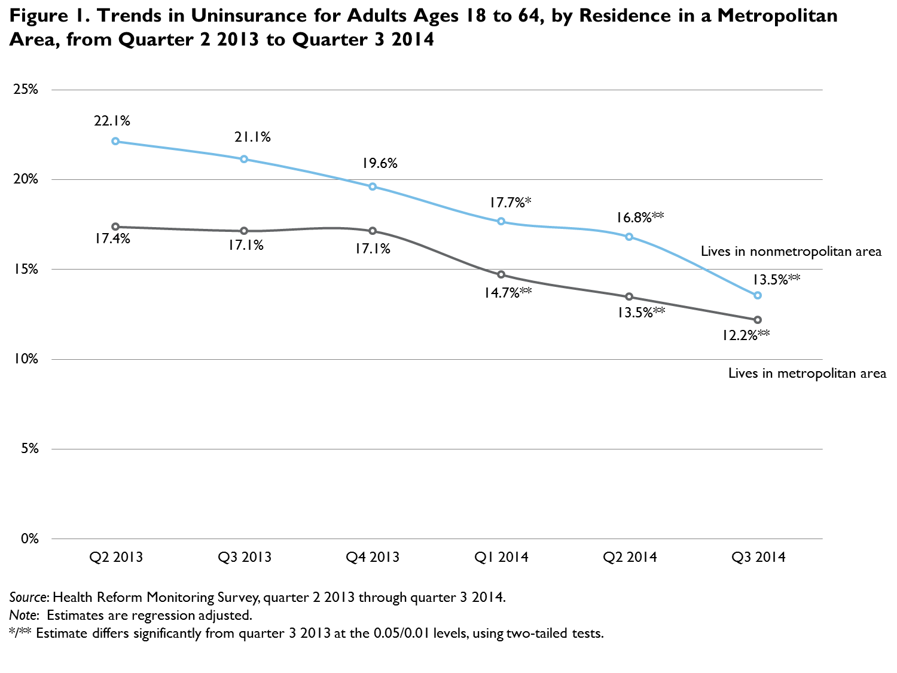

Coverage gains in rural areas were most pronounced among low-income adults, adults in Medicaid expansion states, and women. The uninsurance rate fell most sharply among low-income adults targeted by the ACA’s Medicaid expansion (those with family income at or below 138 percent of the federal poverty level; figure 2). The uninsurance rate declined 14.8 percentage points (95% CI [7.2, 22.4]) among low-income adults in rural areas and 11.3 percentage points (95% CI [8.1, 14.5]) among low-income adults in urban areas. Middle-income adults (i.e., those with family income between 139 and 399 percent of the federal poverty level), targeted by the ACA’s coverage subsidies through the health insurance Marketplaces, experienced an uninsurance rate reduction of 5.3 percentage points (95% CI [3.6, 7.0]) for those in urban areas and 4.9 percentage points (95% CI [0.0, 9.9]) for those in rural areas. Estimated changes for high-income adults in rural and urban areas were not statistically significant.

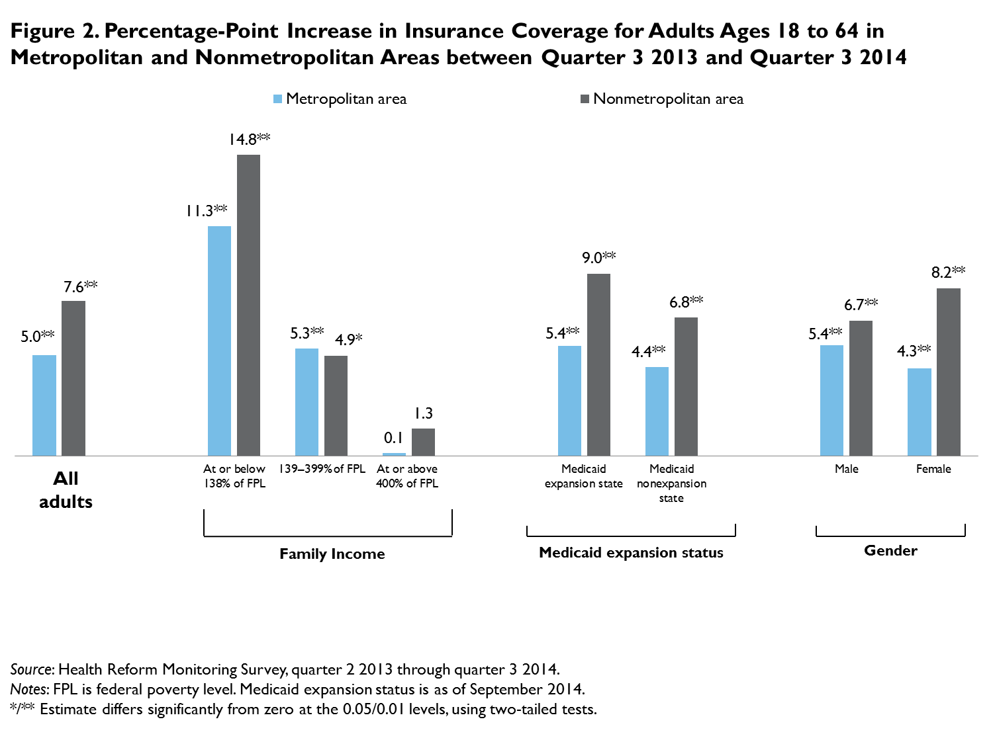

In states that expanded Medicaid, the share of adults without health insurance in rural areas fell from 17.4 percent to 8.5 percent, a change of 9.0 percentage points (95% CI [5.5, 12.4]) and a decline in this group’s uninsurance rate of more than 50 percent. Adults in urban areas living in Medicaid expansion states saw their uninsurance rate fall 5.4 percentage points (95% CI [4.0, 6.8]). In states that did not expand Medicaid, the uninsurance rate fell 6.8 percentage points (95% CI [2.3, 11.3]) for adults in rural areas and 4.4 percentage points (95% CI [2.2, 6.5]) for adults in urban areas.

Women in rural areas experienced larger coverage gains than men: the share of rural women with coverage rose 8.2 percentage points (95% CI [3.9, 12.6]). The uninsurance rate for women in rural areas declined 40.9 percent. For men in rural areas, the estimated decline in uninsurance was 6.7 percentage points (95% CI [1.7, 11.6]), or 30.3 percent. Coverage gains were small but significant among men and women in urban areas.
http://hrms.urban.org/quicktakes/Thirty-Six-Percent-Drop-in-Uninsurance-Rate.html

Access to Health Care Providers Improved between September 2013 and September 2014

The Urban Institute
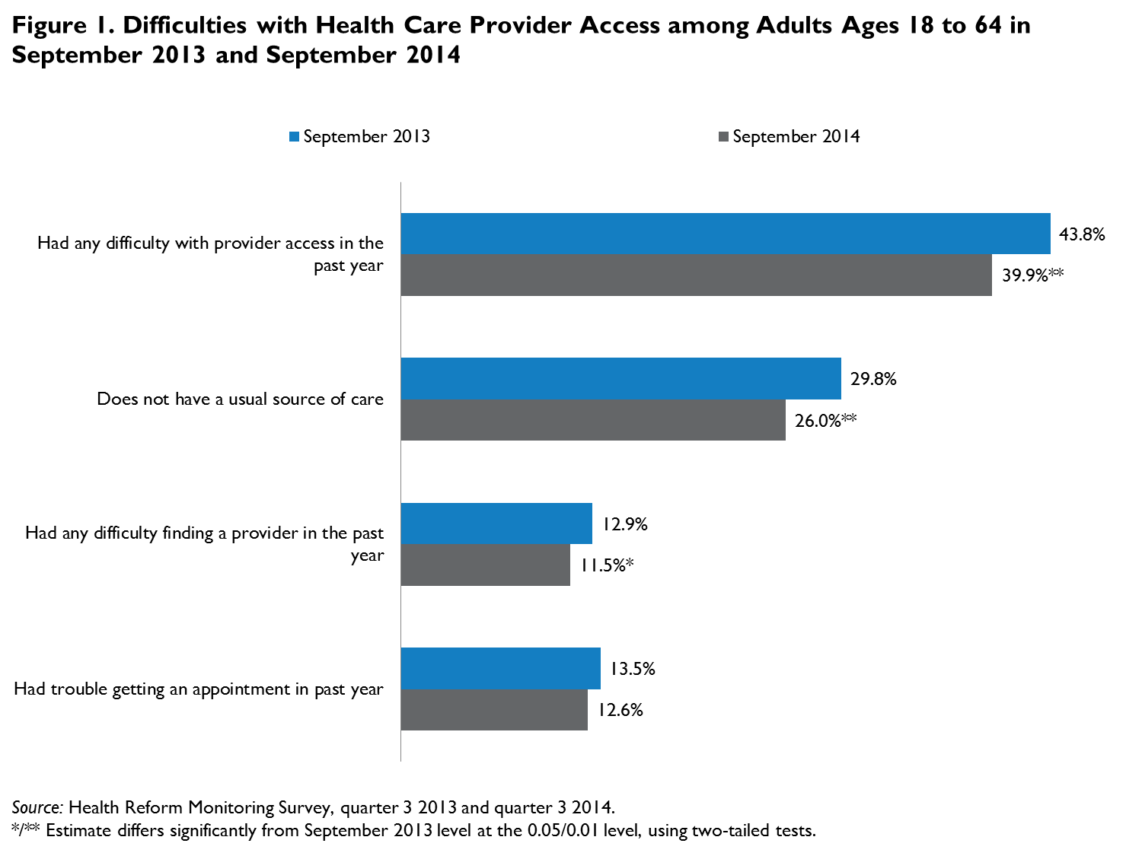

The King Has No Clothes: How the Case against the ACA is Unravelling before Our Eyes
Constitutional Accountability Center
There’s never been much substance to the arguments made by petitioners in King v. Burwell, the case challenging the availability of tax credits under the Affordable Care Act that the Supreme Court will be hearing next month. The case has always relied on taking four words, “established by the State,” out of the context of a 900-page statute, and on an argument about congressional intent that one lower court judge called “nonsense, made up out of whole cloth.” Now that cloth is seriously frayed. In the months since that court’s decision, it’s become increasingly clear not only how weak that argument is, but how weak all the arguments behind King are. Indeed, as oral argument rapidly approaches, the case made by the ACA’s opponents is unraveling around them.
The Government Makes Clear the Strength of the Textual Arguments
Petitioners’ argument about the text of the ACA at least has the advantage of being simple (or, more accurately, facile). The law’s challengers ask the Justices to look at the words “established by the State” in the formula for calculating the amount of the tax credit and declare that these tax credits are not available to individuals around the country that live in states that have refused to establish an ACA-compliant Exchange. But the ACA explicitly states that the condition for eligibility for the tax credits is income level. Moreover, petitioners’ textual argument has always depended upon judges willing to turn a blind eye to all of the other provisions in the law that make clear that a state Exchange is functionally the same as a federal one, and that the tax credits should be available on both. That’s never the way one interprets a statute, as explained by an ideologically diverse array of textualist and administrative law scholars. The federal government’s brief puts it this way:
[P]etitioners must rewrite so many of the Act’s provisions, and explain away or ignore so many textual incongruities and contradictions, that their argument collapses under its own weight—wholly apart from the havoc it would wreak on the Act’s structure and design (citations omitted).
The Government also has a compelling argument about why even the four words on which the law’s challengers rely don’t support their case. As the Government explains, that language is in the law to make clear that the Exchange the statute is talking about is the specific state Exchange on which the individual purchased her insurance, regardless of whether that Exchange was set up by the federal government or by the state itself. This was an important distinction because when the ACA was being debated, there were some Senators who strongly opposed one national Exchange, but were very comfortable with the federal backstop in the law as passed precisely because there would still be individual Exchanges in each state.
As Evidence of Congress’ Intent Piles Up, Petitioners’ Claims Crumble
In fact, one of the key Senators who strongly opposed the national Exchange, but supported the federal backstop, is former Senator Ben Nelson. He’s particularly important because lawyers for the challengers have long said that he was the reason the tax credits were made conditional on state establishment of an Exchange; according to them, it was the only way he would cast his critical vote for the law. Indeed, they make this argument on page four of their most recent brief, and it featured prominently in an oral argument on this issue in the lower courts.
There’s just one big problem with that argument: it isn’t true. Senator Nelson recently made clear in a letter to Senator Bob Casey that he “always believed that tax credits should be available in all 50 states regardless of who built the exchange, and the final law also reflects that belief as well.” In response to this evidence, Michael Cannon, an architect of the King challenge, admitted that “[i]t may well be that Ben Nelson always wanted there to be subsidies in state-established exchanges or federal exchanges.”
And this isn’t the first time Cannon has had to walk back a claim about Congress’ intent regarding the tax credits: in August of last year he retracted a claim that former Senator Max Baucus—who has also repeatedly signed onto briefs supporting the Government—made a statement indicating that tax credits would not be available on the federal Exchanges.
Cannon’s claims that ACA supporters knew the law conditioned tax credits just keep falling. In the amicus brief he filed with Jonathan Adler in December, Cannon claimed that some House Members “recognized [the ACA] conditioned subsidies on states creating Exchanges.” The only evidence he cites is a 2010 letter to President Obama by Representative Lloyd Doggett (D-TX) and ten other Texas representatives, and an article mentioning the letter by NPR’s Julie Rovner. But Doggett has roundly refuted Cannon’s use of his words, stating unequivocally that he and his colleagues “neither specifically mention nor contemplate the far-fetched argument now advanced by reform opponents that premium tax credits would only be available for state-based exchanges.” And for her part, Rovner confirmed that “there was never any discussion about only state exchanges offering subsidies that I was party to” and that she “never meant to imply it in [her] story” (which, for the record, she did not).
All this comes as the Members of Congress most closely involved with the drafting and passage of the ACA are lining up to state on record that they always intended for the tax credits to be available nationwide. Their assertions have been echoed by high-level congressional aides, who have also gone on record explaining that nationwide availability was always the intention behind the law.
Even Conservatives Don’t Line Up Behind the Arguments in King
And supporters of the ACA aren’t the only ones who know the argument in King is completely wrong. Take, for example, Wisconsin Governor Scott Walker. Last month it came to light that Governor Walker told the Wall Street Journal in March of 2013 that, after spending “nearly two years looking at this,” he determined that “in the end, there’s no real substantive difference between a federal Exchange, or a state Exchange.” Walker’s former top health official tried to reason that the Governor wasn’t speaking specifically to the tax credit issue, but then it surfaced that a month before that remark, Walker had unveiled a health care proposal explicitly predicated on the assumption that eligible Wisconsinites who purchased insurance through the federally-facilitated Exchange in Wisconsin would receive tax credits. Walker is in good company with other Republican Members of Congress and state officials whose remarks—past and present—help to debunk the argument that anyone perceived a threat by Congress to withhold tax credits from uncooperative states.
And the lack of support shows in the amicus filings in King. Only six Republican state attorneys general signed onto a brief supporting the challenge, in stark contrast with the two dozen who were plaintiffs in the 2012 Obamacare case. Notably, the biggest federal Exchange states—Florida, Wisconsin, Michigan, and Texas—all with Republican governors, declined to file. By comparison, 22 state attorneys general, from both red and blue states, and with both state-run and federally-facilitated Exchanges, signed onto a brief supporting nationwide availability of the credit.
There’s Also More and More Evidence of How Catastrophic a Win for the Law’s Challengers Will Be
In recent weeks, study after study has indicated that a ruling against the Government would kick nearly 10 million Americans off of their health insurance and seriously destabilize the individual insurance markets in states with federally-facilitated Exchanges, posing a grave threat to the insurance and health care industries and making coverage vastly more expensive for all Americans in those states. As the Government highlighted in its latest brief, in their dissent in the 2012 Obamacare case, four of the Court’s conservatives observed that “[w]ithout the federal subsidies . . . the exchanges would not operate as Congress intended and may not operate at all.”
This may be another reason why amicus support for the law’s challengers was so lackluster: even opponents of the law are wary to put their name on a suit that threatens so much damage to their constituents and to industry, especially given that they offer no credible fix. It’s worth noting that many health industry stake holders such as insurance providers, medical professional associations, and groups representing virtually every hospital in America have filed in support of nationwide availability, while no major industry voices have filed in support of the law’s challengers. These stake holders were involved in the development of the law, so they understand that tax credits were always meant to be available nationwide—and they are in perhaps the best position to understand the consequences of eliminating the tax credit in 34 states, both for patients and for their industry.
Law’s Challengers in Trouble
So as we head into March and oral argument in King, the case against the ACA is coming apart at the seams. That almost certainly won’t stop the law’s challengers from trying to come up with new defenses for their arguments and “evidence” to support their case. But we already know that this King has no clothes.
http://theusconstitution.org/text-history/3110/king-has-no-clothes-how-case-against-aca-unraveling-our-eyes

Total U.S. health care spending grew relatively slowly in 2013 for the fifth consecutive year, rising about 3.6 percent, according to the new CMS data. By way of comparison, health care spending grew by an average annual rate of 7.3 percent from 2000 to 2008.

State Medicaid spending
To this end, calendar year 2013 marked a return to a more typical Medicaid spending pattern after a surge and then retrenchment of federal aid in recent years. Under the American Recovery and Reinvestment Act of 2009 (and later legislation that extended certain provisions of the law), the federal government contributed an extra $103 billion to Medicaid, with states receiving the bulk of that in 2009 and 2010. The Great Recession swelled Medicaid rolls and drove increases in total program expenditures, but the states’ share of Medicaid spending actually declined because of federal stimulus money.
The extra federal money stopped flowing in July 2011, which was the primary reason state Medicaid expenditures rose steeply that year and in 2012, and why federal Medicaid expenditures fell. But in 2013, the temporary effects of this retrenchment in federal aid faded, and both federal and state spending rose by about 6 percent.
Total Medicaid spending was likely to have increased substantially in 2014, when millions of Americans were added to states’ rolls after many of them expanded their eligibility requirements for the program under the Affordable Care Act. But most of this hike will have been paid for by the federal government, which covered the entire cost of care for newly eligible enrollees.

State and local employee health insurance
The slight uptick in spending on health insurance premiums for state and local employees was driven, in part, by continued stagnation in state and local employment. As of December 2014—seven years after the start of the Great Recession—state and local government employment remained below prerecession levels. This, in turn, may have kept the growth in state and local employee health plan enrollment—and, therefore, the growth in total health plan spending—down. (For more information on state employee health plan spending, see here.)

Long-term outlook
Nevertheless, health care spending remains a potential source of fiscal pressure for states and localities as it absorbs a growing share of revenue and competes with other spending priorities. For additional perspective on the long-term outlook of state and local government health care spending, see here. And for information on specific state health care spending categories, including Medicaid, state employee health plans, and correctional health care, see here. [Pew publishes Stateline]
http://www.pewtrusts.org/en/research-and-analysis/blogs/stateline/2015/2/09/new-data-show-slowdown-in-state-and-local-government-health-spending?utm_campaign=2015-02-10%20Stateline%20Daily.html&utm_medium=email&utm_source=Eloqua

Did Chief Justice John Roberts Save the Affordable Care Act?
The New Yorker
The Affordable Care Act, President Obama’s signature achievement, will soon face a challenge, in the Supreme Court case known as King v. Burwell, that could conceivably destroy it. In fact, the Act may survive because of a legal doctrine beloved by conservatives and championed by Chief Justice John Roberts.
Every first-year law student learns about the principle of “standing” in civil-procedure class. Under Article III of the Constitution, the federal courts are only allowed to hear “cases” and “controversies.” For decades, the Supreme Court has interpreted those words to mean that plaintiffs must be able to show an “injury in fact” from a law in order to have the right to bring a case challenging the law.
For many years, liberals who have tried to bring federal cases to challenge government actions—in areas from the environment to welfare rights—have been thwarted by conservatives wielding the standing doctrine as a way to throw these cases out of court. During the George H. W. Bush Administration, a coalition of environmental and conservation groups sued to stop new federal regulations that limited the application of a section of the Endangered Species Act. Chief Justice Roberts, then the Deputy Solicitor General, persuaded the Supreme Court to throw out the case because the plaintiffs would not suffer direct harm from the new regulations and lacked standing to bring the case. In Lujan v. Defenders of Wildlife, the court held that a “generally available grievance about government—claiming only harm to his and every citizen’s interest in proper application of the Constitution and laws, and seeking relief that no more directly and tangibly benefits him than it does the public at large—does not state an Article III case or controversy.”
All of which leads to the case now before the Supreme Court, King v. Burwell, which is to be argued on March 4th. The case, which was expressly devised to take down the Affordable Care Act, centers on a provision that gives individuals who fall within a certain income threshold—roughly above poverty but below wealth—tax subsidies to pay for health insurance. The case is based on the claim that the Obama Administration policy of allowing those who received tax subsidies to buy insurance on the federal exchanges—which cover the thirty-four states that don’t have state-run exchanges—violates the terms of the Affordable Care Act itself. If the plaintiffs succeed in making their case, eight million people are estimated to lose their health insurance, and the A.C.A. itself could subsequently unravel.
But the King case, like any case, can only proceed if the plaintiffs have standing—that is, if they can claim an “injury in fact” from the Obamacare law. Thanks to two recent, excellent pieces of journalism, in Mother Jones and the Wall Street Journal, we now know a great deal about the four plaintiffs. Two are veterans of the Armed Forces and can receive health care through the Department of Veterans Affairs; accordingly, they have no reason to seek the tax subsidies under the law. The other two plaintiffs may make too little money to qualify for the tax subsidies, and, furthermore, one who claimed to be a Virginia resident listed a motel that prohibits long-term stays as her address. In short, the provisions of the Affordable Care Act in question in King v. Burwell may be irrelevant to all four plaintiffs—which would mean that they lack standing to challenge it.
The Obama Administration did not raise the standing issue in its brief to the Supreme Court in King v. Burwell. However, the standing issue is “jurisdictional,” which means that plaintiffs must always prove standing, whether the defendants raise the issue or not. The Justices can always take it upon themselves to investigate the record in the case to determine whether the plaintiffs have standing, and even as late as days before the argument, Administration lawyers can write a letter to the court calling attention to the issue of the plaintiffs’ questionable standing. If the Justices ask questions about standing at the oral argument next month, it’s a good clue that a dismissal of the case on standing grounds is at least a possibility.
Of course, a dismissal of the case because the plaintiffs lack standing would not settle the legal issue of whether the tax subsidies are legal in the thirty-four states. Presumably, another lawsuit could proceed with more appropriate plaintiffs. But, in and out of government, lawyers are taught to believe that a win is a win. If lawyers for the Obama Administration can keep the A.C.A. alive, even temporarily, through the procedural device of standing, then they will be more than pleased to do so.
http://www.newyorker.com/news/news-desk/chief-justice-john-roberts-save-affordable-care-act?auid=15180209

Modified Adjusted Gross Income (MAGI)
- Getting MAGI right: Current monthly income vs. projected annual income- http://ccf.georgetown.edu/all/getting-magi-right-changes-income-counting-rules-medicaid-chip-2/
- Getting MAGI right: A primer on differences that apply to Medicaid and CHIP- http://ccf.georgetown.edu/all/getting-magi-right-assisters-worksheet-determining-household-size-medicaid-chip/
- Getting MAGI right: An assister’s worksheet for determining household size in Medicaid and CHIP (also see attached)- http://ccf.georgetown.edu/all/getting-magi-right-assisters-worksheet-determining-household-size-medicaid-chip/
- UC Berkeley Labor Center’s MAGI under the ACA summary (updated from 2013 version)- http://laborcenter.berkeley.edu/pdf/2013/MAGI_summary13.pdf
- National Health Law Program’s Advocate’s Guide to MAGI- http://www.healthlaw.org/publications/agmagi#.VNQMyS6Vl1A
- How to estimate your income for the Marketplace- https://www.healthcare.gov/income-and-household-information/

How to Explain a $0 APTC Eligibility Determination to Consumers

CMS

As an assister, you may have worked with a consumer who received an eligibility determination that they are eligible for a tax credit of $0. The law says that qualified individuals with projected annual household income generally between 100 - 400% of the Federal Poverty Level (FPL) may qualify for advance payments of the premium tax credit (APTC) for coverage purchased through the Health Insurance Marketplace. To determine eligibility for APTC, the Marketplace compares the maximum amount that the law says a household will contribute to the cost of the applicable benchmark plan. The maximum amount is a percent of household income. The cost of the applicable benchmark plan is the premium for the second-lowest-cost silver plan or plans that cover everyone in the household who is enrolling in coverage through the Marketplace.

If the maximum amount that a household contributes based on the law is higher than the cost of the applicable benchmark plan, that household will not receive APTC, even if the projected annual household income is below 400% FPL, since the premium without the APTC is already affordable. In this situation, a consumer will receive an eligibility determination notice that states, “You are eligible for a tax credit equal to $0. Because the amount you are expected to contribute to health coverage under the law is more than the amount of the premium for the second lowest-cost silver plan in your rating area, you don't get a tax credit.” When using the plan compare tool on HealthCare.gov, the consumer will be asked to confirm the application of $0 APTC to his or her plan selection.

Information on Healthcare.gov Addresses Canceling Marketplace Plans When Eligible for Other Coverage

CMS

The December 19, 2014 assister webinar included a presentation about how assisters can help newly Medicaid-eligible consumers terminate QHPs. This guidance was included in the December 23, 2014 assister newsletter, and you can find it here online; you can also find the slides from the assister webinar online here. We included responses to questions assisters submitted during the webinar in our January 6, 2015 newsletter. Recently, new, consumer-friendly information has been added to HealthCare.gov that also addresses this issue – click here to view this new content.

New Healthcare.gov Content on “What’s Included as Income” for the Application Process

CMS

New information has been added to Healthcare.gov providing clarification about gross vs. net income and how to determine modified adjusted gross income (MAGI) when applying for premium tax credits. This information is available by clicking on the “Gross or net income?” question located on the What’s included as income page.

Slides and Assister Q&A on Exemptions from the Individual Shared Responsibility Payment

CMS

The January 16, 2015 assister webinar featured a presentation on exemptions from the individual shared responsibility payment. The January 20, 2015 assister newsletter included a summary of this presentation. For additional information on exemptions, you can refer to the following: the IRS.gov website section entitled, “Individual Shared Responsibility Provision—Exemptions: Claiming or Reporting” and the Healthcare.gov section entitled, “How to apply for an exemption.”
- Presentation slides from the January 16, 2015 webinar can be accessed here; you can also view them along with other resources on the shared individual responsibility payment and exemptions here.
- Additionally, HealthCare.gov has added a new blog reminding consumers that as of 2014, every person in the country must have had minimum essential health coverage (MEC) or an exemption from having MEC. Otherwise, they may have to pay a fee on their 2014 federal tax return. The blog post details two types of exemptions: (1) IRS exemptions that are obtained from filing a federal tax return using Form 8965- Health Coverage Exemptions; and (2) Marketplace exemptions that a consumer can request by sending an exemption form to the Health Insurance Marketplace.

Q: If someone falls into the Medicaid coverage gap in a non-expansion state, do they need to apply to the Marketplace first and then apply for exemption?

A: Consumers who applied during the 2014 Open Enrollment through the Marketplace, have incomes below 100% of the FPL, and live in a state that did not expand Medicaid do not need to send in a separate exemption application. To claim the exemption, they should have received a letter from the Marketplace with their Exemption Certificate Number (ECN) to list on the IRS Form 8965 as part of their tax return. Otherwise, consumers who meet the criteria for this exemption can list code “G” on their Form 8965. Consumers only need to apply to the Marketplace if they experienced an increase in income after they were previously denied coverage for Medicaid, and therefore are unable to claim this exemption on their tax return because their household income is higher than 138% FPL.

Summary and Slides for Overview of Immigrant Eligibility Policies for Health Insurance Affordability Programs

CMS

The Friday, February 6, 2015 assister webinar included the second installment in a two-part series on immigration. The Deep Dive focused on immigrant eligibility policies in the Marketplace and was presented in partnership with the National Immigration Law Center (NILC), the Center on Budget and Policy Priorities (CBPP), and the Georgetown University Center for Children and Families. It included information about immigration enforcement, privacy and confidentiality, discrimination, language services, identity proofing and navigating the FFM website.

The presentation also included some important tips for talking about immigration status. Assisters may remind consumers that immigration information obtained will only be used for the purpose of eligibility determination and enrollment in the Marketplace. In addition, assisters can help consumers understand they need to submit all relevant immigration numbers to verify eligibility and reduce the occurrence of inconsistencies. Examples of immigration document types as well as applicable numbers are included in the slides. Finally, the presentation provided helpful tips to navigate identity verification requirements.

- Presentation slides from the February 6, 2015 webinar can be accessed here from CBPP, and are linked along with a short summary here. You can view a blog post and slides from additional immigration –related webinars on the Georgetown Center for Children and Families website (use the “Webinar 3” link on this page), and download a pdf version of the presentation posted by NILC. Finally, you can view this slide deck along with other resources on assisting special populations on the Marketplace.CMS.gov website here (scroll down to “Application Process for Families That Include Immigrants – presented January 30, 2015 (slides)”).

Resources for Eligibility and Application Help for Immigrant Families:
- Information on immigration document types
- Information on eligible immigration statuses
- Information on Citizenship and immigration statuses
- Information on Electronic Verification of Immigration Status on HealthCare.gov
- Citizenship & immigration questions on the Marketplace application
- The Health Insurance Marketplace: Resources for Immigrant Families
- More resources on Marketplace.CMS.gov, technical resources, special populations are also available here

Slides for Eligibility for Non-citizens in Medicaid/CHIP

CMS

The slides from the February 6, 2015 presentation are posted here on our Technical Assistance Resources page; you can also view them along with other resources on Medicare, Medicaid, and CHIP here, or with other resources on assisting special populations here.

Changing Tobacco Use Information

CMS

Q: How can consumers report changes to their tobacco use? Can they make those changes at any time?

A: After being determined eligible for a QHP, HealthCare.gov asks, “Within the past 6 months, have you used tobacco regularly (4 or more times per week on average excluding religious or ceremonial uses)?” If the consumer answers “yes”, then the date of last tobacco use is recorded, and subsequently used to determine if the tobacco rate applies. Consumers’ answers to this may change during the course of their policy year (i.e. if they quit or start using tobacco products). However, consumers can only change their answer to these questions during the Open Enrollment period or during a special enrollment period. If there is a change in their tobacco use, consumers should come back to the Marketplace during Open Enrollment to make this update to their application. If a consumer does not come back to the Marketplace to re-enroll, the Marketplace will automatically re-enroll consumers with the same tobacco status that they reported on their last application.

As a reminder, consumers can switch to a different plan and update their application at any time during Open Enrollment. When consumers decide to change plans, their coverage and any new rate will be effective in accordance with normal coverage effective dates. For example, consumers who choose a new plan by February 15, 2015 will continue to be covered by their current plan until February 28, 2015, with the new plan beginning on March 1, 2015.

Immigrant Eligibility for Medicaid

CMS

Q: Some consumers received a Medicaid denial during the last Open Enrollment because they were not eligible for Medicaid due to their immigration status. In some cases, they are being sent back to Medicaid when they apply for 2015 coverage even though they are not eligible (for example, if they are in the 5 year bar period). Why is this occurring?
A: The consumer may be referred to Medicaid if the Marketplace cannot verify their immigration status; this generates a data matching issue. This tends to happen for one of two reasons: (1) the applicant does not provide enough documentation for the Marketplace to verify immigration status; and/or (2) the Department of Homeland Security cannot verify the applicant’s immigration status in real time.
- When an applicant (a) has an immigration status data matching issue, (b) is below 100% FPL and (c) meets the income and other requirements for Medicaid (most often, this means the state expanded Medicaid), then the consumer’s application is transferred to the state. While the FFM does not have enough information to verify immigration status for an applicant who attests to having eligible immigration status, when that consumer meets all other Medicaid or CHIP eligibility requirements, the FFM assumes that the applicant has Medicaid or CHIP eligible immigration status. This is why the applicant is transferred to the Medicaid agency.
- When an applicant (a) has an immigration status data matching issue, (b) is below 100% FPL and (c) does NOT meet the income and other requirements for Medicaid (most often, this means the state did not expand Medicaid), then the consumer’s account remains with the Marketplace and he or she is determined eligible for QHP coverage without APTC or CSRs. As mentioned above, the FFM assumes that the applicant who has attested to having eligible immigration status has Medicaid or CHIP eligible status, which means they would not get APTC/CSRs when under 100% FPL, until the FFM can prove their status makes them Medicaid-ineligible.

Additionally, all applicants who request financial assistance will see the question asking whether they have been denied Medicaid or CHIP in the past 90 days or if they have been denied Medicaid or CHIP based on immigration status since October 1, 2013. Most applicants don’t need to answer “yes” to these questions in order to be assessed for QHP with APTC and CSRs, because the system will determine their eligibility for QHP, APTC and CSRs automatically. However, for applicants who would otherwise be re-routed to Medicaid based on their answers to other questions on the application (e.g., income and immigration status, as described in the paragraphs above) but were denied eligibility for Medicaid/CHIP by their state’s Medicaid/CHIP program, answering “yes” to these questions will ensure that the applicant is not sent back to Medicaid/CHIP, but will instead be determined either eligible or ineligible for APTC and CSRs.

Tips for helping consumers with identity proofing

CMS

To protect consumers’ personal information, the Marketplace application includes a few steps to verify consumers’ identities before they can create a Marketplace account and complete an application. The Identity (ID) proofing process asks questions that can only be answered by an individual consumer, based on accounts and personal information in his or her credit report. When consumers are not able to successfully ID proof through answering the identity proofing questions on HealthCare.gov, they are prompted to contact Experian Help Desk for ID Proofing.

To learn more about ID proofing, see this page on HealthCare.gov and this page on Marketplace.CMS.gov. Additional resources include FAQ on Remote Identity Proofing, Remote Identity Proofing Failures and Application Inconsistencies and FAQ on ID Proofing and Working with Experian, along with the following set of questions and answers.

Q1: When is Identity proofing required?
A1: Identity (ID) proofing is not required to create an application. However, it is required to submit an application online and enroll in coverage online.

Q2: How can a consumer link an existing account to a new account?
A2: In order to link a new online account to an existing application submitted through the Marketplace Call Center or via paper, the consumer must complete ID proofing. The consumer will also need their application ID to link their application to their online account.

Q3: Is there a Reference ID Number related to ID proofing?
A3: A consumer may get a request for a unique Reference ID Number when attempting to complete (ID) proofing. This Reference Number is for consumers who are attempting ID proofing for the first time and are unable to complete ID proofing online. In that case, consumers may be given a unique Reference ID Number to use when contacting Experian to receive assistance with the ID proofing process.

Q4: How many times are consumers required to complete ID proofing?
A4: Identity proofing is only required one time per online account and is not required annually. Consumers who have successfully submitted an online application in 2014 or 2015 have already completed their ID proofing. These consumers do not have to go through the identity proofing process again.

Q5: Can consumers complete ID proofing on a second account using the same social security number?
A5: The system performs a uniqueness check on the e-mail address submitted by the individual to ensure that it is not associated with an existing Marketplace account. Consumers who try to complete ID proofing on a second account with the same social security number that was used to complete ID proofing on a previous account will not see the reference code but will get an error message suggesting that they have already created an account. These consumers should contact the Marketplace Call Center.

Q6: What should consumers do if they do not pass remote identity proofing (RIDP)?
A6: Consumers who do not pass RIDP will get a yellow screen on HealthCare.gov directing them to contact Experian to ensure that they complete ID proofing before submitting their application. When consumers contact Experian for ID proofing, Experian collects information from them, including their unique Reference ID Number obtained from HealthCare.gov in order to attempt successful ID proofing. If the consumer continues to fail remote identity proofing, they will need to upload to their online account or mail to the Marketplace additional identity verification documentation.

________________

Have something you want us to possibly add to next week’s newsletter? Email Kim VanPelt at kim.vanpelt@slhi.org.

