Covered Clips
A Summary of News and Activities for the Cover Arizona Coalition
October 1 – October 29th

The Affordable Care Act: Who Was Helped the Most

An October 29th story by the New York Times provide data on changes in the percentage of people with health insurance. It features an interactive map that shows reduction in uninsured by county. A few of the highlights:

County | Uninsured in 2014 | Uninsured in 2013 | Change 2013-2014
Yuma | 14% | 22% | 8%
Pima | 10% | 17% | 7%
Santa Cruz | 15% | 26% | 11%
Cochise | 10% | 18 % | 8%
Maricopa | 9% | 15% | 6%
Yavapai | 10% | 17% | 7%
Pinal | 11% | 18% | 7%
Mohave | 11% | 20% | 9%
La Paz | 11% | 21% | 10%
Coconino | 8% | 17% | 9%
Navajo | 11% | 21% | 10%
Apache | 11% | 26% | 15%
Greenlee | 12% | 21% | 9%
Graham | 10% | 20% | 10%
Gila | 10% | 18% | 8%

http://www.nytimes.com/interactive/2014/10/29/upshot/obamacare-who-was-helped-most.html?abt=0002&abg=0

Many Uninsured Don’t Know When Next Health Law Sign-Up Begins, Poll Shows
From the Commonwealth Fund
Relatively few uninsured Americans as of early October knew when they'd next have a chance to buy coverage under the health law, according to a survey, and almost half weren't aware they could get subsidies to help pay their premiums. Nevertheless, most said they'd get insured in the next few months.
The Kaiser Family Foundation's latest health law tracking poll, conducted October 8 to 14, surveyed 1,503 insured and uninsured adults. It showed insurers face a tough challenge for the open enrollment period running from Nov. 15 through Feb.15, during which government officials are aiming to enroll twice as many Americans.
While experts say it's better not to heavily promote health coverage when people can't actually sign up, messages about when enrollment begins, and the availability of help paying premiums, could get the period off to a faster start.
The survey found that 89 percent of uninsured respondents didn't know that open enrollment begins in November. Two-thirds of the group says they know "only a little" or "nothing at all" about insurance exchanges where they can sign up. And 53 percent said they were unaware they could get financial assistance to get coverage.
Yet 59 percent of the uninsured said they would get covered in the next few months. Eighteen percent said they expected to remain without coverage because they don't think they could find an affordable plan. And 12 percent of uninsured respondents said they expected to stay that way because they don't want to be forced to buy anything; the cohort included 3 percent who said they'd rather pay a fine for not getting covered than foot the costs of health insurance.
In the overall sample, 43 percent of Americans said they view the health law (PL 111-148, PL 111-152) unfavorably while 36 percent regarded it favorably. Fifty-six percent of Americans said the law had had no direct effect on their family. Among those saying the law had a direct impact, 26 percent said it hurt then and 16 percent said it helped them.
The survey had a margin of error of three percentage points for the full sample and nine percentage points for the uninsured group.
http://www.commonwealthfund.org/publications/newsletters/washington-health-policy-in-review/2014/oct/oct-27-2014/many-uninsured-dont-know-when-next-health-law-signup

Keeping Covered: The Affordable Care Act’s First Re-Enrollment Period for Marketplace Plans
From the Commonwealth Fund Blog
On November 15, the health insurance marketplaces will open for the 2015 enrollment period. As many as 13 million people may have a plan through the marketplaces by the end of the three-month period. Among those will be people who are continuing their coverage and tax credits from last year. This “reenrollment” will be a first-time experience for the marketplaces and consumers, and it will be administratively complex for everyone.¹ We take a look at the questions consumers should ask and what action they need to take to keep covered in 2015.
Will I Receive a Premium Tax Credit in 2015?
About 6 million people who enrolled in plans through the marketplaces this year were eligible for premium tax credits that lowered their premium contributions. This assistance was based on the incomes that people reported at the time they signed up for their plans. This fall, the marketplaces will re-determine these enrollees’ eligibility for premium tax credits.
The U.S. Department of Health and Human Services (HHS) and the state marketplaces are now sending notices to people who received tax credits this year, informing them about open enrollment and the process for re-determining tax credit eligibility.² The notices explain that because people receive their tax credits in advance of their income tax returns, it is critical that they update their income information with the marketplaces to avoid receiving tax credits that are too high or too low. At tax time, the IRS will reconcile people’s advance tax credits with their actual income, and enrollees will either receive a tax dividend if the credit was too low based on their actual income, or pay more in taxes if the credit was too high.
The marketplaces will send notices to people tailored to their personal circumstances:
- People who received tax credits in 2014, and who gave permission to the marketplaces to request their most recent income tax returns from IRS, will be asked to visit the marketplaces to update their income information. People with significant income changes, or who have incomes that place them well above the threshold that makes them eligible for tax credits, will receive special update notices. People who do not contact the marketplaces by December 15 will receive tax credits in 2015 that will be identical to what they were in 2014. This means that someone who did not update their information could automatically pay a higher premium because they are a year older—and could miss out on a higher advance tax credit if their income decreased, or could owe more in taxes in 2015 if their income increased.

- People who received tax credits in 2014, and who did not give permission to the marketplaces to request their tax information, are also urged to visit the marketplaces for a redetermination of their eligibility. If they do not do so by December 15, they will not receive tax credits in 2015.

Will I Have the Same Health Plan in 2015?
Like most health insurance policies through employers, enrollment in marketplace plans lasts for one year. Consumers who still want coverage for 2015 can either reenroll in their current plan, if their insurer is offering the plan in 2015, or go back to the marketplaces and shop for a new plan.
Auto-enrollment. While consumers can shop for a new plan, HHS has sought to make the reenrollment process as automatic as possible. The Affordable Care Act’s consumer protections include “guaranteed renewal” of health insurance policies for individuals and employers who want to renew their policies. But insurers can discontinue plans, if they meet certain federal criteria. So some 2014 plans will not be available in 2015. The federal government requires carriers to follow a standardized process to help consumers auto-enroll in a new marketplace plan if they are interested in doing so.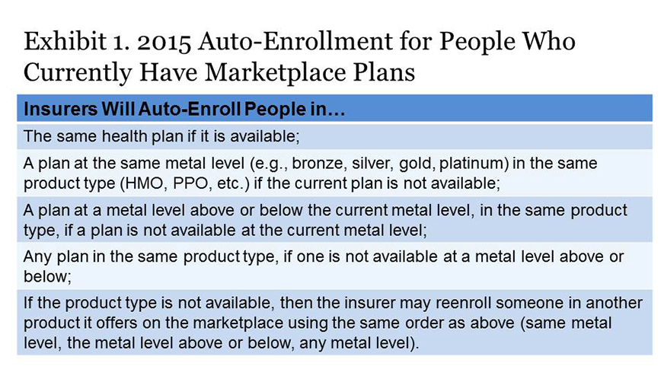
Insurer notices to consumers. HHS requires health insurers to send notices containing key information to people with health insurance through the marketplaces and the individual market outside the marketplaces by November 15. The notices will tell consumers whether their plan is available for renewal or is being discontinued, if they are being auto-enrolled in a new product, their plan’s 2015 premium, and other critical information.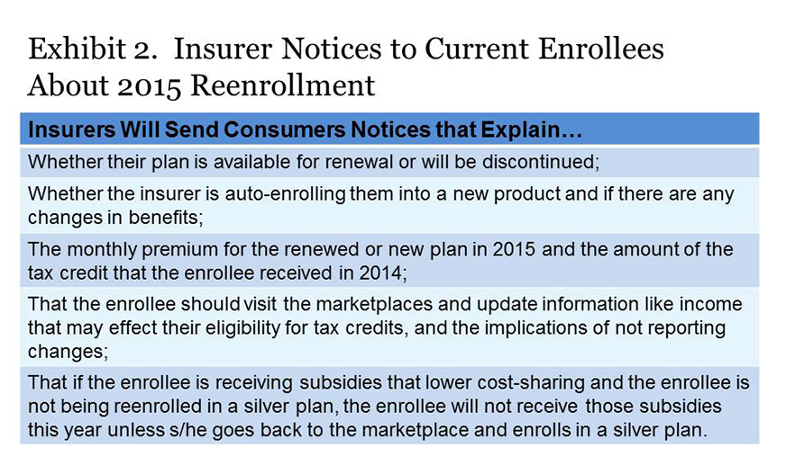
Will the Benchmark Plan Change in 2015?
The amount of someone’s tax credit is calculated as the difference between their required contribution as a share of their income (depending on their income, 2.01%–9.56% of income in 2015) and the premium of the second lowest-cost silver plan, a.k.a. the benchmark plan, sold in the marketplaces. People can apply their tax credit to any plan, with the individual paying the difference if the premium is higher than the benchmark, or pocketing the savings if it is lower.
Many state marketplaces could have a new benchmark plan in 2015 because of changes in relative premiums for plans offered on the marketplaces. This means that if someone stays in a plan that is no longer the second-cheapest silver (benchmark) plan, they will probably pay more in premiums this year.
What Is a Consumer to Do?
Consumers should carefully read notices they receive from the marketplaces and insurers this fall and return to the marketplaces to update their personal information on their applications by December 15. While it may be easiest to auto-enroll for 2015, consumers will likely get the best deals by fully exploring this year’s plan options in the marketplaces. The considerable complexities of this first reenrollment period are nearly certain to create confusion. It is essential that consumers go to the marketplace websites and/or call the phone numbers listed in these notices. They can also seek assistance from navigators and insurance brokers if necessary.
Consumers should also remember that in the pre-ACA world, purchasing individual health insurance policies was every bit, and perhaps more, complicated than it is in the marketplaces this year. Consumers did not have any help defraying premium expenses; there was no place to go for comparative information on the content or value of plans; and they could be denied coverage if they had preexisting conditions.

CMS Releases Information on Marketplace Plan Renewals in Advance of Open Enrollment

From Manatt on Health Reform: Weekly Highlights

In anticipation of the 2014-2015 Open Enrollment Period, CMS sent notices explaining the re-enrollment process to 7.3 million people currently enrolled in health plans purchased through the FFM. CMS took additional steps to notify consumers about their re-enrollment options, including posting a step-by-step plan renewal guide online, increasing call center staff and streamlining the online application process, noting that when consumers sign on to Healthcare.gov, 90% of the application will be pre-populated. Consumers who do not take steps to actively renew will generally be re-enrolled in the same plan that they were enrolled in in 2014.

See http://marketplace.cms.gov/technical-assistance-resources/training-materials/training.html for renewal notices

See http://marketplace.cms.gov/outreach-and-education/5-steps-to-staying-covered.pdf for step-by-step renewal guide

Speculation Swirls around what Happens if Federal Subsidies Go Away

From Modern Healthcare

New language in contracts between the CMS and insurers operating on HealthCare.gov is grabbing attention, with some calling it an admission by the government that it might lose upcoming court battles dealing with insurance subsidies on the health portal and others saying the new wording is just a practical precaution.
The new language appears to allow insurers to stop offering their plans should federal premium subsidies disappear. A number of cases regarding the legality of the subsidies in states without their own exchanges are now working their way through the courts.

The language says, “CMS acknowledges that (the insurer) has developed its products for the (federal exchange) based on the assumption that (advance payments of the premium tax credit) and (cost-sharing reductions) will be available to qualifying enrollees. In the event that this assumption ceases to be valid during the term of this agreement, CMS acknowledges that issuer could have cause to terminate this agreement subject to applicable state and federal law.”
Michael Cannon, director of health policy studies for the Cato Institute, a libertarian think tank, said the new CMS contract language is significant in that it shows the seriousness of the legal challenges facing the subsidies.
“It's the first indication that we've gotten that the administration and its allies are nervous about these losses,” Cannon said. “They've tried to project this image of confidence, of the law is obviously on their side, these lawsuits are frivolous and of course they're confident they're going to prevail in court, but now they're facing two losses.”
In July, in a split decision in Halbig v. Burwell, a three-judge panel from the U.S. Court of Appeals for the District of Columbia Circuit struck down the subsidies, saying residents shouldn't be eligible for them in states that haven't adopted their own exchanges. That decision, however, was invalidated when the full D.C. Circuit Court agreed to reconsider the case. Oral arguments are scheduled for Dec. 17.
That same day in July, a 4th U.S. Circuit Court of Appeals panel ruled unanimously in favor of the administration on the same issue in King v. Burwell. That case has been appealed to the Supreme Court, but the justices have not indicated whether they will hear it.
But Timothy Jost, a professor at Washington and Lee University School of Law in Virginia, said the new language might not necessarily be directly connected to those court cases. Subsidies could also be in danger if Republicans take control of Congress and succeed in defunding or repealing the Affordable Care Act, he said.
Jost doesn't agree with the argument that the language is an admission of possible defeat by the Obama administration.
“This is not, again, a validation of this litigation,” Jost said. “It's simply recognition that this is a risky world.”
Also at issue with the new language is exactly what it might mean should subsidies evaporate. The clause explaining that the new language is “subject to applicable state and federal law” raises a number of questions.
“People are just kind of shaking their heads going, 'I don't know what this means,' ” said Robert Laszewski, president of the Health Policy and Strategy Association, a consulting firm in Washington, D.C.
But Laszewski said if subsidies vanish, it's possible that healthy people will stop paying their premiums and only sick people who really need their insurance would remain. A RAND Corp. report found that eliminating the ACA's tax credits would result in premiums rising by nearly 45% and enrollment falling by nearly 70%.
“If you lose your insurance it's devastating, and if you're an insurance company and you lose 87% of your block and only keep the sick people that's pretty devastating too. This would be chaos and devastation in these 36 markets,” Laszewski said, referring to the states that have not adopted their own state exchanges.
It's unclear whether and how insurance companies might be able to exit the exchanges should subsidies be taken off the table. Laszewski said the federal Health Insurance Portability and Accountability Act says if an insurer cancels coverage for those who bought it through the exchange then it has to cancel that entire class of coverage, meaning that type of coverage offered off the exchange as well. Also, the Patient Protection and Affordable Care Act prohibits canceling policies because of nonpayment for three months. That means if subsidies ended and people stopped paying their premiums, they would still have to be covered for at least three months. It's possible insurance companies might, if subsidies stopped mid-2015, decide to stay on the exchange until they can exit Jan. 1 without complications because the government has agreed to cover most of any losses the companies experience on the exchanges through 2016, he speculated.
Complicating the issue are varied laws at the state level as well. For example, Linda Sheppard, with the Kansas Health Institute, said companies in Kansas would likely have to provide 60- to 90-days notice to consumers, depending on the situation.
It's also unclear whether insurance companies would actually try to leave the exchanges if subsidies stopped.
Clare Krusing, a spokeswoman with America's Health Insurance Plans, which represents the health insurance industry, said insurers and the government developed the new language and agreed on it together. But she said Friday it's still unknown exactly how things would play out should subsidies stop, given all the different state and federal legal questions.
Matt Wiggin, an Aetna spokesman, said Friday that the company is monitoring the situation but can't speculate on what might happen. The court cases involving subsidies aren't changing the company's strategy, he said.
“The courts have a process, and we'll continue to monitor where they go,” Wiggin said, “and then following any court ruling, we'll assess what that ruling means.”

http://www.modernhealthcare.com/article/20141027/NEWS/310249935&utm_source=AltURL&utm_medium=email&utm_campaign=am&AllowView=VXQ0UnpwZTRDdmFaL1IzSkUvSHRlRUtwalVnZEErVlk=?mh

Breakdown of Marketplace Enrollment by Legislative District (2013-2014)

Source: St. Luke’s Health Initiatives (Based on data from ASPE. These are estimates derived from matching zip codes to legislative districts.)

District 1: 5,364
Rep Karen Fann
Rep Andy Tobin
Sen Steve Pierce

District 2: 3,592
Rep Andrea Dalessandro
Rep Rosanna Gabaldon
(vacancy)

District 3: 3,147
Rep Sally Ann Gonzales
Rep Macario Saldate
Sen Olivia Cajero Bedford

District 4: 3,505
Rep Juan Carlos Escamilla
Rep Lisa Otondo
Sen Lynn Pancrazi

District 5: 2,434
Rep Sonny Borrelli
Rep Doris Goodale
Sen Kelli Ward

District 6: 2,794
Rep Brenda Barton
Rep Bob Thorpe

Sen Chester Crande

District 7: 2,174
Rep Albert Hale
Rep Jamescita Peshlakai
Sen Carlyle Begay

District 8: 2,406
Rep Frank Pratt
Rep Thomas Shope
Sen Barbara McGuire

District 9: 3,409
Rep Ethan Orr
Rep Victoria Steele
Sen Steve Farley

District 10: 3,642
Rep Stefanie Mach
Rep Bruce Wheeler
Sen David Bradley

District 11: 4,413
Rep Adam Kwasman
Rep Steve Smith
Sen Al Melvin

District 12: 4,817
Rep Eddie Farnsworth
Rep Warren Petersen
Sen Andy Biggs

District 13: 3,562
Rep Darin Mitchell
Rep Steve Montenegro
Sen Don Shooter

District 14: 3,608
Rep David Gowan
Rep David Stevens
Sen Gail Griffin

District 15: 4,319
Rep John Allen
Rep Heather Carter
Sen Nancy Barto

District 16: 4,140
Rep Doug Coleman
Rep Kelly Townsend
Sen David Farnsworth

District 17: 5,219
Rep Tom Forese
Rep J.D. Mesnard
Sen Steve Yarbrough

District 18: 5,290
Rep Jeff Dial
Rep Bob Robson
Sen John McComish

District 19: 5,946
Rep Mark Cardenas
Rep Lupe Contreras
Sen Anna Tovar

District 20: 5,420
Rep Paul Boyer
Rep Carl Seel
Sen Kimberly Yee

District 21: 5,402
Rep Rick Gray
Rep Debbie Lesko
Sen Rick Murphy

District 22: 3,688
Rep David Livingston
Rep Phil Lovas
Sen Judy Burges

District 23: 4,480
Rep John Kavanagh
Rep Michelle Ugenti
Rep Michele Reagan

District 24: 3,445
Rep Lela Alston
Rep Chad Campbell
Sen Katie Hobbs

District 25: 3,317
Rep Justin Olson
Rep Justin Pierce
Sen Bob Worsley

District 26: 3,090
Rep Juan Mendez
Rep Andrew Sherwood
Sen Ed Ableser

District 27: 2,735
Rep Ruben Gallego
Rep Catherine Miranda
Sen Leah Landrum Taylor

District 28: 5,609
Rep Kate Brophy McGee
Rep Eric Meyer
Sen Adam Driggs

District 29: 2,073
Rep Lydia Hernandez
Rep Martin Quezada
Sen Steve Gallardo

District 30: 2,568
Rep Jonathan Larkin
Rep Debbie McCune Davis
Sen Robert Meza

Insurance Lobbyist Predicts Smoother Health Law Sign-Ups, Battle over Networks

From the Commonwealth Fund

The top lobbyist for health insurers expressed optimism that the next open enrollment period under the health law will proceed more smoothly but warned that a lobbying battle looms over networks that could lead to higher premiums.
Visitors to federal and state health insurance exchanges will have a much easier time enrolling when the marketplaces reopen Nov. 15 to start selling coverage for the 2015 plan year, America's Health Insurance Plans President Karen Ignagni predicted in an hour-long interview with CQ HealthBeat last week.
Ignagni was unconcerned about the lack of a major outreach effort earlier this year to make the uninsured aware of the upcoming enrollment period and the availability of federal subsidies to help some pay their premiums.
Ignagni described insurance companies as well-prepared to retain existing exchange enrollees and to keep plan renewal rates high. "This is what they do," she said.
She was careful not to project enrollment for the second year of plan sales under the law. Such predictions could be cited as evidence of failure if things don't go well. "Our job isn't to worry about prognostications but to do the best job on the ground for each individual customer," she said.
But Ignagni elaborated at length on a major area of concern to the industry: that powerful providers will exercise lobbying clout to muscle their way into the narrower networks insurers use to keep low-cost plan options available in insurance exchanges. A big battle is brewing and costs could "explode" if providers get their way, she said.
Ignagni said the debacle surrounding last fall's launch of the federal insurance website healthcare.gov that served 36 states is a thing of the past.
The government has spiffed up the "front door" of exchanges covering the shopping and sign-up process. And health plan officials have provided guidance about how to facilitate enrollment, she said.
"We've marshaled the best and the brightest people on the operations side in the plans to work collaboratively with the federal officials that are running the exchange," she said. "The technical people with the plans have been working for a very long time now, for more than a year, with exchange officials."
"What consumers will see this year in the front door is definitely an improved experience from last year," she said.
Ignagni said consumers who are new to the exchange will see a considerably shortened application and will be able to go through the process fairly quickly. Federal officials say that about 70 percent of first-time marketplace customers will use an application that uses 16 computer screens, down from 76.
Less far along is the "back door" –the administrative processes associated with the exchange and its interactions with insurers.
For all the improvements, health plans are uncertain whether the reenrollment process for existing customers will run smoothly.
"We're in uncharted waters because we've never gone through a reenrollment process," she said.
Among the challenges are ensuring that existing enrollees update any changes to their marital status, incomes, and other changes affecting the size of subsidies for 2015 coverage. It will be important for customers to know what their 2015 subsidies are when they are evaluating coverage choices, Ignagni said.
Health plans are doing a great deal of outreach to make sure people know they need to update their information at the exchange, Ignagni said, adding that AHIP was "very pleased" to see that the Obama administration launched a similar effort last week.
Industry outreach efforts include setting up storefronts in local communities to assist with the enrollment process and maintaining 24-hour consumer call centers, AHIP officials say. One example are storefronts in Harlem and Queens, N.Y., operated by New York-based insurer EmblemHealth.
Consumers will get a letter before the Nov. 15 start of open enrollment telling them about any premium or other changes in their plan for next year. Consumers can consider coverage alternatives if they want to stretch their dollars, Ignagni said.
Ignagni said insurer outreach draws on health plans' experience in other markets, such as Medicare Advantage and Medicare Part D prescription drug plans.
Asked how confident she is plans will be able to get good renewal rates, Ignagni said "they know how to do this work."
She shrugged off questions about whether a more aggressive government or private outreach effort should have been launched by now to bring in new customers by targeting the uninsured.
A poll released this week by the Kaiser Family Foundation found 89 percent of the uninsured surveyed in early October didn't know that the next open enrollment period starts in November. Slightly more than half weren't aware that in many cases, subsidies are available to help pay premiums.
"It wouldn't have made sense in September to start this outreach effort because you want to do it close to open enrollment," Ignagni said.
Ignagni also addressed consumer concerns that some networks are too narrow and leave out some of the most important hospitals in a service area.
The National Association of Insurance Commissioners is working on revising its model state law on the adequacy of networks. Health and Human Services Secretary Sylvia Burwell has said that federal officials will monitor those efforts before deciding whether they will take added steps to ensure that the number and types of providers in a network are adequate.
Ignagni said that one major difference between tight networks in the HMOs in the 1990s and the current environment is that consumers in exchanges have a choice of plans. Back then, it was the employers not the consumers making the choices, she said.
"They make those decisions themselves and they are getting lower premiums as a result" if they choose tighter networks, she said.
Ignagni said that providers are beginning to lobby "to see whether or not they can be written into specific networks and to have regulations and legislation which forces them in."
The risk for consumers "is that would not only be bad for affordability, that will make costs explode," she said, adding the NAIC has an important job balancing these issues.
"Without a doubt, there are provider groups that don't want to reduce their prices and are looking to regulation and ultimately legislation to protect them," Ignagni said.
The health plan lobbyist said it's "going to be important this time for regulators and legislators to understand that this is a whole different situation because consumers are choosing for themselves and they're balancing all this information at their kitchen table."
"Now the public is much more interested in this question of what are the prices being charged, as opposed to simply what are the premium prices," she said, noting that the costs for medical procedures in the United States are far higher than in other nations.
http://www.commonwealthfund.org/publications/newsletters/washington-health-policy-in-review/2014/oct/oct-27-2014/insurance-lobbyist-predicts-smoother-health-law

Health Plans Give Consumers a Guide to Networks and Insurance

From the Commonwealth Fund

The health insurance industry recently released a 22-page guide to help consumers understand how to enroll in coverage, evaluate different plans' provider networks, and recognize that costs may be higher when a patient gets care from a provider that is not in a plan's network.
The information is designed to help patients, especially those gaining coverage for the first time, realize that there are financial consequences if they are not treated by doctors and hospitals within an insurer's network.
The issue has gotten notice because some consumer advocacy groups and providers have recently charged that the networks health plans are offering through the new insurance marketplaces are tighter than insurers have provided in the past or for other types of coverage.
The National Association of Insurance Commissioners is working on revising its model state law on the adequacy of networks and will be holding a call to discuss those changes.
Health and Human Services Secretary Sylvia Burwell said that federal officials will monitor those efforts before deciding whether they will take additional steps to ensure that the number and types of providers that consumers can use is sufficient.
"Over the next few weeks, families across the country will be making important decisions about their health care coverage," America's Health Insurance Plans Foundation President Karen Ignagni said. "Empowering consumers in their health care decisions is a key priority, and this guide is designed to help individuals navigate and understand the choices available to them."
The next marketplace sign-up period runs from Nov. 15 to Feb. 15.
http://www.commonwealthfund.org/publications/newsletters/washington-health-policy-in-review/2014/oct/oct-27-2014/health-plans-give-consumers?omnicid=WHPR602738&mid=kim.vanpelt@slhi.org

Burwell Appears Reluctant to Add New Network Adequacy Standards
From Washington Health Policy Week in Review
Health and Human Services (HHS) Secretary Sylvia Mathews Burwell signaled last week that the federal government is unlikely to step in anytime soon to ensure that health insurers are offering sufficiently broad provider networks or that the lists of providers that plans give to consumers are up-to-date and accurate.
The National Association of Insurance Commissioners (NAIC) is already trying to come up with revisions by December to their state law template addressing the issue. The organization is expected to vote on approving the draft and recommending it to state officials next year. NAIC senior health and life policy counsel Jolie Matthews said two weeks ago that the model state law may add requirements for insurers to update their provider lists on a regular basis.
Burwell referenced that work in a briefing with reporters when she was asked whether HHS officials will tighten their own standards. The wide-ranging briefing also covered the fight against Ebola, electronic medical records, payments to insurers that are not as profitable as expected, the federal health enrollment website and the upcoming marketplace enrollment period.
"The role of the state insurance commissioners in the networks is the place where" changes are likely to emerge, said Burwell. "We want to continue to listen and understand how the marketplace is working."
The health care law (PL 111-148, PL 111-152) requires networks to be adequate and to include a sufficient number of providers that serve low-income, medically underserved patients.
But many consumers have complained that some plans' networks offered in the new marketplaces leave out the largest or most important hospitals or physician groups in their communities.
The law also requires insurers to offer provider directories online, but consumers and research groups examining the issue also have found it hard to figure out which providers are actually in the network because the information often is outdated or confusing.
Burwell said that because HHS officials project that the number of plans offered nationwide will increase by 25 percent this year, "we're hopeful that that's going to increase more competition and diversity of the type of plans that will be in place."
HHS officials will provide "any support we can to efforts of state insurance commissioners if they have questions or need help as they're thinking through how to work on this issue," said Burwell.
Consumer and patient advocacy groups are concerned that some large children's hospitals or cancer treatment centers that are well-regarded in the community are among the providers that are not covered by insurers.
A Robert Wood Johnson Foundation––Urban Institute case study of six states released last month found that in four of them, insurers made significant changes to the providers included in their networks as they designed their marketplace coverage. In the other two states, at least some insurance companies narrowed provider networks in order to exclude more expensive providers and try to keep costs lower than they otherwise would be. Across all six states, insurers and state officials reported confusion from both consumers and providers about which providers were in insurers' networks.
Insurers may drop providers or providers may decide to stop participating in a network at any time during the year, according to insurance industry lobbyists.
Burwell said she believes the adequacy of provider networks and accurate information is "an issue for the entire system," including employer-provided insurance, and "not simply a marketplace-based issue."
She also suggested that some consumers may accept narrower networks if the plans hold down costs.
"One of the things that we saw last year in terms of what many consumers make their decisions on, and you see it in the private employer place, is actually they do make that decision often based on price and so as we continue to move forward we're going to learn––and we want to continue to learn— what consumers are making choices on and have that inform how we try and shape and influence," Burwell said. "But it is a marketplace. It is an open market and that is part of the system we have and that we support and work within."
Asked whether a consumer should have the ability to switch plans during the year if the patient's provider is no longer covered by an insurer, Burwell suggested she would think about it further.
"As we work through this and understand what the consumer actually cares about and wants, those are things that we will incorporate into our thinking," she said.
http://www.commonwealthfund.org/publications/newsletters/washington-health-policy-in-review/2014/oct/oct-14-2014/burwell-appears-reluctant-to-add-new-network-adequacy-standards

Insurer Transparency Requirements Won’t Be Enforced Until Administration Issues Guidance
From The New York Times
With health insurance marketplaces about to open for 2015 enrollment, the Obama administration has told insurance companies that it will delay requirements for them to disclose data on the number of people enrolled, the number of claims denied and the costs to consumers for specific services. For months, insurers have been asking the administration if they had to comply with two sections of the Affordable Care Act that require ‘transparency in coverage.’ In a bulletin sent to insurers last week, the administration said, “We do not intend to enforce the transparency requirements until we provide further guidance.” Administration officials said the government and insurers needed more time to collect and analyze the data. ‘We expect this will begin after a full year of claims data is available,’ said Aaron Albright, a spokesman at the Centers for Medicare and Medicaid Services, when asked about the government’s eventual plan to enforce the transparency requirements. Consumer advocates said they were disappointed because the information would be helpful to millions of consumers shopping for insurance in the open enrollment period that starts on Nov. 15. The data will not be available before the enrollment period closes on Feb. 15.
http://www.nytimes.com/2014/10/26/us/insurers-consumer-data-isnt-ready-for-enrollees.html?ref=politics&utm_campaign=KHN:+First+Edition&utm_source=hs_email&utm_medium=email&utm_content=14651860&_hsenc=p2ANqtz-9D13YRiG6q-KQw4BL1r-kCS1RXZtxjMLYcw_Ew6k&_r=1

Obamacare Has Reduced the Uninsured Rate for Virtually Everyone – Except Kids
From the Washington Post
By now, the evidence seems pretty clear that Obamacare has reduced the ranks of the uninsured across virtually every demographic since the start of the law's coverage expansion in January. Except for one, apparently: kids.
The good news is that children under 18 have had a pretty low uninsured rate over the past few years, around 7 percent, thanks to previous coverage expansions of Medicaid and the Children's Health Insurance Program. But the children's uninsured rate has hardly budged in the first six months of 2014, even as the uninsured rate for adults dropped 4 percentage points over the past year, according to the new Urban Institute Health Reform Monitoring Survey. The researchers say this is the first measure of the Affordable Care Act's effects on children's coverage.
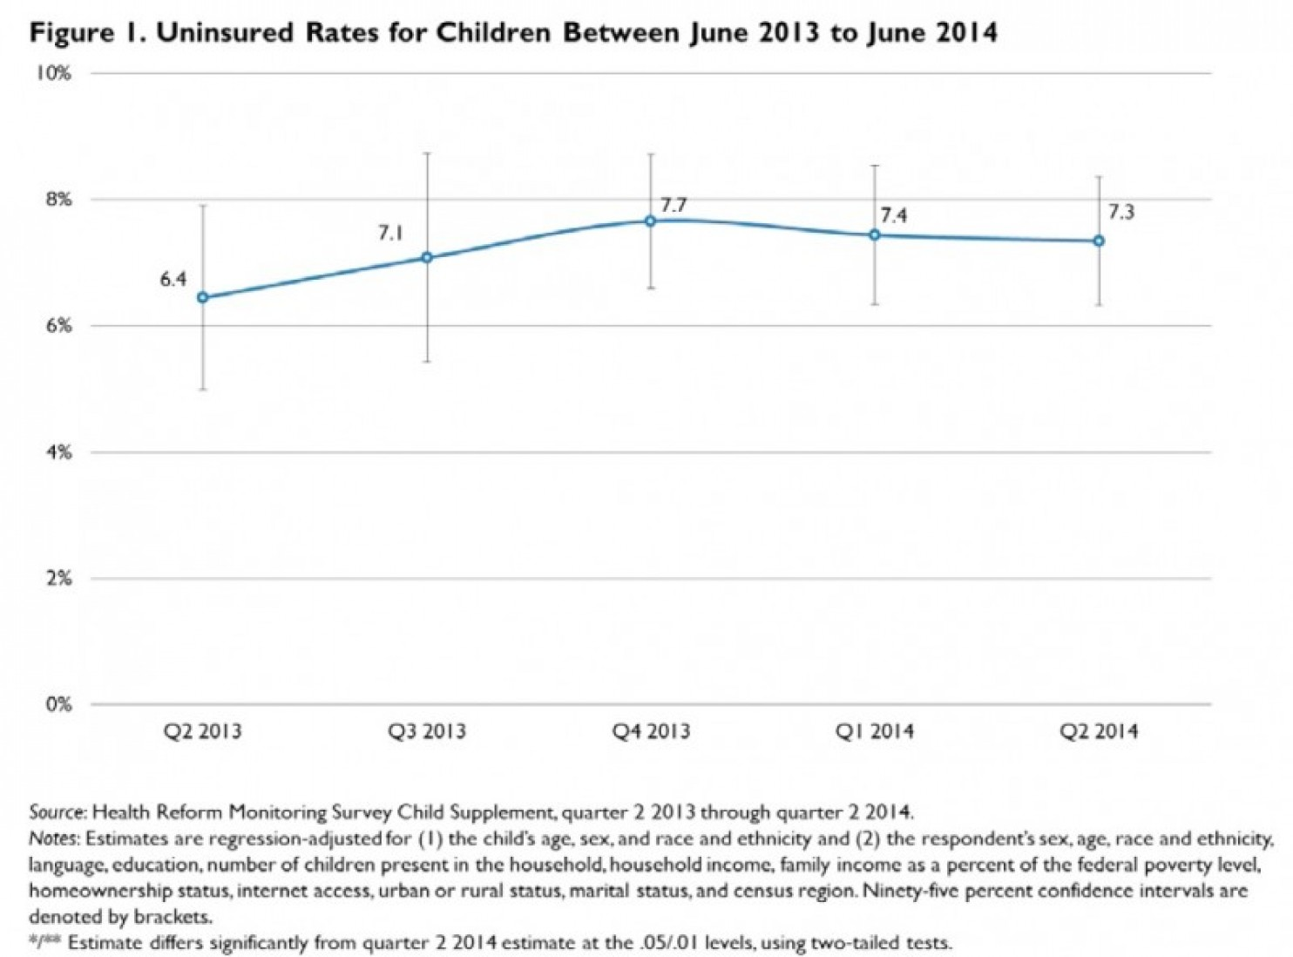

It's not that kids were overlooked by the ACA, but its main coverage features, like the Medicaid expansion, mostly benefit adults. And kids make up just 6 percent of enrollees on the new health insurance exchanges offering subsidized private coverage to low- and middle-income individuals and families.
But researchers at the Urban Institute and the Georgetown University Center for Children and Families see some factors that could lower the children's uninsured rate in the future. Medicaid enrollment is increasing even in states that haven't expanded coverage, which could bring more children into the program. The health-care law also moves some low-income kids off of CHIP eligibility, where insurance premiums could be prohibitive for some families, and into Medicaid. About 55 percent of still-uninsured kids, the researchers estimate, are eligible for public coverage through Medicaid or CHIP.
There are still some major looming policy decisions that could shift the uninsured rate either way. The report points out that some of the states with the highest rates of uninsured children, like Florida and Texas, haven't expanded Medicaid coverage to parents — and past research shows expanding public health insurance to parents makes it more likely their kids will get insured.
http://www.washingtonpost.com/blogs/wonkblog/wp/2014/09/09/obamacare-has-reduced-the-uninsured-rate-for-virtually-everyone-except-kids/

Marketplace Begins Sending Consumer Notices About the Renewal Reenrollment Process
From CMS
Assisters should encourage consumers that are currently enrolled in QHPs to come back to the Marketplace at the start of Open Enrollment on November 15, update their 2015 application, and compare their options to make sure they enroll in the plan that best meets their budget and health needs for next year. And, of course, assisters should encourage uninsured consumers to come to the Marketplace so they can enroll in coverage for which they are eligible, whether it is a QHP or Medicaid.
We know it’s important for you to be aware of the notices that consumers may get from the Marketplace so that you can help consumers understand them. CMS recently posted the Federally-facilitated Marketplace Model Open Enrollment and Redetermination notices – in English and in Spanish - which consumers will receive from the Marketplace. The model notices are available on the Marketplace.cms.gov website on the Technical Resources page under “Marketplace Open Enrollment and Annual Redetermination Notices.” To view the Marketplace notices, visit: http://marketplace.cms.gov/technical-assistance-resources/training-materials/training.html.
The Marketplace began sending Marketplace Open Enrollment and Annual Redetermination Notices last Friday to consumers via the mail or their Healthcare.gov accounts, depending on their communication preferences. These notices explain the renewal process and how consumers can return to the Marketplace between November 15, 2014 and February 15, 2015 to update their application, shop for the plan that best meets their budget and health needs, and determine if they are eligible for financial assistance for 2015 coverage that begins as early as January 1, 2015. If consumers do not return to the Marketplace to update their application by December 15, 2014, they may be auto-enrolled in the same plan—with the same amount of advance payments of the premium tax credit and same cost-sharing reductions—as they had in the 2014 plan year. However, the overall premium of the plan may increase somewhat, so the monthly amount paid by the consumer may increase even though they are eligible for the same amount of APTC. If after re-enrolling or being auto re-enrolled, consumers realize that they want a different plan, they can change plans during Open Enrollment through February 15, with coverage in their new plan starting on the first day of the next month or second following month depending on when they enroll. HealthCare.gov has been updated to reflect this information with a new page on “Keep or change your plan: 2015 Marketplace enrollment choices.” Assisters and consumers can find more information here: https://www.healthcare.gov/keep-or-change-plan.
As a reminder, on Thursday, October 2, we shared information about the renewal and re-enrollment process for 2015, including how assisters can help returning enrollees navigate the process for 2015 coverage and information on the notices that 2014 Marketplace consumers will receive from their issuers and from the Marketplace. The PowerPoint presentation used during this webinar is available on our Technical Assistance Resources page within the “Eligibility & enrollment resources” category; please use the following link to access it:
- Assisting Consumers with the Renewal and Reenrollment Process for 2015: http://marketplace.cms.gov/technical-assistance-resources/renewal-reenrollment-process.pdf

Latest on Data Matching Issues

From CMS
Over the last few weeks, we’ve shared several updates on assisting consumers resolve their data matching issues. We would like reemphasize that it is important to keep reaching back to consumers who have unresolved data matching issues and encourage them to submit documentation to resolve the issues. All of these individuals should still submit documents to resolve their data matching issues, including both consumers with income data matching issues whose financial assistance is set to end October 31, 2014, and consumers who had immigration and citizenship data matching issues and were unable to resolve the issues before their Marketplace coverage ended on September 30, 2014.

NEW: This past week, CMS sent a second wave of notices from the Marketplace to consumers who have outstanding immigration/citizenship data matching issues and for whom we did not receive any copies of requested documents by the deadline. The notice informs these consumers that their Marketplace coverage will end by October 31st. As part of the second wave of consumer terminations, these consumers’ data matching issues were generated later than those for consumers that were part of the first wave of consumer terminations. These consumers in the second wave had until September 30th to submit documentation.

As we have shared previously, the first wave of warning notices to consumers with immigration/citizenship data matching issues requested that consumers submit documents by Friday, September 5; if these consumers did not do so, they should have received an official Marketplace notice in mid-September letting them know that Marketplace coverage would end September 30th and the next steps available to them.

Last week’s newsletter included an update on how to help consumers who are working to resolve income and immigration and citizenship data matching issues in the Marketplace. Below is a summary of this information with two clarifications (see underlined text).

What consumers should do now:
- Consumers with income data matching issues whose financial assistance is set to end October 31, 2014 and consumers who had immigration and citizenship data matching issues and were not able to resolve them before their Marketplace coverage ended on Tuesday, September 30, 2014, should still submit documents to resolve their issues. Consumers can still submit documents by mail to resolve their data matching issue even if they are terminated from their current Marketplace coverage and/or advance premium tax credits (APTCs) and cost-sharing reductions (CSRs).
  - If consumers with outstanding income data matching issues did not send documentation by September 30, 2014 the Marketplace will re-determine their APTCs and CSRs. Thus, they may have to pay a higher monthly premium, deductible, copayments and/or coinsurance through the Marketplace.
  - While the Marketplace is working to review documents that consumers have submitted to resolve outstanding income data matching issues, consumers will continue to receive their current financial assistance until October 31, 2014.
- If consumers are able to resolve their immigration/citizenship data matching issue, they may be eligible to enroll in coverage through the Marketplace with a 60-day special enrollment period (SEP).
- Consumers who are eligible for a SEP will receive an official eligibility notice in the mail that says “the Health Insurance Marketplace Verified Your Information” or an email informing consumers that there is an update to their account that indicates that the consumer is eligible to reenroll for coverage in the Marketplace.
  - The consumer can call the Marketplace Call Center at 1-800-318-2596 (or TTY: 1-855-889-4325) and explain that the Marketplace sent him/her a notice that the data matching issue is resolved and that the consumer wants to re-enroll in a Marketplace health plan. The consumer will have 60 days to re-enroll from the day that he/she calls the Call Center.
  - Consumers enrolling in coverage through this SEP can either request a retroactive effective date of coverage that dates back to the 1st of the month following termination to prevent a gap in coverage, or they can receive a “prospective” effective date that is the 1st of the month following plan selection. If the consumer does not take either of these options, he/she will receive a normal effective date of either the 1st of the following month or the first of the second following month, depending on the date of plan selection.
  - For example, if a consumer’s previous coverage ended on September 30, the consumer can ask for new coverage to be effective back to October 1, so there is not a gap in coverage. Alternatively, the consumer can ask for a “prospective” effective date of November 1, even if he/she selects a plan between October 15 and October 21. If the consumer does not ask for this option, his/her coverage will start on a “normal” effective date of the 1st of the next month if he/she selects her plan between the 1st and 15th of the month, or the 1st of the second following month if the consumer selects her plan between the 16th and the end of the month. For example, if a consumer selects a plan on October 12, coverage would start on November 1; if the consumer selects a plan on October 22, coverage would start on December 1.
- Consumers who lost eligibility for Marketplace coverage due to an immigration/citizenship data matching issue may also be able to purchase a plan sold outside the Marketplace through an SEP because of a loss of minimum essential coverage; these consumers will be directed to contact the issuer directly to enroll.
- Remember, consumers can also call the Call Center at 1-800-318-2596 to see if they have a data matching issue. The Call Center can verify if a consumer has a data matching issue, if the Marketplace has received documents from the consumer, and whether the issue has been resolved.

Updated Healthcare.gov Content Addresses SHOP and Coverage Options for People with Disabilities

From CMS

Earlier this month, Healthcare.gov was updated with new content addressing the needs of small businesses and individuals with disabilities. Under the “Small Businesses” tab, a new “Overview of the SHOP Marketplace” provides information on applying for coverage through SHOP, available benefits, and how the program will change for the 2015 open enrollment period.

Under the “Individuals and Families” “Get Answers” tab, a new section on “Coverage Options for People with Disabilities” reviews programs available for individuals with disabilities and links to pages addressing rights and protections under the Affordable Care Act and benefits that health insurance plans must cover according to the law.

- To view the new “Overview of the SHOP Marketplace,” use this link: https://www.healthcare.gov/small-businesses/provide-shop-coverage/shop-marketplace-overview/
- To view additional new SHOP-related pages, use these links:
  - https://www.healthcare.gov/small-businesses/employees-shop/renew-shop-employee-coverage/
https://www.cuidadodesalud.gov/es/small-businesses/employees-shop/renew-shop-employee-coverage/
  - https://www.healthcare.gov/small-businesses/provide-shop-coverage/renew-shop-employer-coverage/
https://www.cuidadodesalud.gov/es/small-businesses/provide-shop-coverage/renew-shop-employer-coverage/
  - https://www.healthcare.gov/small-businesses/other-aca-information-for-business/
- To view the new section on “Coverage Options for People with Disabilities,” use this link: https://www.healthcare.gov/people-with-disabilities

Upcoming Webinars and Trainings

Open Enrollment for Consumers New to the Marketplace (CMS)
- Wednesday, October 29, 2-3PM ET (11AM-12PM AZ time)
- Register- https://goto.webcasts.com/starthere.jsp?ei=1039683
- This webinar will focus on consumers new to the Marketplace in 2015. It will provide an overview of the Marketplace and information on when and how individuals and families new to the Marketplace can apply and enroll in coverage during the Open Enrollment Period. It will include a walkthrough of the online Marketplace application as if one was a consumer new to the Marketplace in 2015.

CMS Marketplace Webinar Schedule
http://marketplace.cms.gov/technical-assistance-resources/training-materials/2014-marketplace-webinars.pdf
- Wednesday, October 29, 2-3PM ET (11AM-12PM AZ time), Marketplace Open Enrollment- https://goto.webcasts.com/starthere.jsp?ei=1039683
- Wednesday, November 5, 2-3PM ET (11AM-12PM AZ time), Marketplace for Immigrant Families- https://goto.webcasts.com/starthere.jsp?ei=1039686

ACA 101 Webinars for Small Employers (http://www.sba.gov/healthcare)
For those of you reaching out to small business owners/employers, you might want to provide this information to them (note that listed times are for the Eastern time zone). Also, if you, as an assister, need a refresher on SHOP, attending a session would be beneficial.
English
SBA, the Department of Health Human and Services, and Small Business Majority have teamed up for a free weekly webinar series where small employers can learn the basics of the Affordable Care Act and what it means for their organization and employees. Topics covered include cost containment, the Small Business Health Care Tax Credit, the new Health Insurance Marketplace, and Employer Shared Responsibility. Webinar content will generally be the same each week. Below are the registration links for upcoming webinars. For more information on how the new health care law affects small businesses, check out www.business.usa.gov/healthcare.
· October 30 at 2:00 PM ET: Click to Register

Spanish
Starting July 8th, Spanish-speaking small employers throughout the country can join representatives from SBA, HHS, and Small Business Majority for ACA 101 webinars in Spanish. Below are the registration links for the upcoming Spanish-language webinars, which will be held every other Tuesday at 4 pm ET/1 pm PT throughout the summer and fall.
- November 4, 2014 at 4 pm ET: Click to Register
- November 18, 2014 at 4 pm ET: Click to Register
- December 2, 2014 at 4 pm ET: Click to Register
- December 16, 2014 at 4 pm ET: Click to Register

Best Practices in Screening and Assessment of Refugee Youth (NCTSN)
- Thursday, October 30, 1:30-3PM EST (10:30AM-12PM AZ time)
- http://learn.nctsn.org/mod/page/view.php?id=8072
- This one hour webinar will address screening and assessment issues and best practices when working with refugee youth. The trainers will cover the following topics: 1) Challenges and issues when conducting mental health assessments with refugee children and adolescents 2) Evidence-based screening and assessment tools for refugee youth and best practices in assessment administration 3) Best practices in the use of screening and assessment instruments for treatment planning and program evaluation.

Plan Design and Plan Selection (CBBP)
- Thursday, October 30, 2-3:30PM EDT (11AM-12:30PM AZ time)
- Register- https://www4.gotomeeting.com/register/970737767
- This webinar will cover health plan design, including cost-sharing charges in Marketplace plans, eligibility for cost-sharing reductions, and how cost-sharing reductions affect costs for consumers. We will also discuss how to evaluate Marketplace plans based on cost-sharing and plan design and will walk through the plan selection process.

Reaching and Enrolling Families in Rural Communities (Connecting Kids to Coverage)
- Thursday, October 30, 3-4:30PM EDT (12-1:30PM AZ time)
- Register- https://www4.gotomeeting.com/register/715582671
- Reaching rural communities presents unique challenges but there are effective strategies being used in rural areas to successfully find and enroll eligible families in Medicaid. Learn more about tips, techniques and Campaign resources that you can use in your efforts.

Health-e-Arizona Plus NEW USER Training (HEAplus)
- Tuesday, November 4, 9AM-12PM
- Register- https://www4.gotomeeting.com/register/308551231
- All persons who will be using their organization accounts to help customers apply, renew benefits or report changes are required to complete this training if they did not attend this training in 2014 or HEAplus training in 2013. These training sessions are designed for NEW HEAplus users, including: New users from existing HEAplus Community Partner organizations and Staff from new HEAplus Community Partner organizations.

Access to Coverage: How to Work with the LGBTQ Community (Out2Enroll/AACHC)
- Save the date! Tuesday, November 4, 9:30-11:30AM
- Arizona Alliance for Community Health Centers, 700 East Jefferson St, Suite 100, Phoenix 85034 (Conference room)
  - NE corner of 7th St and Jefferson. Parking available—UNCOVERED parking spots only.
- Register- TBA (in-person & webinar-available)
- Training/webinar will cover cultural competency and specific health issues related to the lesbian, gay, bisexual, and transgender population. Out2Enroll’s curriculum is highly recommended by HHS for all Navigators/CACs/assisters.

The Latest and Greatest in Health Care Reform Developments (Benefit Express Services, LLC)
- Tuesday, November 4, 1-2PM CST (12-1PM AZ time)
- Register- https://www1.gotomeeting.com/register/392315064
- This webinar will keep you up to date on all things Health Care Reform related.
  - Webinars by Benefit Express Services are targeted towards HR and benefits professionals for any-sized businesses, but they might be helpful with regards to SHOP.

Reaching LGBTQ Communities and Engaging them in Health Care (Fenway Institute)
- Wednesday, November 12, 12-1PM AZ time
- Register- https://fenwaylgbthealtheducation.webex.com/mw0401l/mywebex/default.do?siteurl=fenwaylgbthealtheducation
- With the Affordable Care Act expanding coverage to thousands of Americans, health centers are working to reach and understand the needs of population groups who are not fully engaged in the health care system, including LGBTQ populations. Benjamin Perkins, MDiv, Associate Director for Community Engagement at The Fenway Institute, Fenway Health, will explain best practices in community engagement that will help you learn more about the needs of LGBTQ people in your community, including developing community advisory groups, running focus groups, and producing materials to “get the word out” about community events. In addition, the webinar will address how to structure building these partnerships to create lasting relationships within the community.

________________

Have something you want us to possibly add to next week’s newsletter? Email Kim VanPelt at kim.vanpelt@slhi.org. As always, special thanks to Meryl Deles for much of the content.

