Covered Clips
A Weekly Summary of News and Activities for the Cover Arizona Coalition
Week of May 5th

Arizona Leads Nation of Children Signed Up for ‘Obamacare’

From Cronkite News
Arizona leads the nation in the percentage of children who enrolled in health care through the federal marketplace, according to the latest numbers from the Department of Health and Human Services.
But the state trailed the national average in every other age category after the opening round of enrollment in Obamacare – including the desirable 18- to 34-year-olds, where Arizona was second-worst in the nation, beating only West Virginia.
While experts said the number of under-18-year-olds “bodes well” for the insurance program in Arizona, the lack of young adults could be problematic, as that relatively healthy age group is needed to make coverage affordable.
“Young people tend to be a little bit healthier than older people,” said Sara R. Collins, vice president of health care coverage and access for the Commonwealth Fund.
“They carry a lower risk of having high medical expenditures” that drive up costs to insurers and, in turn, to consumers, she said.
The HHS numbers released Thursday showed that about 21 percent of the 120,000 people in Arizona who enrolled in the Affordable Care Act through healthcare.gov in the first six-month enrollment period were under age 18. Nationally, just 6 percent of the more than 8 million people who enrolled in that time were children.
John Hsu, an associate professor of health-care policy at Harvard Medical School, noted that children cannot sign up for policies themselves, which could mean that more families in Arizona got insurance. He thinks that “bodes well for the program.”
“I think that’s a promising sign for the acceptability and sustainability of the exchanges, in general,” Hsu said of the family involvement.
Families have “a slightly different set of reasons for signing up early” than people with illnesses who may have rushed to get coverage when it became available, he said.
“If you have children, and you’re a parent – and I’m a parent – then one is likely to be concerned about making sure that they have access to health care” when they need it, Hsu said.
Not only are children generally healthier, he said, families could be more oriented to cost-saving preventive care that “has slightly different implications for future spending and premiums.”
But while a large share of children is good news for the federal marketplace in Arizona, the state’s relatively low number of “young invincibles” may spell trouble in the long run. Nationally, the 18-34 age group made up 28 percent of all enrollees; the share was 21 percent in Arizona and 19 percent in West Virginia.
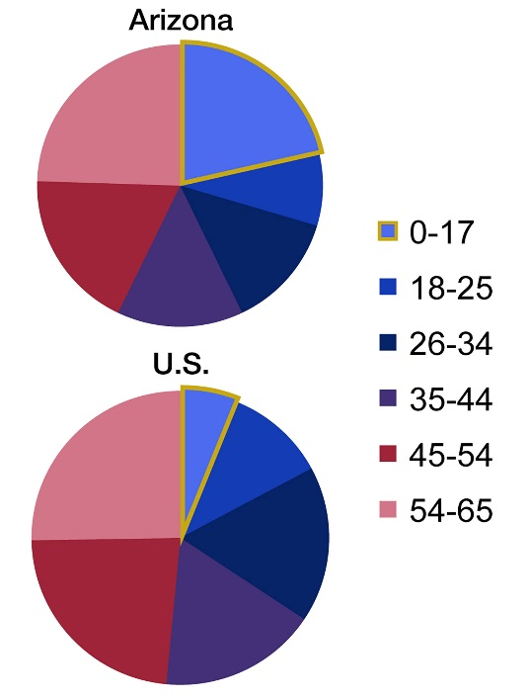
A Kaiser Family Foundation report in December outlined the potential impact of low enrollment by young adults: If they accounted for only 25 percent of enrollees, “overall costs in individual market plans would be about 2.4 percent higher than premium revenues.”
That difference would decrease insurers’ profits, which they might try to recoup through higher premiums, the report said. If increases were too high, it could trigger a “death spiral,” driving consumers away, which would raise costs, a process that would keep repeating itself.
“However, a 1 to 2 percent premium increase would be well below the level that would trigger a ‘death spiral,’ which would occur if insurers needed to increase premiums substantially,” the report said.
While the young adult numbers are lagging in Arizona, experts said the high number of children could help offset that.
Audrey L. Halvorson, chairwoman for the health care costs work group for the American Academy of Actuaries, said a larger risk pool is almost always a good thing for insurance premiums because it creates stability.
“I like to think of it as a swimming pool,” Halvorson said in an email. “A small child-size wading pool is affected more from a large boulder being dropped into it than an Olympic-sized pool with the same boulder.”
One critic of Obamacare said it’s too early to draw conclusions about the success or failure of the program based on enrollments.
“What I think the people who are pro-Obamacare would like to show is that there’s not going to be a death spiral, which is where predominantly older and sicker people sign up but young people don’t,” said Tom Jenney, the Arizona director of Americans for Prosperity. “That’s what they would hope.”
http://cronkitenewsonline.com/2014/05/arizona-leads-nation-in-children-who-signed-up-for-obamacare/

Insurers Say Most Who Signed Up under Health Law Have Paid Up

From the New York Times
Most of the people choosing health plans under the Affordable Care Act — about 80 percent — are paying their initial premiums as required for coverage to take effect, several large insurers said Tuesday on the eve of a House hearing about the law.
But the health insurance industry said the total of eight million people who signed up included “many duplicate enrollments” for consumers who tried to enroll more than once because of problems on the website.
“Insurers have many duplicate enrollments in their system for which they never received any payment,” said Mark Pratt, a senior vice president of America’s Health Insurance Plans, an industry trade group.
“It may be a matter of months,” Mr. Pratt added, “before insurers know how many people activated their coverage by paying their share of premiums.”
President Obama said last month that eight million people had signed up for health insurance under the Affordable Care Act, surpassing the administration’s original goal of seven million in the federal and state insurance exchanges.
In testimony prepared for a hearing of a panel of the House Energy and Commerce Committee on Wednesday, Mr. Pratt said, “Health insurers have been doing everything possible to encourage exchange enrollees to pay their premiums.”
Paul Wingle, the executive director of exchange operations and strategy at Aetna, said: “As of the third week of April, Aetna had over 600,000 members who had enrolled and roughly 500,000 members who had paid. For those who had reached their payment due date, the payment rate, though dynamic, has been in the low- to mid-80 percent range.”
Aetna said it was selling insurance to individuals and families in the exchanges of 17 states.
The Obama administration extended deadlines for people to sign up and pay for insurance, making it difficult to establish an accurate count of enrollment, insurers said. The federal government is still working on a financial management system to reconcile enrollment records of insurers and the exchanges.
J. Darren Rodgers, the chief marketing officer of the Health Care Service Corporation, which offers Blue Cross and Blue Shield plans in Illinois, Montana, New Mexico, Oklahoma and Texas, said his company had received 600,000 applications through the exchanges in Texas and the four states it serves. On average, according to data provided by Mr. Rodgers, about 15 percent of customers missed their initial payment deadlines from January through April.
About two-thirds of subscribers with exchange policies scheduled to take effect on May 1 have paid their premiums, Mr. Rodgers said, but some of the others have more time to pay.
Dennis Matheis, the executive in charge of exchange strategy for WellPoint, said the company was satisfied with returns on its business in the 14 states where it was selling health plans on the exchanges.
“We are seeing strong membership growth and large percentages of our newly enrolled customers are successfully paying their premiums by the due date,” Mr. Matheis said.
For people who signed up from Oct. 1 to April 15, Mr. Matheis said, about 70 percent have paid their premiums. For people who have passed the payment deadline, he said, the proportion is higher, “ranging up to 90 percent, depending on the state.”
Republicans on the committee said last week that only about two-thirds of people signing up for private health insurance in the federal exchange had paid their premiums as of April 15. Administration officials and congressional Democrats called that statistic grossly misleading. Given the surge in enrollment near the end of March, they said, it is understandable that some policyholders would not have paid by April 15.
Frank E. Coyne a vice president of the Blue Cross and Blue Shield Association, said 283,800 people had signed up for coverage offered by “multistate plans” sold by Blue Cross and Blue Shield under contract with the federal government.
Congress authorized the multistate insurance program to increase options for consumers shopping in the online insurance markets. The plans are available in the marketplaces, or exchanges, of 30 states.
http://www.nytimes.com/2014/05/07/us/politics/insurers-say-most-who-signed-up-under-health-law-have-paid-up.html?_r=0

The Biggest Reason People Didn’t Sign Up for Obamacare
From the Huffington Post
The top reason uninsured people didn't enroll in coverage under Obamacare this year is they still don't feel like they can afford health insurance, according to a new survey.
The findings in a report published by the Henry J. Kaiser Family Foundation Tuesday highlight the affordability gap facing some U.S. households, especially those with incomes near or above the income cutoff for tax credits that reduce premiums, or those who simply don't believe health insurance is a good value.
Thirty-six percent of people without health coverage reported they looked for health insurance during the enrollment period that nominally ended March 31, but found the available plans too expensive, according to the Kaiser Family Foundation survey. Just 7 percent said they preferred to pay a tax penalty under the law's individual mandate, rather than purchase an insurance policy. Others said they believed the mandate doesn't apply to them, didn't know about the mandate, or tried and failed to enroll.
Health insurance remains a costly product and the Affordable Care Act targets its financial assistance to low-income families. Tax credits to defray the cost of coverage aren't available to households that earn more than 400 percent of the federal poverty level, which is $45,960 for a single person. The law also provides subsidies to reduce out-of-pocket costs for those who earn up to 250 percent of poverty, or $28,725 for an individual.
The tax credits provided under the Affordable Care Act are pegged to the price of the second-cheapest "silver" level plan in a person's geographical area, and to household income. The subsidy gets smaller as income increases, so people who earn near 400 percent of poverty receive relatively little help paying for their coverage, and those who make just a little more pay full price.
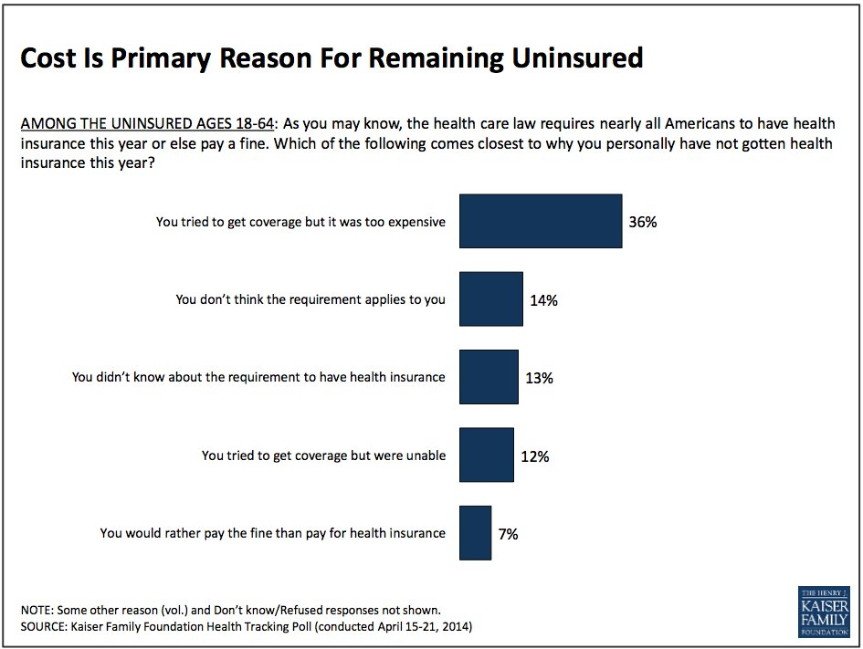
The average national price for one of these benchmark silver plans is $808 a month for a household of two 40-year-olds with two minor children that earns over 400 percent of poverty, which is $94,200 for a family of four, according to a calculator on the Kaiser Family Foundation website. The same family making exactly 400 percent of poverty would be eligible for a tax credit worth $63 a month.
The vast majority of those enrolling in private insurance under Obamacare are getting help paying for their coverage. As of March 1, 83 percent of enrollees received tax credits for premiums, according to the Department of Health and Human Services.
The Kaiser Family Foundation report includes quotations from some of those surveyed that illustrate the point of view that health insurance is too costly. "What's out there now is just unaffordable," one respondent said. "Because I think food on the table is more important," wrote another. Coloring those views may be a general lack of awareness about the availability of the tax credits, previous surveys have shown.
Although not addressed in the Kaiser Family Foundation poll, the largest affordability gap in health coverage is found in 24 states that didn't adopt the Affordable Care Act's expansion of Medicaid to more poor people after the Supreme Court made it optional for states. Those earning up to 133 percent of poverty, or $15,282 for a single person, were supposed to have access to Medicaid, while tax credits are reserved for those who earn at least poverty wages, which amounts to $11,490 for an individual. That means the poorest residents of those 24 states aren't eligible for any help, so millions are expected to remain uninsured.
The Kaiser Foundation Family poll also shows a majority of Americans continue to disapprove of the Affordable Care Act, with 46 percent having an unfavorable view, compared with 38 percent holding a favorable opinion. These attitudes are closely tied to partisan affiliation, with Republicans being much more likely to disapprove and Democrats more likely to approve. A majority, however, wants Congress to improve the law, compared with more than one-third who would prefer it to be repealed and replaced with an alternative.
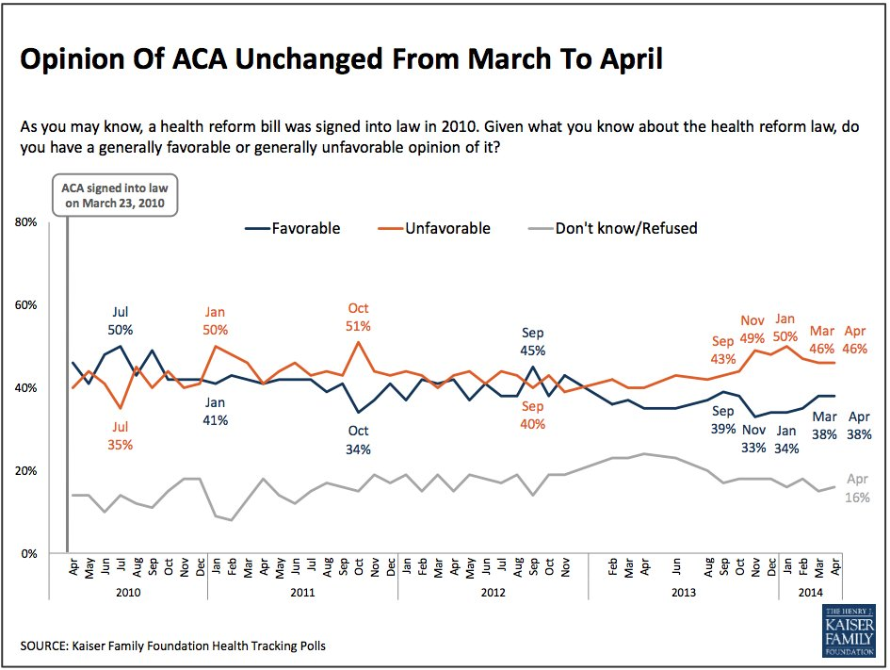
Despite President Barack Obama trumpeting the news this month that private insurance enrollments via the Obamacare exchanges have exceeded 8 million -- or 1 million more than the highest projection from the Congressional Budget Office -- the public doesn't see it that way. Even though more than 40 percent were aware that signups had topped 8 million, nearly six out of 10 said enrollment came in below the federal government's expectation.
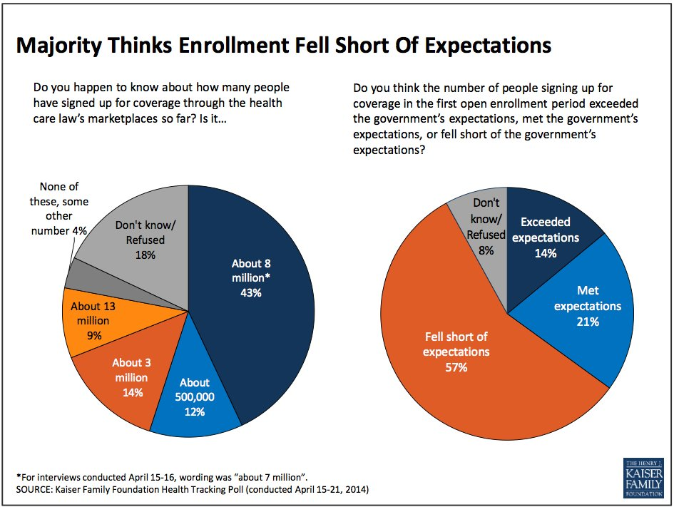

New Special Enrollment Periods Announced

This past Friday, three new special enrollment periods (SEPs) were announced for people to enroll in a Marketplace plan, along with a new hardship exemption from the shared responsibility payment:
- Special Enrollment Periods for Individuals Eligible for or Enrolled in COBRA
- Special Enrollment Periods for Individuals Whose Individual Market Plans are Renewing Outside of Open Enrollment
- Special Enrollment Periods and Hardship Exemption for AmeriCorps/VISTA/National Civilian Community Corps Members
- Hardship Exemption for Persons who Obtained Coverage that was Effective as of May 1, 2014

You can read the full announcement, with details, here: http://www.cms.gov/CCIIO/Resources/Regulations-and-Guidance/Downloads/SEP-and-hardship-FAQ-5-1-2014.pdf.
The most time-sensitive one is the SEP for people with COBRA, as the SEP ends July 1st. Generally, people with COBRA can only enroll in a Marketplace plan either during an annual enrollment period or after they’ve exhausted their COBRA benefit. With this SEP, through July 1st, 2014, people currently enrolled in COBRA can drop their COBRA coverage and elect a Marketplace plan, if they choose.

Deadlines for Special Enrollment Periods and Exemptions

From CMS
While the opportunity to enroll in health insurance through the marketplace has ended for consumers who were "in line" before March 31st or who submitted a paper application, consumers who experienced difficulty completing the application process can still enroll if they qualify for a "complex case" special enrollment period.
Survivors of domestic violence who qualify for a special enrollment period because they were incorrectly determined ineligible for financial assistance must select a health plan by May 30. Due to system limitations, consumers in this circumstance must indicate on the marketplace application that they are not married.
Consumers who qualify for "complex case" special enrollment periods for other reasons, will have 60 days to select a plan from the date they are granted a special enrollment period, which could be one of the following dates:
- The date that the consumer receives a letter informing them that they are eligible for a special enrollment period. This may happen:
  - If the marketplace finds that a consumer is eligible for an SEP resulting from an appeal
  - If the marketplace finds that the health plan a consumer selected did not receive the consumer's application
  - If a health plan finds that there were errors in the information provided about the health plan on the marketplace website
- The date that the consumer contacts the call center and is found eligible for a special enrollment period. This will be the date that applies to most consumers who qualify for a special enrollment period because most consumers will need to contact the call center in order to be determined eligible for a special enrollment period.
- The date that a caseworker finds an individual eligible for a special enrollment period. This date will apply to consumers whose applications have been referred to casework.
Consumers can continue to get exemptions from the penalty for not having health insurance: by completing an application for health insurance through the marketplace (if they cannot enroll because their state has not expanded Medicaid), or by submitting an exemption application. Consumers who get an exemption because their state has not expanded Medicaid will be able to get a special enrollment period to enroll in a health plan through the marketplace later in the year, if their income increases such that they lose eligibility for the exemption.

“We’ve reset your Healthcare.gov password” Email

From CMS

The following is an email that consumers may have received around the end of April. Depending on the email service provider, the email may not appear in their inbox. For example, in Gmail, this email appeared under the “Promotions” tab for me (Meryl).
-----
Recently, you may have heard about a new internet security weakness, known as Heartbleed, which is impacting some websites. HealthCare.gov uses many layers of protections to secure your information and we’ve recently enhanced our systems to add additional protections. While there’s no indication that the Heartbleed vulnerability has been used against HealthCare.gov or that any personal information has ever been at risk, we have reset consumers’ passwords out of abundance of caution.

This means the next time you visit the website, you’ll need to create a new password. We strongly recommend you create a unique password – not one that you’ve already used on other websites.

How to reset your password
- Use the online Forgot Password feature
- Enter your username and click “Send email”
- Wait for the “Forgot Marketplace Password” email we’ll send you to create a new password for your account

Here are some password tips and information about managing your HealthCare.gov account. For additional information about the Heartbleed vulnerability, please visit HealthCare.gov/heartbleed.

Tips for Applications where Household Contacts are Tax Dependents

From CMS
As we mentioned in last week’s newsletter, currently there is an application issue when the person listed as the household contact on an application is also claimed as a tax dependent. When this happens, those individuals listed on the application are unable to select a QHP on HealthCare.gov. Specifically, when the consumers get to Plan Compare and select the APTC amount, they will see a red box error with the message “Unable to access HUB Error ID: 500.100,” and they will be unable to proceed to select a plan. Again, if a person listed as the household contact on an application is also claimed as a tax dependent the applicants will be unable to pick a plan. An example is: A daughter lists herself as the household contact applying for herself and her mother. The daughter also indicates that her mother claims her as a dependent. In this scenario, they will not be able to select a plan.
We are currently working to address this issue. In the interim, we recommend removing the application and starting over to make sure that the family member that is the filer claiming others is ALSO listed as the household contact on the “Get Started” page.

Navigators and Assisters in the SHOP Marketplace

From CMS
Although Open Enrollment is closed in the Individual Marketplace, Navigators and assisters can be helpful by making sure that small employers know that they can purchase employee coverage year-round through the Small Business Health Options Program (SHOP) Marketplace. Employers may also qualify for a tax credit when purchasing coverage through SHOP.
Employers will use the “direct enrollment” process for the Federally-facilitated SHOP Marketplace (FF-SHOP) in 2014, and Navigators and assisters can help small employers find information about available SHOP plans in their area on HealthCare.gov. Navigators and assisters can also help small employers find, fill out, and download the SHOP eligibility application, to obtain a determination of their eligibility for a Small Business Health Care tax credit. This is not required before employees can enroll in a SHOP Qualified Health Plan, however.
SHOP will not offer an online application or enrollment in health insurance plans in 2014. CMS expects to offer these functions on HealthCare.gov starting in November 2014, for coverage taking effect in 2015. Instead, employers will need to enroll directly through an agent, broker or insurance company that offers a Qualified Health Plan. This process, called “direct enrollment,” is similar to the way many small employers have gotten coverage in the past.
The SHOP “direct enrollment” process was created to make sure that employers could get insurance for their employees and take full advantage of the Small Business Health Care Tax Credit as soon as possible, while CMS continues to work on improving the user experience on HealthCare.gov. The tax credit is available to employers with fewer than 25 employees with average wages of less than $50,000 a year. For tax years beginning with 2014, this credit is only available when you buy coverage through the SHOP Marketplace.
This week, HealthCare.gov posted two new tools to help small businesses learn if they are eligible to use the Small Business Health Options Program (SHOP) and if they might qualify for a tax credit when they enroll in a plan through the Federally-facilitated SHOP Marketplace. As a best practice, Navigators and assisters working with employers may help by walking them through the tools, and pre-screening them for SHOP and Small Business Health Care Tax Credit eligibility, before employers complete their SHOP applications.
The Full-time equivalent (FTE) employee calculator will help small businesses determine whether or not they meet the size requirements to participate in the SHOP Marketplace. For 2014, the Federally-facilitated SHOP Marketplace is open to employers with 50 or fewer full-time equivalent employees (FTEs). If employers have fewer than 25 employees, they may also qualify for the Small Business Health Care Tax Credit. Generally, the tax credit is available to tax-exempt and non-exempt employers who purchase coverage through the SHOP Marketplace. To access the credit, employers must pay at least 50% of their full-time employee premium costs their average employee wages must be about $50,000 per year or less to qualify for the tax credit.
The SHOP tax credit estimator on HealthCare.gov provides details about what information employers should have handy in order to use the SHOP tax credit estimator, such as a list of full-time and part-time employees. Information taken from the Premium Estimator Tool on HealthCare.gov can also assist employers when inputting their estimated premium costs into the tool. The eligibility results are just an estimate, and employers must be sure to file for the credit at the end of the tax year to receive the tax credit. Generally, the SHOP Tax Credit Estimator helps employers see how much the tax credit could be worth when purchasing coverage through the SHOP Marketplace.
For more information on the Small Business Health Care Tax Credit, please visit the IRS website at Small Business Health Care Tax Credit Questions and Answers: Determining FTEs and Average Annual Wages.
In 2014, employers using “direct enrollment” to get SHOP coverage for their employees, and who want to qualify for the tax credit must do two things:
- Confirm with an agent, broker or insurance company that their employees are enrolling in a SHOP Qualified Health Plan.
- Apply for and receive a notice of SHOP eligibility from the SHOP Marketplace, at any time before filing their business tax returns for the 2014 tax year.
There is no list of federally certified agents and brokers for SHOP currently available. However, CMS has modified Find Local Help on HealthCare.gov to include local agent and broker organizations, searchable by zip code. As a best practice, Navigators can connect with agent and broker associations in their communities, and their State Departments of Insurance, to find the local agents and brokers in their area to connect employers.
To apply for SHOP eligibility, employers have a variety of resources – including agents and brokers – that can help them get, complete and mail a paper application. The paper application can be filled out and downloaded from HealthCare.gov, which also has instructions and the mailing address. The employer can just choose their state to get started. Employers can get help completing their application over the phone from the SHOP Small Employer Call Center at 1-800-706-7893 (TTY: 1-800-706-7915), which is open Monday - Friday, 9 a.m. - 7 p.m. EDT. Employers do not need to wait to receive notice of their SHOP eligibility before enrolling in a SHOP qualified health plan.
There are presenter slides and corresponding speaker notes on SHOP that will be updated shortly to spotlight the new SHOP tools on the Marketplace.CMS.gov website. We will make sure to share the link with assisters when this resource is posted. This presentation is a lengthier version of the one we presented last Friday during our assister webinar/conference call. More resources follow.
- New Blog on SHOP Tools—How Much is Your Small Business Health Care Tax Credit Worth: How much is your Small Business Health Care Tax Credit worth?
- FAQs on Direct Enrollment Process for the Federally-Facilitated SHOP Marketplace all Assisters should read: FAQs on SHOP Enrollment Process
- Blog on the Enrollment Process for SHOP: A Direct New Path to SHOP Marketplace Coverage
- Bi-fold brochure (general resource): About the SHOP Marketplace

FAQ’s
Q: How many plans may an employer offer employees in FF-SHOPs?
A: For this year, employers in FF-SHOPs will select a single health plan and a single dental plan, if they choose to offer a dental plan to employees. In 2015, employers may be able to offer employees multiple health and dental plans from more than one insurance company.
Q: Who may assist employers with SHOP enrollment?
A: Agents and brokers may assist an employer with SHOP enrollment. Navigators and certified application counselors (CACs) may also assist employers, but CACs are not required to assist employers in the SHOP Marketplace.
Q: How are navigators and CACs able to best assist employers?
A: Navigators and CACs can walk an employer through the pre-screening full-time equivalency eligibility tool, the premium estimator tool, and the SHOP tax credit estimator tool. Employers will complete the enrollment process working with an agent/broker or directly with the issuer in 2014.
Q: If an employer offers SHOP coverage to his or her employees, are employees required to accept coverage or can employees enroll in an individual market plan instead?
A: Employees can choose to accept or reject coverage. For example, employees may waive coverage if they already have coverage through a spouse. Employees may also choose to go to the individual Marketplace. However, if the employer-sponsored coverage offered meets the affordability requirement, employees would not be eligible for advance premium tax credits (APTC) or cost-sharing reductions (CSR) in the individual Marketplace.
Q: What is the definition of a common law employee? Who is eligible for SHOP and how are employees counted for purpose of determining SHOP eligibility?
A: A common law employee is an employee on an employer’s payroll, not including a business owner or sole proprietor or their spouses if they’re on payroll; therefore, a sole proprietor and his or her spouse without any common law employees on payroll are not eligible for SHOP. Sole proprietors without any common law employees should apply for coverage in the individual Marketplace. For the purpose of SHOP eligibility, employers must have 50 or fewer full-time equivalent employees who work an average of 30 or more hours a week. The number of hours worked by part-time employees may equal the equivalent of a full-time employee. For example, two employees who work 15 hours per week equal one full-time equivalent employee working 30 hours per week.
For the purpose of determining eligibility for the tax credit, the full-time equivalent calculation is based on an average of 40 or more hours worked per week.
Q: What is the Pre-existing Condition Insurance Plan (PCIP) and when does it end?
A: PCIP is a transitional bridge program for individuals with pre-existing conditions who might have otherwise been shut out of coverage. PCIP ends on April 30, 2014, so the remaining PCIP enrollees are eligible for a 60-day special enrollment period (SEP) to enroll in new coverage. The SEP automatically begins May 1, 2014, but PCIP consumers may complete an application and select a plan before May 1, 2014 in order to avoid a gap in coverage. The SEP ends on June 30, 2014. Additionally, all PCIP enrollees that enroll in a Marketplace plan by June 30 will have a QHP coverage effective date of May 1.

IRS Premium Tax Credit Videos
IRS premium tax credit YouTube videos are now available on the IRS YouTube Channels: IRSvideos, IRSvideosmultilingua and IRSvideosASL. The three IRS videos listed below, about the Premium Tax Credit, were posted on the IRS YouTube channels last week. As you can see, the video tips are available in English, Spanish and ASL. In addition, the Small Business Health Care Tax Credit video (in English) was posted several weeks ago.

Premium Tax Credit - IRS English YouTube Video
http://www.youtube.com/watch?v=T3myAaV2yvI

Premium Tax Credit - IRS Spanish YouTube Video
http://www.youtube.com/watch?v=8TV-aXcBCLc

Premium Tax Credit - IRS ASL (American Sign Language) YouTube Video
http://www.youtube.com/watch?v=SOCEvuD9LRk

Small Business Health Care Tax Credit
https://www.youtube.com/watch?v=1LrHZ4aftD4

________________

Have something you want us to possibly add to next week’s newsletter? Email Kim VanPelt at kim.vanpelt@slhi.org. As always, special thanks to Meryl Deles for much of the content.

