Covered Clips
A Weekly Summary of News and Activities for the Cover Arizona Coalition
Week of March 31st

Federal Marketplace Enrollment Exceeds 7.1 Million
The White House announced Tuesday that more than 7.1 million Americans had selected a health plan on the Marketplace – surpassing original CBO estimates of 7 million who would be enrolled.

Enrollment Grace Period Ends April 15th
You must finish your enrollment by April 15 to get coverage for 2014. If you enroll by April 15, your coverage will begin May 1.

If you enroll this way and your coverage begins May 1, you won’t need to pay the individual shared responsibility payment for the months of 2014 that you didn’t have health coverage.

See https://www.healthcare.gov/what-if-i-tried-to-enroll-by-march-31-but-didnt-finish-in-time/

Financial Assistance Received by Arizonans Enrolled In the Marketplace
 | Total Number of People Who Have Selected a Marketplace Plan as of March 1, 2014  (Thousands of People) | Percentage of Enrollees Who Have Qualified for Assistance | Number of Subsidized Enrollees (Thousands of People) | Subsidized Enrollees as a Percentage of Subsidy-Eligible Individuals | Average Subsidy Per Enrollee | Total Premium Subsidies (Millions of Dollars)
Nationwide | 4,283 | 83% | 3,472 | 21% | $2,890 | $10,019
Arizona | 58 | 74% | 43 | 14% | $1,940 | $83

Source: The Henry J. Kaiser Family Foundation
http://kff.org/report-section/how-much-financial-assistance-table-8569/

5.4 Million Americans Gained Health Insurance since September
New data released this week show the percentage of uninsured non-elderly adults fell from 17.9 percent in September 2013 to 15.2 percent at the beginning of March—meaning approximately 5.4 million non-elderly adults gained insurance during that period.
Conducted by the Urban Institute and funded in part by RWJF, the Health Reform Monitoring Survey findings are the first estimates of how many non-elderly adults gained coverage since enrollment in the Affordable Care Act marketplaces began. The data show that declines in uninsured populations are considerably greater in states that expanded Medicaid. From September to early March, states that expanded Medicaid saw an average decline in uninsured non-elderly adults of 4.0 percentage points. States that did not expand Medicaid saw a drop in uninsured adults of 1.5 percentage points over the same period.
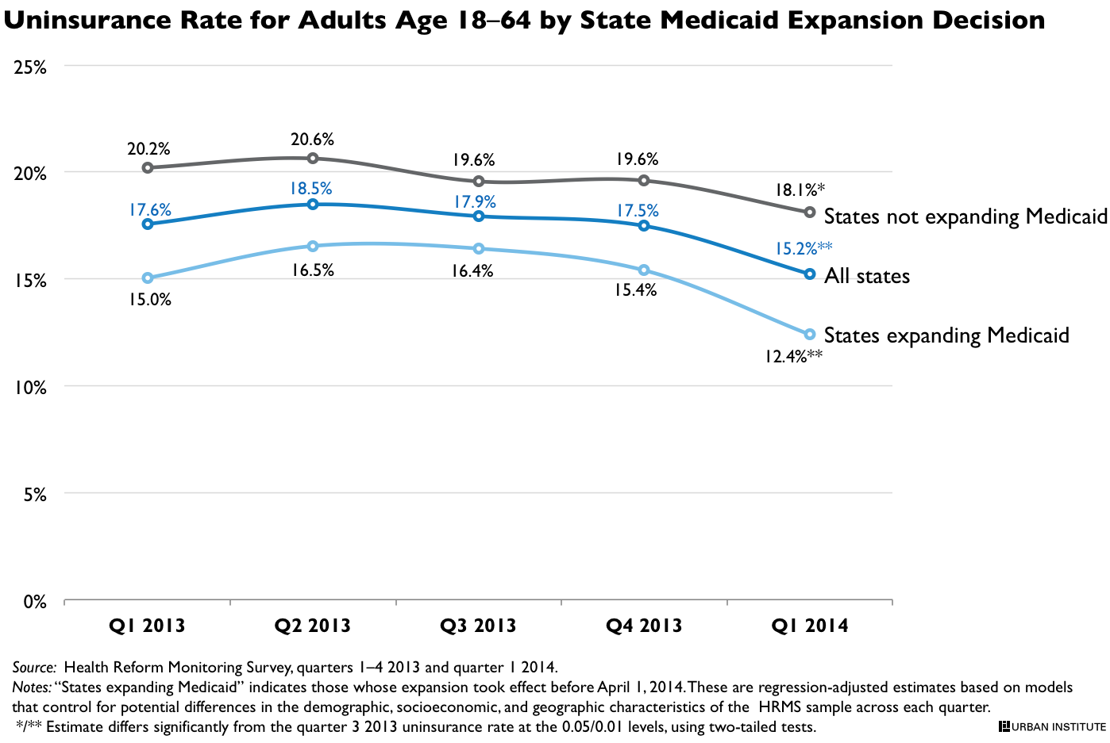
Source: http://hrms.urban.org/quicktakes/changeInUninsurance.html?cm_ven=ExactTarget&cm_cat=5.4+Million+Uninsured+Gain+Coverage&cm_pla=Topics+Coverage&cm_ite=http%3a%2f%2fhrms.urban.org%2fquicktakes%2fchangeInUninsurance.html&cm_lm=kim.vanpelt@slhi.org&cm_ainfo=&%%__AdditionalEmailAttribute1%%&%%__AdditionalEmailAttribute2%%&%%__AdditionalEmailAttribute3%%&%%__AdditionalEmailAttribute4%%&%%__AdditionalEmailAttribute5%%

Private Plans outside the Marketplace
From the Alliance of Community Health Centers:
- As far as we know, Meritus is the only insurance company in AZ still taking Individual/Family applications after March 31st even without a Qualifying Life Event. We will keep you updated if we hear of other insurance companies who are doing the same. If you’ve heard of anything, please let us know so that we can share with others.
- In some limited cases some insurance companies may sell private health plans outside the Marketplace and outside Open Enrollment that count as minimum essential coverage. These plans meet all the requirements of the health care law, including covering pre-existing conditions, providing free preventive care, and not capping annual benefits. If you have one of these plans, you won’t have the pay the fee that some people without coverage must pay. Insurance companies, agents, brokers, and online health insurance sellers may offer these health plans outside the Marketplace. The Marketplace does not list or offer these plans. You can’t get premium tax credits or lower out-of-pocket costs for plans you buy outside the Marketplace. Insurance companies can tell you if a particular plan counts as minimum essential coverage. Each plan’s summary of benefits and coverage also includes this information.
  - https://www.healthcare.gov/how-can-i-get-coverage-outside-of-open-enrollment/#part=4
- http://www.lifehealthpro.com/2014/03/18/what-will-brokers-sell-after-march-31

Network Adequacy Requirements for 2015

In its Final 2014 letter to Issuers in the Federally-facilitated Marketplaces (released 3/14/14), CMS outlines many of the requirements for 2015 for health plans offering coverage on the FFM. Some highlights:
Unlike the certification process for benefit year 2014, CMS will no longer simply utilize issuer accreditation status, identify states with review processes at least as stringent as those identified in 45 C.F.R. 156.230(a), or collect network access plans as part of its evaluation of plans’ network adequacy. Rather, CMS will assess provider networks using a “reasonable access” standard, and will identify networks that fail to provide access without unreasonable delay as required by 45 C.F.R. 156.230(a)(2). In order to determine whether an issuer meets the “reasonable access” standard, CMS will focus most closely on those areas which have historically raised network adequacy concerns. These areas may include the following:

• Hospital systems,
• Mental health providers,
• Oncology providers, and
• Primary care providers.

If CMS determines that an issuer’s network is inadequate under the reasonable access review standard, CMS will notify the issuer of the identified problem area(s) and will consider the issuer’s response in assessing whether the issuer has met the regulatory requirement and prior to making the certification or recertification determination. CMS will share information and analysis and coordinate with states which are conducting network adequacy reviews. Additional technical guidance regarding the collection method for a plan’s provider list will be provided as part of the certification/recertification instructions.

CMS also intends to use information learned during the QHP Application process to assist in its articulation of time and distance or other standards for FFM QHP networks that CMS intends to reflect in future rulemaking. CMS will share its network adequacy findings with states and will incorporate state input into its network adequacy review process. CMS will also continue to monitor network adequacy, for example, via complaint tracking, to determine whether the QHP’s network(s) continues to meet these certification standards. For future years, CMS is further considering appropriate formats for collection of provider network data, which would both enable CMS to review provider network adequacy and allow for the creation of a search engine function for consumers to find particular providers and provider types on HealthCare.gov.
Source: http://www.cms.gov/CCIIO/Resources/Regulations-and-Guidance/Downloads/2015-final-issuer-letter-3-14-2014.pdf

How to Assist Consumers Who Are Still “In Line” to Enroll or May Be Eligible for a Limited Circumstances Special Enrollment Period after March 31

From CMS:

“In-line” SEPs
As of March 31, the open enrollment period for the Marketplace has closed. CMS is not extending open enrollment. However, we want to make sure that those consumers who are still “in line” at the end of March are able to complete their enrollment. As assisters, you can help these “in line” consumers complete their applications either online or through the Marketplace Call Center.
CMS has created a limited Special Enrollment Period (SEP) for these “in line” consumers. Consumers should activate the “in line” SEP by attesting that they tried to enroll in coverage through either the Marketplace (online or by phone) or a state Medicaid or CHIP agency by March 31, 2014, and weren’t able to complete enrollment because of a system problem. A “system problem” could include heavy traffic to HealthCare.gov or the Call Center, maintenance periods, or another issue that prevents consumers from finishing the process. Consumers can attest online or through the Call Center.

Process for activating the “in-line” SEP:
- Attesting online on the Enroll To-Do List before continuing; OR
- Attesting through the Call Center by explaining how they have been trying to enroll prior to March 31 and why they couldn’t finish by the March 31 deadline. The Call Center will read the same attestation message on the Enroll To-Do List to the consumer and the consumer must agree to it before proceeding. Be sure that consumers tell the Call Center customer service representative that they’ve been trying to enroll and explain why they couldn’t finish by the March 31 deadline.
Consumers who are enrolling through their state’s Marketplace and want to know if they qualify for an SEP should contact that State-based Marketplace. Visit HealthCare.gov/how-can-i-get-consumer-help-if-i-have-insurance.
As assisters, you should support the enrollment of consumers who are eligible for “in line” SEPs as well as other SEPs (including hosting enrollment events for these consumers, if desired). When planning activities for April, you will want to take into account the need to continue to focus on enrolling these consumers rather than transitioning exclusively into activities related to helping people understand their insurance.

Limited Circumstances or “complex cases” SEPs
CMS also announced another type of SEP last week known as Limited Circumstances SEPs. These are SEPs that, in limited circumstances, allow consumers who were blocked from enrolling in coverage to have more time to enroll. Eligible consumers include those who have experienced any of the following:
Enrollment errors. For example:
- Consumers who enrolled through the Marketplace but the insurance company didn’t get their information due to technical issues
- Consumer’s information was received by the insurance company and may be processed, but the enrollment file contains defective or missing data (insurance company unable to enroll the consumer)
- Consumer’s enrollment may have been rejected by the insurance company’s system (errors in reading data)
Exceptional circumstances. For example:
- Consumer experienced a serious medical condition (e.g., unexpected hospitalization, temporary cognitive disability)
- Consumer prevented from enrolling because of a natural disaster (e.g., earthquake, massive flooding, hurricane)
- Consumer couldn’t enroll because of a planned system outage around plan selection deadlines (e.g., Social Security Administration outage)
Misinformation, misrepresentation, or inaction. This includes misconduct by individuals or entities providing formal enrollment assistance (including an insurance company, a Navigator, Certified Application Counselor (CAC), Call Center representative, or agent or broker) that resulted in one of the following:
- Failure to enroll the consumer in a plan
- Consumer enrolled in wrong plan against their wish
- Consumer was eligible but did not receive Advanced Payments of the Premium Tax Credit (APTC) or Cost-sharing Reductions
Specific system issues. These include system errors related to immigration status; plan display errors on HealthCare.gov; application transfer issues between Medicaid/CHIP and the Marketplace; error messages; unresolved casework issues; and other system issues. For example:
- Errors related to immigration status: An error in the application submitted by immigrants caused the consumer to get an incorrect eligibility result (for example, immigrant with income <100% FPL in non-Medicaid expansion state)
- Display errors on HealthCare.gov: Plan data display errors (premiums, benefits, co-pay/deductibles, service area)
- Medicaid/CHIP transfer: Consumers who were found ineligible for Medicaid or CHIP and their applications weren’t transferred between the State Medicaid/CHIP agency and the Marketplace in time for the consumer to enroll in a plan during open enrollment
- Error messages: A consumer is not able to complete enrollment due to error messages (for example, error or box screen indicating that the data sources were down and they could not proceed with enrollment)
- Unresolved casework: A consumer is working with a caseworker on an enrollment issue that is not resolved prior to March 31
- Other system errors, as determined by CMS, which hindered enrollment completion
Victims of domestic abuse. A consumer who is married but living apart from his or her spouse and is a victim of domestic abuse, and is not filing a joint tax return with their spouse (for instance, it could be dangerous or prohibited by law to contact their spouse), can obtain APTC and CSRs -- as long as they are otherwise eligible. Due to system limitations, consumers in this unique circumstance should indicate on the Marketplace application that they are not married. (As of April 1, the consumer should call the Call Center to explain the situation and activate the SEP. When completing the application, the consumer should indicate that they are not married on the application.)

What is the process for activating a Limited Circumstance SEP and enrolling?
In general, a consumer who wants a Limited Circumstance SEP must call the Call Center. There are some circumstances in which the Marketplace, insurance company, or state Medicaid or CHIP agency may be able to identify some consumers that are eligible for a Limited Circumstance SEP. In these cases, the consumer will be contacted. These consumers should then call the Call Center to activate the SEP.
Note: In the case of system defects, the consumer and assister should monitor that the system defect is fixed by continuing to try to reprocess the application. Once the defect is fixed, the consumer or assister should contact the Call Center to activate the SEP.
The steps to complete the Limited Circumstances SEP are:
Step 1: Consumer calls the Marketplace Call Center (1-800-318-2596; TTY 1-855-889-4325) and requests an SEP.
Step 2: Call Center will ask the consumer a variety of questions to help understand if the consumer is eligible for an SEP. The Call Center will forward cases that need additional review to CMS.
Step 3: If an SEP is granted, Call Center “activates” the SEP which allows the consumer to complete the enrollment. (If approved by CMS staff, the consumer will be notified and then will need to call the Call Center to “activate” the SEP.)
Step 4: Consumer enrolls online or through the Call Center.
Step 5: If the SEP is denied, the consumer can appeal the decision.
After following the process above, in most cases, consumers will have 60 days to select a plan from the date they are granted the SEP, which could be one of the following “triggering events”:
- The date that the consumer receives a letter informing them that they are eligible for an SEP;
- The date that the consumer contacts the Call Center and is found eligible for an SEP; OR
- The date that the caseworker finds an individual eligible for an SEP.
Coverage effective dates will generally follow the regular effective dates.

What are consumers' options if they were denied an SEP?
Consumers have a right to appeal. A consumer has 90 days to request an appeal with the Marketplace from the date their SEP is denied or 90 days from the date of the eligibility determination.
How to file an appeal: Visit HealthCare.gov/can-i-appeal-a-marketplace-decision/ to find and complete the appeal request form for the consumer’s state.
Mail appeal documents to:
Health Insurance Marketplace
465 Industrial Blvd.
London, KY 40750-0061

Reminders and Tips
- For Limited Circumstance SEPs, the Call Center must activate the SEP. Consumers will then be able to complete enrollment through the Call Center or on HealthCare.gov.
- To select a plan and complete enrollment after March 31, a consumer must receive an SEP. Consumers may always enroll in Medicaid or CHIP year-round if they are determined eligible.
- If the consumers you are assisting continue to experience difficulty enrolling due to system errors, please contact the Call Center, continue to help consumers keep a record of those issues, and tell us about the issues, as you have been doing for the past several months.
- A consumer who has already enrolled in coverage and then receives an SEP has the option to change plans or stay in their current plan, depending on what is offered to them on the Marketplace.
- If a consumer does not qualify for any type of SEP, such as the ones we’ve highlighted in detail or by experiencing a qualifying life event, the consumer should be aware that the online application will allow them to create an account or begin a Marketplace eligibility application. However, since this consumer doesn’t qualify for an SEP, they will not be able to select a plan and complete enrollment until the next open enrollment period begins on November 15, 2014 for 2015 coverage.

Reminder: For Qualifying Life Event SEPs
As we’ve mentioned before in past webinars, if a consumer has a qualifying life event (i.e., losing minimum essential coverage, having a baby, adoption, foster care, or getting married), they can enroll or change coverage outside of open enrollment.
- The consumer activates the change in coverage through the “change in circumstance” (CiC) function through HealthCare.gov or through the Call Center. (Overview of the New Change in Circumstances Functionality)
- You may also visit www.healthcare.gov/how-can-i-get-coverage-outside-of-open-enrollment to learn more about these qualifying life events. (This document is written for consumers; assisters can print and provide to consumers, as needed.)

Resources
Be sure to check out newly posted materials on the Resources for Assisters page of Marketplace.CMS.gov relating to SEPs, including:
- Assisting consumers who are trying to enroll by March 31? We can help.
- Helping Consumers with Complex Cases Enroll in Special Enrollment Periods in the Health Insurance Marketplace
HealthCare.gov also has new information for consumers:
- Special Enrollment Periods for complex cases in the Marketplace
We also posted guidance for issuers on this topic on the CCIIO website:
- Guidance for Issuers on People “In Line”
- Guidance for Issuers on Complex Cases
As we transition from open enrollment to the next phase of our work, you will want to be sure to check out these and other updates posted on marketplace.cms.gov and HealthCare.gov that contain new information about Special Enrollment Periods.

Medicaid/CHIP Inbound and Outbound Account Transfer SEPs
In the vast majority of states, individuals who started applications at the state Medicaid agency but were determined not to be eligible for Medicaid have had their accounts transferred to the Marketplace. However, eight states are not yet sending these denied Medicaid applications (known as “inbound account transfers”); currently, these states are: Alaska, Arkansas, Georgia, Kansas, Missouri, New Jersey, South Carolina, and Tennessee. Consumers in these states who have received denial letters from Medicaid can access coverage most efficiently by applying directly to Marketplace. However, this is not required. As long as these consumers applied for Medicaid prior to March 31, they will receive an SEP for enrolling in the Marketplace once their account is transferred to the Marketplace.
For consumers who started their applications at the Marketplace, there are some instances where the Marketplace might assess them as eligible for Medicaid/CHIP, but once their application is transferred to the state Medicaid agency it turns out that they are not eligible. This might have to do with differences in how the state and the FFM count income or household size. As long as these individuals started the process before March 31, they will receive an SEP for enrolling in the Marketplace once their account is transferred to the Marketplace, or if they indicate in their Marketplace application that they have been denied by Medicaid.

Weekly FAQ

From CMS:
Q: Will a consumer who receives a special enrollment period for being “in line” by March 31 and selects a plan within the limited amount of additional time provided still have to pay a fee for the individual responsibility requirement for the months prior to May 1, or whichever is the effective date of their coverage?
A: No. Consumers who receive a special enrollment period for being “in line” by March 31 and select new coverage within the limited amount of additional time to enroll in coverage, will be able to claim a hardship exemption from the fee, or individual responsibility requirement, for the months prior to the effective date of their coverage, because they will be treated as if they had enrolled in coverage by March 31.

________________

Have something you want us to possibly add to next week’s newsletter? Email Kim VanPelt at kim.vanpelt@slhi.org. As always, special thanks to Meryl Deles for much of the content.

