Covered Clips
A Weekly Summary of News and Activities for the Cover Arizona Coalition
Week of March 10th

Messaging on the Deadline
As the enrollment deadline grows closer, it is important to use effective messaging for consumers. Enroll America has been testing some different ways to talk about the mandate/penalty, and have found that by framing it as “sign up before March 31st to avoid paying a fine”, they’ve seen some real quantitative separation from some of the other ways of talking about it (like “penalty” or “fee”).

New Enrollment Numbers for Marketplace
Tuesday, the US Department of Health and Human Services released new numbers on Marketplace coverage. As of March 1st, 57,611 Arizonans have enrolled in the Marketplace and picked a health plan.
Of the thirty-six federally facilitated marketplace states (including partner states), Arizona ranks 15th in plan selection.

Rank/State | Individuals Who Selected a Plan | Individuals Who Selected a Plan as Percent of Uninsured
1/FL | 442,087 | 11%
2/TX | 295,025 | 4%
3/NC | 200,546 | 15%
4/PA | 159,821 | 11%
5/MI | 144,587 | 13%
6/GA | 139,371 | 8%
7/IL* | 113,733 | 6%
8/VA | 102,815 | 10%
9/OH* | 78,925 | 6%
10/TN | 77,867 | 9%
11/MO | 74,469 | 9%
12/NJ* | 74,370 | 6%
13/WI | 71,443 | 13%
14/IN | 64,972 | 8%
15/AZ* | 57,611 | 5%

*States that are also conducting outreach for expanded Medicaid
It is important to note that Arizona is one of only a few FFM states where enrollment is also occurring for expanded Medicaid. As of March 1st, AHCCCS reported that there had been 85,309 Arizonans added to AHCCCS under the Prop 204 restoration category (adults between 0-100 FLP) and 5,806 added to the expansion category (100 -133 FPL) since October.
That means that – in total – 158,726 Arizonans have been added to coverage since October 1st, or 14 percent of the population of uninsured Arizonans.

Arizona is trailing the national average in young adult enrollment (ages 18-34). Nationally, 25 percent of Marketplace enrollment is in this age range. In Arizona, 19 percent of Marketplace enrollment falls in this age category. However, we are also exceeding the national average for enrollment of children (19 percent in Arizona versus 6 percent nationally.)
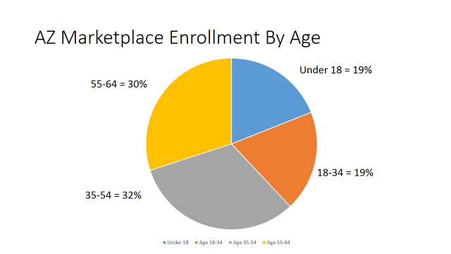
Arizonans continue to pick silver-level plans more frequently than other metal level plans.
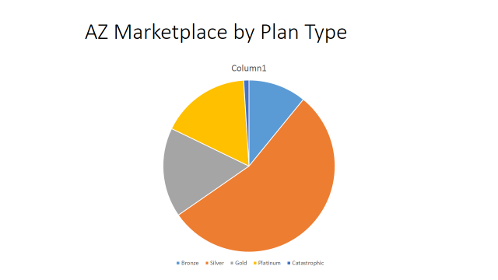
Sources: http://aspe.hhs.gov/health/reports/2014/MarketPlaceEnrollment/Mar2014/ib_2014mar_enrollment.pdf; http://www.azahcccs.gov/reporting/Downloads/PopulationStatistics/2014/Mar/AHCCCS_Population_by_Category.pdf

Uninsured Rate Declines Nationally

With less than three weeks left to sign up for the Marketplace, a major survey tracking the rollout finds that the uninsured rate nationally is declining.
The Gallup-Healthways Well-Being Index found that 15.9 percent of U.S. adults are uninsured thus far in 2014, down from 17.1 percent for the last three months — or calendar quarter— of 2013.
That translates roughly to 3 million to 4 million people getting coverage.
http://www.modernhealthcare.com/article/20140310/INFO/303109934?AllowView=VDl3UXk1TzZDL1NCbXgzS0M0M3hlMENvajBVZENlST0=&utm_source=link-20140310-INFO-303109934&utm_medium=email&utm_campaign=am

Full Impact of ACA on the Uninsured
Here is another analysis of the impact of the Affordable Care Act on Coverage. It comes from statistician Charles Gaba. When additional factors such as enrollment in coverage by young adults on their parent’s plans is considered, enrollment in coverage nationally is up between 11 – 13.7 million.
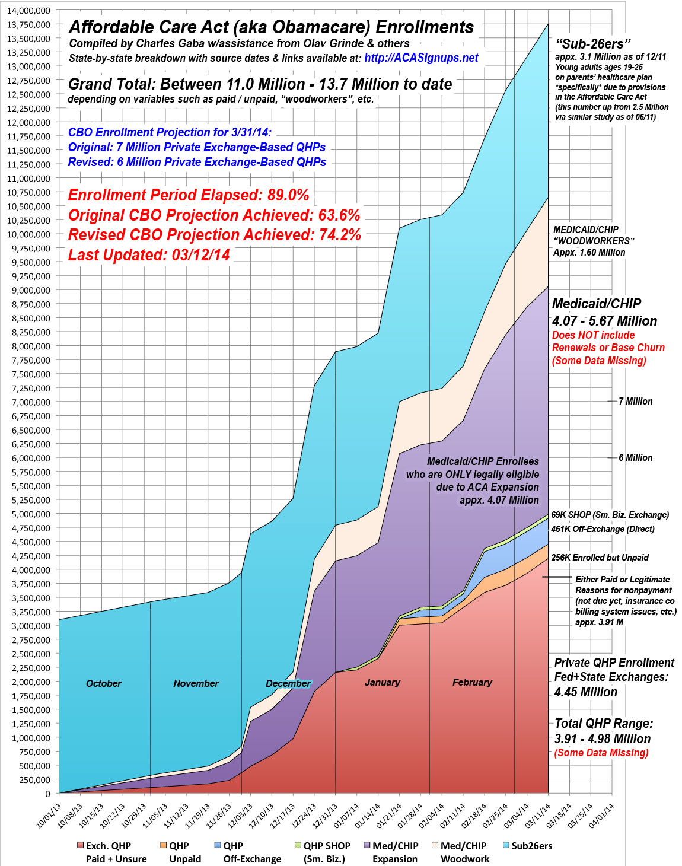

New Video Featuring President, Zach Galifianakis Promotes Marketplace

A new video went viral Tuesday, featuring President and comedian Zack Galifianakis. The six-minute video clip includes messaging from the President urging young adults to sign up for the Marketplace. As of Thursday, more than 15 million Americans had viewed the video. The White House has been reporting that traffic to healthcare.gov is up 40 percent.
Those conducting outreach may want to consider sharing through social media:
http://www.funnyordie.com/videos/18e820ec3f/between-two-ferns-with-zach-galifianakis-president-barack-obama

New Questions on the Application about COBRA Coverage
From Families USA:
New questions have been added to the healthcare.gov marketplace application to allow consumers eligible for COBRA coverage to enroll in a marketplace plan with financial assistance. It is important for consumers who are eligible for or enrolled in COBRA to know that they can still get financial assistance to help pay for a health plan through the marketplace, as long as they are not enrolled in or plan to cancel COBRA before coverage starts under their new marketplace plan.
The new application questions allow consumers to indicate that they are not planning to enroll in COBRA, the date they plan to drop their COBRA coverage, or when their COBRA coverage will end.
COBRA is available to people who formerly had health insurance through their job to continue coverage under their employer’s health plan for a limited time if they lose their job or their employment terms change. However, typically to keep this coverage, the employee must pay the full monthly premium for the health plan, and COBRA is therefore unaffordable for many consumers.
It is important to note that if a person is enrolled in COBRA after open enrollment ends on March 31st, they will not qualify for a special enrollment period if they drop COBRA coverage. They will have to wait until their COBRA coverage ends or until the next open enrollment period before they can enroll in a marketplace plan. People who lose job-based health insurance outside of the open enrollment period will qualify for a special enrollment period to enroll in a marketplace plan, as long as they don’t enroll in an offer of COBRA coverage.

Selecting the Right Metal Level

The National Health Council and its patient advocacy members have created a web tool where people can enter their unique health needs – the number of doctor visits, specialist visits, hospitalizations, and specific medications (both generic and brand name) – to learn how the different metal plans in their state can affect their out-of-pocket costs. The tool generates a personalized report that a patient can print off or e-mail; the report helps the person narrow in on the metal plan level that more appropriately meets his or her needs.

The tool at www.PuttingPatientsFirst.net is unlike any other web tool being used. It is an excellent complement to Healthcare.gov and can be used with subsidy calculators, such as the one created by the Kaiser Family Foundation.

Consumers Needing to Make Changes to Their Marketplace Application or Coverage

Many enrollment assisters attended training sessions in Phoenix and Tucson a week ago last Friday regarding changes to Healthcare.gov and clarification on how to help consumers in specific situations. Slides from the training and a related critical guidance document from CCIIO can be found here:
http://coveraz.org/consumers-needing-to-make-changes-to-marketplace-applications-or-coverage/
Bulletin #3 (contained in the CCIIO bulletin found through the link above) is of great importance to people in Arizona who have selected a qualified health plan (QHP) that has no providers in their area. NOTE: Pg-2, Item 6.b. has a typo. It should read provided does NOT trigger an SEP.
In summary, for people in Arizona, if they selected a plan from an issuer that does have a local network of providers, they can switch plans by calling the issuer (insurance company) before March 31st. See the rules on Pg-11, Bulleting #5.
If they have selected a plan from an Issuer that does not offer any providers in their area, the consumer needs to call the Marketplace hotline and they will fall under the rules found in Bulletin #3. Note: The Aetna situation (bought Aetna but live outside of Maricopa County) is being treated as a marketplace display error – the call center should already have a list of people who enrolled outside Maricopa. The consumer calls in, say they’re in Aetna and there aren’t any providers in their area the CSR should be able to confirm the name on the list and give them an immediate SEP to choose another plan.

Mixed- Status Families and Coverage

Last week, an op-ed piece appeared in La Opinion, a Spanish-language newsletter, where the Departmnet of Homeland Security Secretary, Jeh Johnson, assures mixed-immigration status families that it’s safe to apply for coverage on the Marketplace, and that the information consumers provide applying for health insurance coverage through the Marketplace will not be used for immigration enforcement. Dept. of Homeland Security Secretary Jeh Johnson encourages eligible consumers to visit HealthCare.gov or CuidadodeSalud.gov to see their options and sign up for coverage.

Since October 2013, Immigration and Customs Enforcement (or "ICE" as it is commonly known) has had a policy which states that the information consumers provide in their application for enrollment for health insurance under the Affordable Care Act will not be used as the basis for immigration enforcement. This policy remains in effect. No one in the United States should be afraid to apply for health coverage because they have a family with mixed immigration status.

Link to the Immigration and Customs Enforcement’s policy found here.

Link to Dept. of Homeland Security Secretary Jeh Johnson’s op-ed piece in La Opinion found here.

FAQs of the Week

From HHS:

Change in Circumstances
Q: Are consumers able to report life changes through HealthCare.gov?
A: Yes. Consumers are able to report changes directly through the Marketplace. Consumers should log into their account and click the “Report a Life Change” button. Life changes include marriage, birth, adoption or placement of a child, and a permanent move to a different county and zip code and may trigger a special enrollment period (SEP).
If the consumer is eligible for an SEP, the consumer will have the opportunity to compare and select from all QHPs available in the consumer’s service area. The SEP applies to the entire family not just to the family member with a life change.
Q: Will reporting a change in income change a consumer’s eligibility for advance payments of the premium tax credit or lower out-of-pocket costs? How does this relate to Special Enrollment Periods?
A: Yes, changing the amount of tax credits or cost-sharing reductions applied to the consumer’s coverage. The Marketplace will also then determine whether they are eligible for a special enrollment period; they will be allowed to keep the existing coverage or enroll in a different health plan.
Q: If a consumer reports a change in their MyAccount Communication Preferences (such as address, phone number and notification preferences) through the Marketplace does that update get automatically communicated to the insurance company?
A: No. Changes to MyAccount Communication Preferences are not sent from the Marketplace to the issuer automatically. A consumer must report information updates directly to their insurance company in addition to updating their MyAccount Communication Preferences on HealthCare.gov.
Q: Does a consumer have to reenter all their application information again if they become eligible for a special enrollment period (SEP)?
A: No. Consumers reporting changes that affect eligibility will see a version of their application with most information pre-populated on their screen and may correct the application.
Q: Is a consumer limited in what application information they may update when they go to the “Report a Life Change” functionality?
A: No, the consumer has the ability to edit all available fields in the application. However, if the new information being provided does not trigger a special enrollment period (SEP), the individual will be limited to confirming his or her enrollment information in the QHP in which he or she is currently enrolled and changing the amount of tax credit (APTC) applied to their premium. The Marketplace will not prompt the consumer to compare and select another plan.
Q: Does the change in circumstances functionality allow a consumer to make updates if they have been “looping” between Medicaid and the Marketplace?
A: Yes. The change in circumstances functionality provides a method for a consumer to follow to prevent the consumer denied Medicaid and CHIP from “looping” between Medicaid and the Marketplace. The instructions to the new question on the financial assistance application state that the consumer should ONLY checks the box if a person was found not eligible for Medicaid or CHIP by their state, not by the Marketplace, and if the family’s income or household size hasn’t changed since the person was found not eligible.
Q: Will the insurance company be notified if the consumer selects or confirms a plan using the change in circumstances Marketplace functionality?
A: Yes. Once the consumer selects or confirms a plan, the tool informs the consumer that they have successfully completed all steps with the message that they must activate their new coverage by paying the first month’s premium by the plan’s due date. A consumer may see their existing and past enrollments under the account button: “My plans & programs.”

Immigration
Q: Is there a waiting period for a lawfully present immigrant to purchase a QHP, like there is with Medicaid eligibility?
A: No, unlike with Medicaid, there is no 5-year waiting period for a lawfully present immigrant to enroll in a Qualified Health Plan or for tax credit/cost sharing reduction (APTC/CSR) eligibility.
Q: If a consumer has a Green Card, but due to computer errors will not receive their Social Security Number until April, should they wait to apply then?
A Social Security Number is not required to apply for coverage, so the consumer should apply now, and can use their Green Card to attest to an eligible immigration status for Marketplace coverage.
Q: Can a U.S. Passport be used to verify naturalized citizenship?
A: The Marketplace can’t electronically verify a U.S. passport as proof of citizenship, but consumers whose citizenship cannot be electronically verified will be asked to provide proof of their citizenship to the Marketplace, and can submit a U.S. passport to the Marketplace for review. A copy can be uploaded via My Account, or mailed to the Marketplace. Please note that you don’t need to wait for the Marketplace to process your documents before you select and enroll in a plan.
Q: Are all dreamers excluded from Marketplace coverage?
A: Immigrants in Deferred Action for Childhood Arrivals (DACA) status, often referred to as Dreamers, are not eligible to purchase coverage through the Marketplace.
Q: Legal Permanent Residents with fewer than five years' residency are still be denied by the Marketplace. Are there plans to fix this? Or must we go through the process of securing Medicaid denials before again applying to the Marketplace?
A: We are aware that HealthCare.gov is not consistently providing APTC eligibility for non-citizens who are lawfully present under 100% FPL, and we are working on a package of fixes that is designed to remedy this issue. We will notify folks broadly when these fixes have been deployed so that they can work with consumers to update applications. We are aware that the open enrollment period is quickly drawing to a conclusion and are pushing to have this fixed very quickly.

Assisting Consumers with Disabilities

From HHS:
The Affordable Care Act takes a number of steps to bring people with disabilities into the mainstream of health care delivery in Health Insurance Marketplaces, and Navigators, CACs and federally funded entities assisting with enrollment are, and will continue to be called upon, to help people with disabilities to navigate this dramatically changed environment.
Prior to the Affordable Care Act, insurance companies could discriminate against individuals with disabilities and chronic conditions on the basis of pre-existing conditions, subject them to lifetime limits, decline to provide essential benefits and more. Although the Americans with Disabilities Act of 1990 constituted a dramatic advance for the civil and employment rights of people with disabilities, it did not require non-discrimination in health insurance meaning that most people with disabilities had to secure employment which offered large group insurance or remain on Medicaid. Effective 2014, the Affordable Care Act bans lifetime limits & preexisting conditions discrimination, allows people with disabilities to escape job lock, work for small employers, as independent contractors or start their own businesses.
Who are the consumers with disabilities you will be encountering?
According to the US Census Bureau’s 2012 American Community Survey, there are about 19.6 million people with disabilities ages 18 to 64, or roughly 10.10% of the population in the age group. Roughly 3.5 million each have difficulty with hearing and vision, about 8 million have a cognitive disability, and about 10 million have a mobility disability. Contrary to public perception, this includes a diverse group of people, including 1) Workers with Disabilities including some who had previously been excluded from individual and small group insurance; 2) Individuals on Social Security Disability Insurance in the two-year Medicare waiting period; 3) Families with dependents under age 26 with disabilities; and 4) some “young invincibles” in excellent health, who are not overly high users of health care services, but may need some accommodations to navigate the Marketplace due to visual or hearing disabilities. It is important to dispel the myth that all people with disabilities are best served by Medicaid/Medicare. In fact, there are substantial numbers of people with disabilities who should be able to benefit from the ACA, not only because they were previously excluded from private insurance because of pre-existing conditions, but because private insurance did not previously meet their health needs.
What are the responsibilities of Navigators, Assisters and Recipients of Federal Funding in Serving Consumers with Disabilities?
All Recipients of Federal Funding must adhere to the Program Access Requirements of Section 504. “No otherwise qualified individual with a disability in the United States . . . shall, solely by reason of her or his disability, be excluded from the participation in, be denied the benefits of, or be subjected to discrimination under any program or activity receiving Federal financial assistance . . . ." In practical terms this means that individuals with disabilities must be offered reasonable accommodations and auxiliary services and aids by recipients of federal funding to ensure that they are not excluded from the programs and services of the Marketplaces created by the Affordable Care Act. If you are a federally qualified health center, a state agency that receives federal funding, you are covered by Section 504 –even if your agency is serving as a certified application counselor and not a federally-funded Navigator grantee.
Regulations Applicable to Navigators in Federally- Facilitated Marketplaces (45 CFR 155.215 (d)) Navigators in Federally Facilitated Marketplaces are required to provide individuals with disabilities with 1) accessible consumer education materials, Web sites, or other tools utilized for consumer assistance purposes; 2) auxiliary aids and services for individuals at no cost where necessary for effective communication; 3) assistance to consumers in a location and in a manner that is physically and otherwise accessible to individuals with disabilities. Navigators are also expected to ensure legally authorized representatives are permitted to assist consumers with disabilities, acquire sufficient knowledge to refer people with disabilities to local, state, and federal long-term services and supports programs (LTSS) when appropriate and be able to work with all individuals regardless of age, disability, or culture, and seek advice or experts when needed.
Requirement of CAC’s at § 155.225
CAC’s must, either directly or through an appropriate referral to a Navigator or non-Navigator assistance personnel or to the Marketplace call center, provide information in a manner that is accessible to individuals with disabilities. Many local affiliates of national disability networks are available and would be eager to help you strategize and serve as resources to enhance your capacity to serve consumers with disabilities. Look for Centers for Independent Living (CILs), Protection and Advocacy Agencies (P&A’s), University Centers of Excellence in Developmental Disability (UCEDDs), State Developmental Disability Councils and/or Aging & Disability Resource Centers (ADRCs) in your area for more information. Also consider collaborating with some of the many disability/ disorder specific affiliates of national organizations such as United Cerebral Palsy, the MS Society, The ARC, American Diabetes Association, etc.
What is Disability Etiquette?
Some considerations you should be aware of when working with individuals with disabilities include the following:
- While some disabilities are visible, others are hidden.
- People with functional impairments may not see themselves as someone with a disability.
- Always be respectful and avoid referring to someone by his/her disability.
- Use “people first” language – e.g. person with a disability.
- Speak directly to the individual and not to the person accompanying him/her.
- Do not make assumptions about what the individual can do/not do, understand/not understand.
- Be willing to spend extra time, if necessary.
How to Assist People with Disabilities
Examples of ways to make assistance for people with disabilities accessible include: 1) American Sign Language Interpreters; 2) TTY phone lines; 3) Large Print, Braille & electronic versions of literature; 4) Plain Language; 5) Wheelchair Accessible Offices located close to public transit. If you are having difficulties identifying how to best assist consumers with disabilities, please consult the National Disability Navigator Resource Collaborative, the DOJ Effective Communications Guidance and Other Resources referenced in the additional resources section. Keep in mind that in some cases you will be asked to work with authorized representatives who are authorized to represent and act on behalf of consumers with certain disabilities.
Identification of Disability on the ACA Application
What is the disability question: Do any of these people below have a physical disability or mental health disability that limits their ability to work, attend school or take care of their daily needs?
Why the question is asked: The application asks this question to help determine whether someone may be eligible for Medicaid based on disability and to help identify possible needs for long-term supports and services (LTSS). People with disabilities who require community based services and supports may be interested in qualifying for Medicaid since most private health plans do not fund LTSS.
Examples of Disability Questions we’ve been getting on the ACA Application
- Why isn’t my disability mentioned? It is not practical or necessary to mention every disability. The specific condition or diagnosis does not matter at this stage, since all this stage determines is whether an individual’s application will be sent on to a state Medicaid agency for consideration as to whether the consumer is eligible for Medicaid based on his or her disability.
- What if I'm a person with disabilities but do not want to be considered for Medicaid? If the person prefers to be considered for the Marketplace then s/he should NOT identify as a person with a disability and should continue applying through the Marketplace. Note, however, if the Marketplace determines that the individual is eligible for Medicaid based on income, the individual's application will be sent to the state Medicaid agency.
- What if I'm receiving Social Security Disability Insurance (SSDI) and I’m in the 2 year waiting period before getting Medicare? The individual may be eligible for Medicaid, and Medicaid eligibility may possibly continue even after Medicare enrollment begins. If the individual is not eligible for Medicaid, s/he be eligible for a Qualified Health Plan and may qualify for lower costs based on income and household size. When asked about their income on the marketplace application, these consumers should be sure to include their SSDI income on their Marketplace application.
- What if I’ve applied for SSDI but it hasn’t come through? Decisions for SSDI take a variable amount of time so individuals cannot assume they will get SSDI or include it in estimating income. And, even if they are found eligible for SSDI, there is a 24-month waiting period for Medicare coverage to begin. Individuals waiting for an SSDI determination must enroll before March 31 in order to avoid a penalty. These individuals may still be eligible for Medicaid and should answer yes to the disability question if they want their application considered for categorical Medicaid eligibility. If they do not want to be considered for Medicaid eligibility based on disability, they should apply through the Marketplace. Note that once they are found eligible for SSDI and their income changes due to increased benefits, these individuals will need to report the SSDI income in the Marketplace account because it may impact tax credit or Medicaid eligibility. If their SSDI application is denied, they will retain their Marketplace or Medicaid coverage and not have to report a change in income.
Examples of Other Disability Questions
- People with disabilities may be particularly interested in Long-Term Services and Supports, the Habilitative and Rehabilitative services Essential Health Benefits, access to durable medical equipment, and specific information on specialist providers and prescription drug formularies. They may want more detailed information about these benefits than is provided in the Summary of Benefits and Coverage (SBC) and may need to request an Evidence of Coverage (EOC) from the health plan. Unfortunately, consumers sometimes encounter difficulties in obtaining the EOC, the plan's formulary, and the plan's provider directory.
- What if the Marketplace lacks a TTY line for deaf callers in order to verbally authorize assistance? This is inconsistent with Section 504 of the Rehabilitation Act of 1973 and/or Title II of the Americans with Disabilities Act. If this happens, please file a casework complaint with the regional CMS office. An interim solution may be to have the consumer call using relay services for the deaf in order to give verbal authorization. For more information on relay services see http://www.fcc.gov/guides/telecommunications-relay-service-trs.
- What if individuals with disabilities are told that there are pre-existing conditions clauses that require them to wait for 12 months before the policy will pay on pre-existing conditions? By statute these provisions are banned in all plans in the Marketplace, and non-grandfathered plans generally. Consumers should check with the health plan and file a casework complaint with the regional CMS office.
Additional Resources
- Administration for Community Living www.acl.hhs.gov
- National Disability Navigator Resource Collaborative http://www.nationaldisabilitynavigator.org/
- NDNRC Disability Guide http://www.nationaldisabilitynavigator.org/ndnrc-materials/disability-guide/
- DOJ Effective Communications Guidance http://www.ada.gov/effective-comm.htm
- National Council on Disability www.ncd.gov

Tips for Submitting Supporting Documents to the Health Insurance Marketplace
From HHS:
We recently published a useful FAQ document that outlines information on identity (ID) proofing and on application inconsistencies: http://marketplace.cms.gov/help-us/remote-identity-proofing-faqs.pdf. All Assisters should be sure to read this new document.
There are two reasons consumers may need to submit supporting documents. Consumers may need to submit documentation to the Marketplace to:
- Verify their identity for identity (ID) proofing purposes or
- Resolve application inconsistencies.
These are two different topics and two different stages in applying for health coverage through the Federally-facilitated Marketplace (FFM). ID proofing is one of the first steps to set up your online Marketplace account. ID proofing must be completed in order for you to submit an online application for coverage through the FFM. Application inconsistencies occur when some of the information in your application for coverage does not match information in trusted data sources we check to verify your eligibility. It is important to remember that, regardless of whether the applicant has an inconsistency, the consumer can still continue on to enroll in coverage consistent with the eligibility the consumer was provided by the Marketplace in their eligibility determination notice.
There are two ways consumers can submit documentation to the Marketplace:
- Upload documentation to HealthCare.gov on a consumer’s account.
- Send copies of documentation to the Marketplace processing center via postal mail.

Identity Proofing
What is ID Proofing?
ID proofing is one of the first steps of the process to apply for health coverage through the Federally-facilitated Marketplace. ID proofing must be completed in order to submit an online application for coverage through the Marketplace. ID proofing is used to verify identity and is done by asking questions based on personal and financial history. If the consumer fails the online process, a manual process is needed in order for the consumer to submit an online application.
Steps to ID Proof Online
- After logging into consumer’s account, click “My Profile” to begin ID proofing
- Click “Verify Now” to begin ID proofing process
- Consumer enters the information needed to verify identity
If the Marketplace informs a consumer that their identity couldn’t be verified, they must take additional steps to verify their identity. First, the consumer will be directed to call the Experian Help Desk (Experian is the contractor the Marketplace uses to complete the ID proofing process) at (866) 578-5409 and provide the reference code displayed on their computer screen. If the consumer’s identity cannot be verified by the Experian Help Desk, the consumer will be asked to upload documents showing their identity to their My Account on HealthCare.gov, or mail documentation to the Marketplace for review at the address below. Consumers should choose one process, not both.
When submitting documents for ID proofing errors, below is a list of possible documents; however, please refer to the notice the consumers receives upon failing identity proofing for the list of possible documents. The consumer needs to upload two different documents if the provided documents do not include photo identification of the consumer.
- Driver’s license
- School identification card
- U.S. Military draft card or draft record
- Any identification card issued by federal, state, or local government
- Military dependent identification card
- Tribal card
- Authentic Document from a Tribe declaring membership of an individual
- U.S. Coast Guard Merchant Mariner card
- U.S. public birth record
- Social Security card
- Marriage certificate
- Divorce decree
- Employer identification card
- High school or college diploma
- Property deed or title
Tips for Uploading Documents Online for ID Proofing
- Consumers may either upload documents to the consumer’s Marketplace Account OR mail them. Do not submit documents multiple ways, it will not expedite processing.
- Documents will be processed more quickly if uploaded.
- If you’re helping a consumer upload documents through HealthCare.gov, it’s not necessary for the consumer to include the barcode page from his or her eligibility notice.
- The following are accepted file formats for uploading documents: .pdf, .jpeg, .jpg, .gif, .png, .tiff, and .bmp.
Sending Identity Documents by Mail for ID Proofing
- When mailing documents, consumers should provide copies of their documents, not the original.
- When mailing documents, consumers should include the barcode page from their ID proofing failure notice in the same envelope
- If the consumer doesn’t have the page with the barcode, write the consumer’s application ID# (if they have one), date of birth, and SSN (if available) on all of the documents. Note—The Marketplace is required to abide by strict privacy and security standards to make sure consumer’s information is protected.
- Consumers should keep a copy of all documents mailed to the Marketplace, including proof of mailing (if they have one)
Status of Submitted ID Proofing Documents
- You can expect identity verification documents to be processed and turned around quickly, typically within 7-10 business days.
- After identity verification documents are processed, the status should change in their account on HealthCare.gov to say “identity verified” if the consumer passes ID proofing and “Identity not verified” if the consumer does not pass ID proofing.
- If after two weeks a consumer’s identity has not been verified after submitting documentation, he or she should contact the Marketplace Call Center at 1-800-318-2596 (or TTY: 1-855-889-4325) to ask for an update. The Call Center will ask for some information, such as name and date of birth, and should be able to provide the consumer with an update. In the event the Call Center is not able to provide a status update, the Marketplace Call Center will research the issue and will be in touch with the consumer.

Application Inconsistencies
What is an Inconsistency?
When consumers fill out their application for Marketplace coverage, they enter certain information about themselves and their family including: the state of residence, their citizenship or immigration status and, if applying for help paying for coverage, their income. The Marketplace will attempt to match the information provided with information contained in data sources we use for eligibility verification. If any of the information provided does not match information contained in data sources we use for eligibility verification, we call this an application inconsistency.
It is important to remember that, regardless of whether the applicant has an inconsistency, the consumer can still continue on to enroll in coverage consistent with the eligibility the consumer was provided by the Marketplace in their eligibility determination notice. The Marketplace will inform the consumer of his or her final eligibility determination after the inconsistency is resolved.
How Will a Consumer or Assister Know if a Consumer has an Application Inconsistency?
In the consumer’s Marketplace account, under “Applications details,” there will be a list of all unresolved inconsistencies. An inconsistency will be listed in the consumer’s eligibility notice or in the consumer’s Marketplace account, under “Applications details,” there will be a list of all unresolved inconsistencies. Please note that a message does NOT appear on screen during the application.
Tips for Submitting Documents to Resolve Inconsistencies
- You may either upload inconsistency documents to the consumer’s Marketplace Account or mail them.
- Review the consumer’s eligibility notice to determine which household member(s) needs to provide more information and the list of documents that can be provided.
- Make a copy of the needed document and have the consumer submit the copy and keep the original. Cell phone photos are permitted if a copy can’t be scanned.
- If you get a red box error message, make sure you uploaded the right type of document (e.g., PDF not Excel file)
- List of acceptable documents will be in consumer’s notice, or can view on HealthCare.gov: www.healthcare.gov/help/how-do-i-resolve-an-inconsistency/
Uploading Inconsistency Documents Steps
- Log into the consumer’s Marketplace account, and select the submitted application.
- Click “Application details” from the left navigation.
- Next, click the “Verify” button by the information that needs to be uploaded.
- After choosing “Verify,” select a document type to upload from the list, then click on “Select file to upload”
- If you get a red box error message, make sure you uploaded the right type of document (e.g., PDF not Excel file)
Sending Inconsistency Documents by Mail
- When mailing documents, consumers should provide copies of their documents, not the original.
- When mailing documents, consumers should include the barcode page from their eligibility determination notice in the same envelope
- If the consumer doesn’t have the page with the barcode, write the consumer’s application ID#, date of birth and SSN (if available) on all of the documents. Note—The Marketplace is required to abide by strict privacy and security standards to make sure consumer’s information is protected.
- Consumers should keep a copy of all documents mailed to the Marketplace, including proof of mailing (if they have one).
Status of Submitted Inconsistency Documents
- If a consumer has sent in documents but has not yet received a notice with the result or status of their inconsistency, the consumer’s information is likely still being processed.
- The consumer does not need to take any action unless the consumer hears from the Marketplace that more information is needed. When the consumer’s paperwork is processed, the consumer will receive a notice.
- If a consumer has not received a notice from the Marketplace after two weeks, he or she should contact the Marketplace Call Center at 1-800-318-2596 (or TTY: 1-855-889-4325) to ask for an update. The Call Center will ask for some information, such as name and date of birth, and should be able to provide the consumer with an update. In the event the Call Center is not able to provide a status update, the Marketplace Call Center will research the issue and will be in touch with the consumer.
Most importantly, the consumer will still be eligible for health coverage and the consumer can continue on to enroll in coverage consistent with the eligibility the consumer was provided by the Marketplace. This is true even if the deadline for submitting documents listed on the consumer’s eligibility determination notice is very soon or has already passed. The Marketplace will inform the consumer of his or her final eligibility determination after the inconsistency is resolved

________________

Have something you want us to possibly add to next week’s newsletter? Email Kim VanPelt at kim.vanpelt@slhi.org.

